St Edmunds Parish Website
Notes – December 2019

Welcome to the St Edmund’s parish website. This note is intended to help you use and navigate the site. Please feel free to send comments on the site and note to Alan Lion.

Some General Advice

- To access the site, please follow this link: https://stedsgod.com/ or type the URL into your browser

- To return to the Home Page from any screen, click on the words “Home St Edmund’s Parish”. These words are to the left of the screen on a computer and at the top of the screen on a mobile.

- The system is built using a tool called Faithlife. Sometimes you will be taken to a Faithlife screen. Please note that:

- All Faithlife screens have the Faithlife logo near the top. This looks like this:
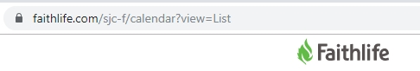

- The URL for a Faithlife page will always start with words “faithlife.com”
- Faithlife screens will always open in a new browser window.
- When you have finished looking at whatever is on the relevant Faithlife page or pages, simply close the window. The website window you came from remains open.

- Please also note that weekday services can and do vary from week to week. Please always check a day or two before if you are planning to come to a weekday service.

Frequently Asked Questions

Below are some things that you might like to do. If you find what you are want, please click on the suggestion and you will be taken to the relevant part of the document where we will explain how to find what you want.

- I would like to know what services are on this week.
- I would like to see what is happening in the parish
- I would like to see what is happening outside the parish
- I would like to make a prayer request
- I would like to pray for somebody who needs prayer
- I would like to know how you help young people
- I am interested in finding out about Children’s Liturgy
- I would like to know more about the music that the parish provides
- I would like to know what music is planned for a given service
- I would like information about Sacraments for young people
- I would like information about Sacraments for adults
- I would like details of courses you are running to help adults grow spiritually
- I would like to join a course or group for community and spiritual nourishment
- I would like a copy of the latest parish newsletter
- I would like to contact somebody in the parish

Other Information

Apart from providing answers to the above FAQs, the website holds a lot of other information. Since most of these pages are self-explanatory, we have listed them below. If you click on each link, you will be taken to page on the website:

- This Week’s Message – the most recent message from our parish priest
- Our Mission – tells you more about our parish’s direction
- A Better World – we are responsible for the care of those outside our parish and for our world. If you would like to participate, take a look here.
- Safeguarding – all the contact details and information relating to the care of the young and vulnerable
- Parish Pictures – budding photographers can contribute
- Bumps and Babes – we run special sessions for parents with very young children. You need to scroll down to the relevant details
- Schools - details about and links to our local Catholic schools

Chat Groups – PLEASE NOTE

You will see a number of references on the site to Chat Groups. To access these you have to contact the person mentioned. Everybody is welcomed to join the Parish Chat Group on the Home page. The other chat groups are special groups for individuals involved in particular areas of parish life (e.g. music, youth, confirmation, First Holy Communion). In due course, we will look to expand the use of these Chat Groups into meaningful communities. For the present, the immediate focus is on the content and usability of the new website.

If you click on a Chat Group link that you have not joined, you will find yourself somewhere in the Faithlife system! In this case, please just close the browser window and, if you want to join the relevant Chat Group, contact the person mentioned. Chat Groups require the Faithlife program (on computers) and the Faithlife application (mobiles). When you ask to join a Chat Group, you will receive details of how to obtain these.

SERVICE DETAILS

I would like to know what services are on this week.

Scroll down the Home page and there is a calendar of services and key events in the parish. This looks like the following:
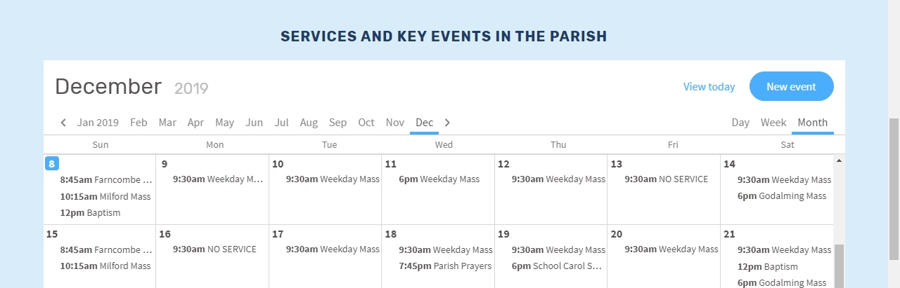

If you want more information about a service, place your cursor over it (computer) or tap on it (mobile). You can see later dates by scrolling down (computer) or swiping down (mobile). This will look like:

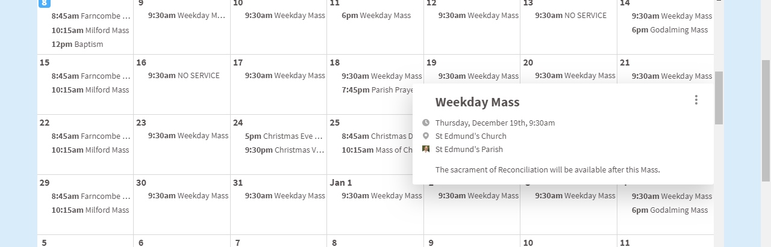

To see future dates not immediately visible, please scroll up. If you hover over the title (e.g. “School Carol Service”) and click, you will be taken to screen showing the event and, if relevant, a description. The screen that appears is shown below:

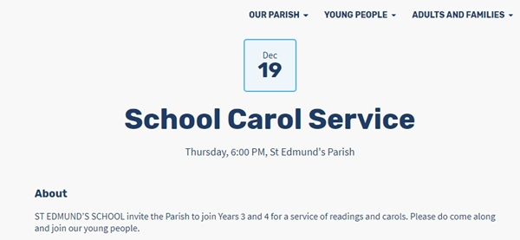

You can see the services in a different format by selecting Our Parish -> Services And Churches. This will result in the following appearing:
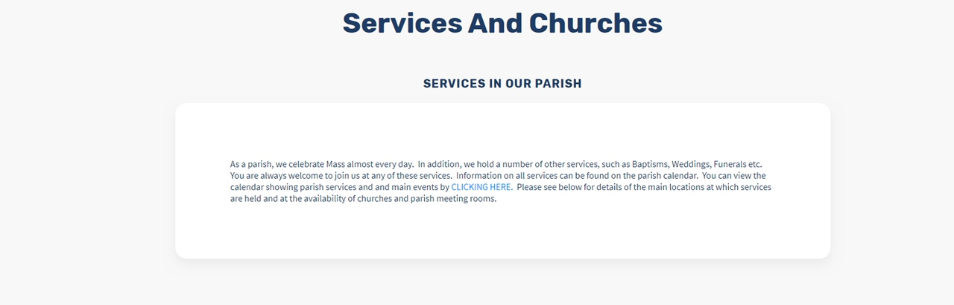

If you click on the blue text “CLICKING HERE”, the following Faithlife screen with the dates will appear:

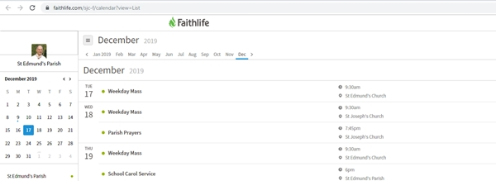

This action has taken you to a Faithlife system screen. Faithlife screens are described in the introduction to this note. In this case, if you hover over the title and click, the following Faithlife event screen will appear:
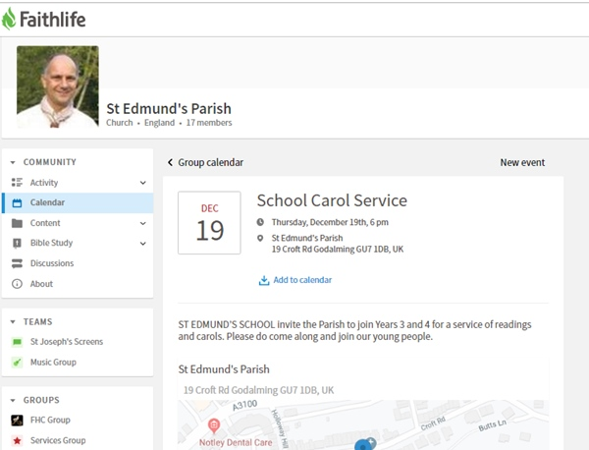

To exit this screen or the previous Faithlife calendar screen, close your browser.
EVENTS IN THE PARISH AND AROUND AND ABOUT

I would like to see what is happening in the parish

To do this, select Our Parish -> Latest News. This will result in the following appearing:

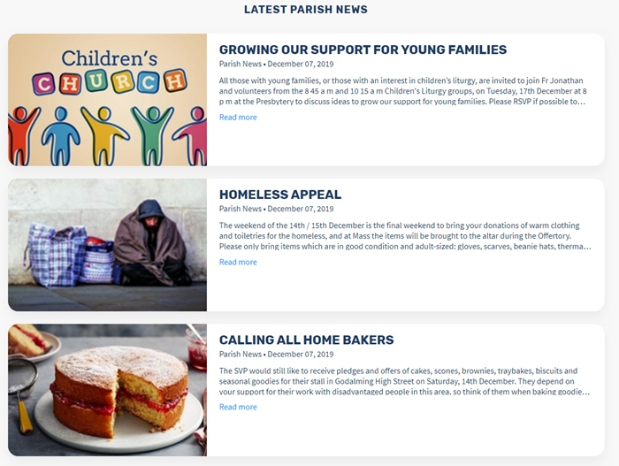

To find out more about the news event, click on Read More.

I would like to see what is happening outside the parish

To do this, select Around And About -> What’s On. This will result in the following appearing:

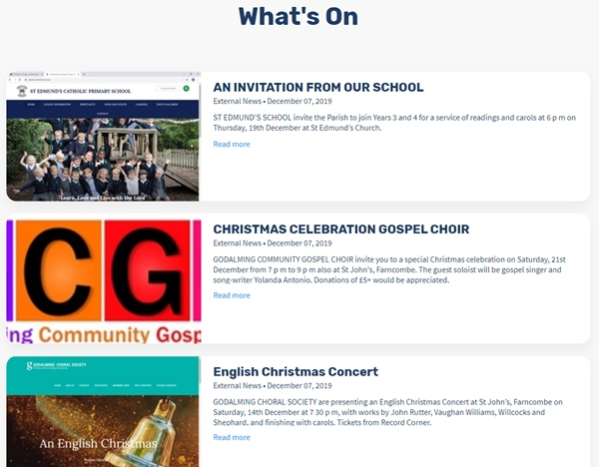

PRAYER REQUESTS AND PRAYING FOR PEOPLE

I would like to make a prayer request

To do this, select Prayer -> Praying Together. This will result in the following appearing at the top of the screen:
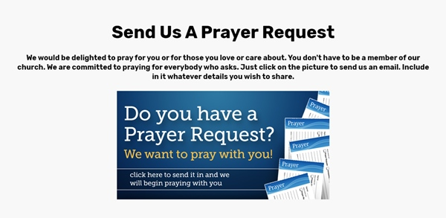

If you click on the picture, you should be taken to a partially completed email. Please complete the email and send it to the Parish Assistant. If you have indicated that you would like it, we will include your request on our prayer wall.

I would like to pray for somebody who needs prayer

To do this, select Prayer -> Praying Together. Scroll down the screen until you come to the prayer wall. The wall contains prayer requests such as:
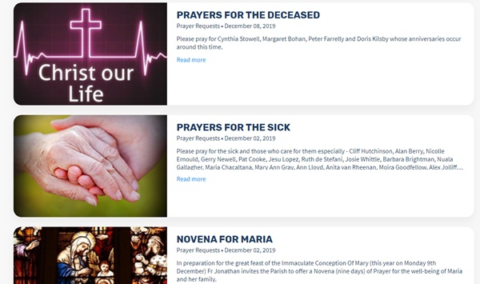

Please choose one or more of the requests and pray for the intention expressed.

NEW TO THE PARISH

I am new to the parish and would like to get in touch

To do this, select Our Parish -> Welcome To Newcomers. The following screen will appear:

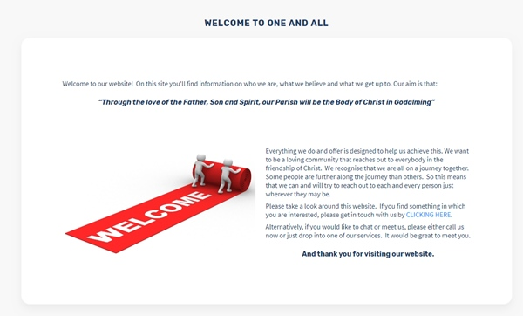

If you would like to get in touch, please click on the blue text marked “CLICKING HERE”. If you do this the following form will appear:

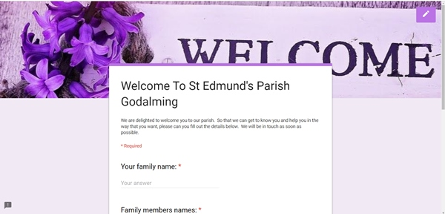

Please complete the form and press SUBMIT. We will be in touch as soon as possible.

YOUNG PEOPLE / CHILDREN’S LITURGY

I would like to know how you help young people

There is a page devoted to how we try to serve young people. It can be accessed via Young People -> Youth Fun, Chat and Music. The screen looks as follows:

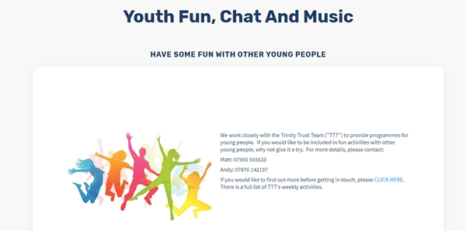

Clicking on the link marked CLICK HERE will take you to the Trinity Trust Team website where you will find out about youth groups etc. The page also includes some comments on music, a Youth Chat Group and some videos. We encourage young people to contact us to let us know what we can do to serve them.

I am interested in finding out about Children’s Liturgy

For younger children, we run a child friendly service during the first half of the Mass. Details can be accessed via Young People -> Children’s Liturgy. The screen looks as follows:

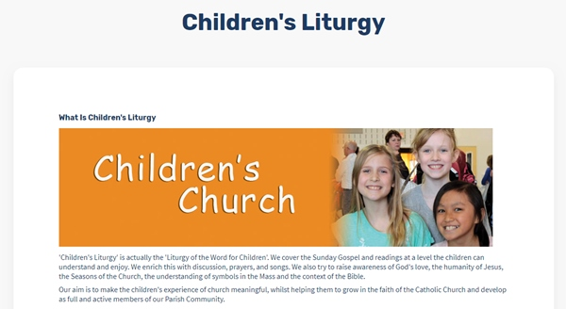

If you wish to find out which services are scheduled to have Children’s Liturgy, please click on the Children’s Liturgy Dates calendar. You will be taken to a Faithlife screen with the dates.

MUSIC

I would like to know more about the music that the parish provides

There is a page devoted to music. It can be accessed via Our Parish -> Music Ministry. The screen looks as follows:

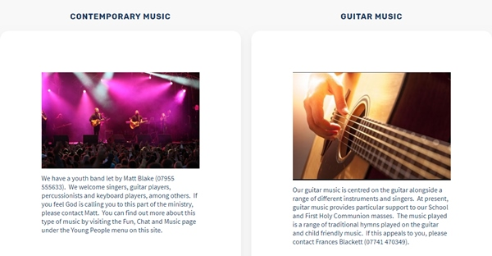

Here you will find out about the different types of music at our services. If you are interested in joining in (either as a musician or singer), please contact the relevant person.

I would like to know what music is planned for a given service

At the bottom of the music page, you will find a Music Calendar. If you click on the Music Schedule button, the following Faithlife screen appears:

Please note that the schedule is based on the availability of suitable musicians and singers. If there is no scheduled music, the parish priest may choose to lead the congregation in song.

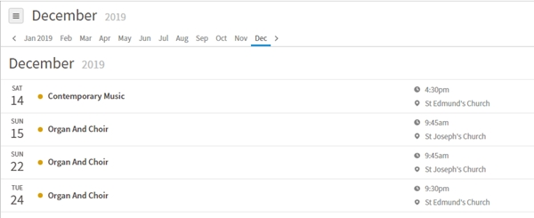

SACRAMENTS

I would like information about Sacraments for young people

Please click on the Young People menu item and you will find pages covering Baptism, First Holy Communion (“FHC”) and Confirmation. In relation to the two later Sacraments, the pages hold additional information about dates and have Chat Groups. The FHC programme also includes useful forms for parents. These are shown below:

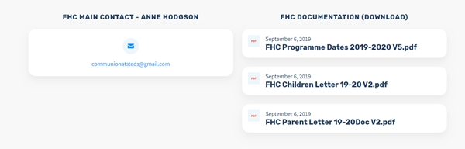

To view or download a document, just click on it.

I would like information about Sacraments for adults

Please click on the Adults and Families menu item and select Sacraments For Adults. The page displayed looks as follows:

The page contains details about the Sacrament of marriage and the RCIA program (for adults thinking of joining the Catholic Church). Information and contact details are on the page.
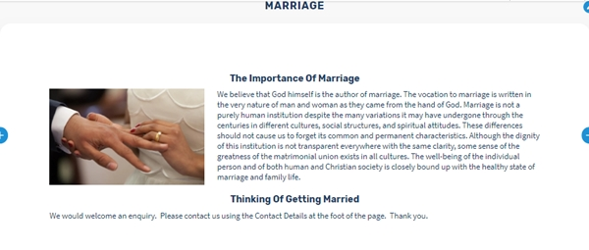

GROWING TOGETHER SPIRITUALLY

I would like details of courses you are running to help adults grow spiritually

Details of recent and current courses may be found by selecting Adults and Families -> Growing Spiritually. To find out about a particular course, please call the contact.

I would like to join a course or group for community and spiritual nourishment

If there is a course open for registration, the details will be on the Home Page. By clicking on the words CLICK HERE, you will be taken to a registration form. The precise format of the registration form varies from course to course. Here is an example:

If no course is open for registration, we would still be delighted to hear from you. Please contact the Parish Assistant.
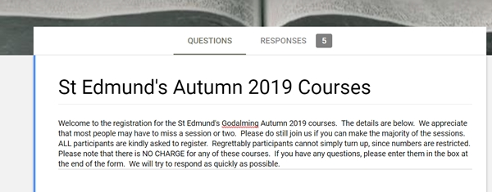

NEWSLETTER AND CONTACTS

I would like a copy of the latest parish newsletter

Scroll down the Home page and there is an area which holds the latest parish newsletters. Click on the relevant newsletter to download it. The screen looks like:

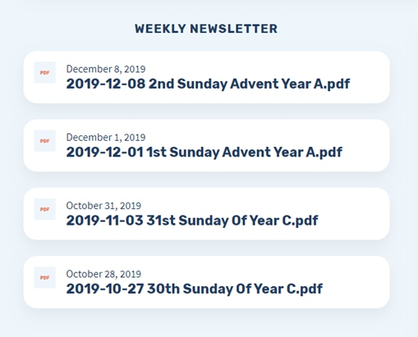

I would like to contact somebody in the parish

Contact information can be found by selecting Our Parish -> Contacts and Documents. A screen such as the following will appear:
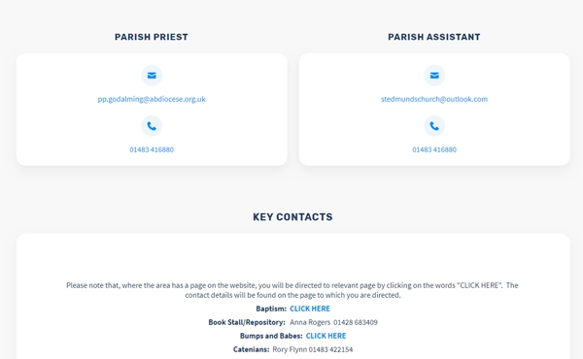

In some instances the contacts details will be shown on this page. In others, please follow the link CLICK HERE and this will take you to the page which contacts this information.

