Good afternoon FBJC family,

As followers of the Lord Jesus Christ, we are blessed to have access to God’s Word and access to the Lord himself through prayer. During this challenging time, one of the ways we can share prayer requests is to post them to [FBJC’s Faithlife Group](https://faithlife.com/fbjc-ny). Below you will find step-by-step instructions to guide you in posting prayer requests to the Prayers menu on the FBJC Faithlife Group page. You will also find step-by-step instructions to guide you in accessing the FBJC Group Reading plan on the FBJC Faithlife Group page. The current reading plan is a 14-day set of Bible readings focused on hope.

**Creating a Prayer Request in FBJC’s Faithlife Group**

1. Using the **Desktop site** of FBJC’s Faithlife page, navigate to the Prayer menu on the right side of the Faithlife FBJC Group page. You should see this menu:

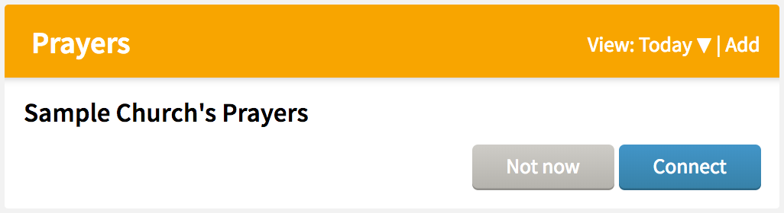

1. Click the blue “**connect**” button.
2. After you click the connect button, you will see this menu on your screen:

**View: Today ▼ |**[**Add**](https://faithlife.com/account/prayers/create?groupId=7940604)

**Prayers**

[**Pastor Jim and FBJC Leadership**](https://faithlife.com/prayers/4c976a28e6f8416d9d9c528a3fa97740/42ea8fb94c794e11813d925b710aabd7)

Pastor Chris Terry · FBJC's Prayers

[**The Governor and State Leadership**](https://faithlife.com/prayers/4c976a28e6f8416d9d9c528a3fa97740/10b96e00f9374155bbe694503a13eec3)

Pastor Chris Terry · FBJC's Prayers

[**The President and Federal Leadership**](https://faithlife.com/prayers/4c976a28e6f8416d9d9c528a3fa97740/43c6baf2034f421992880a118e659fc3)

Pastor Chris Terry · FBJC's Prayers

1. When you would like to add a prayer request or even a praise to the prayer list, click “add” (**highlighted in the picture above in pink**) and then you will see this menu:

**New Prayer Request**

**Top of Form**

**Choose a Prayer List**



**Title (?)**



**Details (?)**



** Schedule Pray for this item daily**

**Cancel Save**

1. Click “Choose a Prayer List” (highlighted in the picture above in **green**) and you will select “FBJC’s Prayers.”
2. Then you will add a Title for your prayer request (highlighted in the picture above in **light** **blue**).
3. Then you will add the Details of your prayer request (highlighted in the picture above in **medium** **blue**).
4. Click inside the box entitled “Schedule” to make sure this prayer request will continue to be listed in the prayer menu for others to see (highlighted in the picture above in **red**).
5. Finally, click Save. The prayer request will then be added to the list of requests (highlighted in the picture above in **yellow**).
6. **Please note:** the person who created the request is the only one who can mark it as answered.
7. **Please note:** this is a prayer list that will go out to every member and regular attendee at FBJC that is connected to FBJC’s Faithlife Group.

**Following the Bible Reading Plan**

Below the *Prayers* menu you will find a menu entitled *Group Readings.* In this menu you will be able to access a Bible reading plan. The current reading plan is a 14-day set of readings on *hope*.

1. Using the Desktop site of FBJC’s Faithlife Group page, navigate to the ***Group Readings*** menu. Click connect. [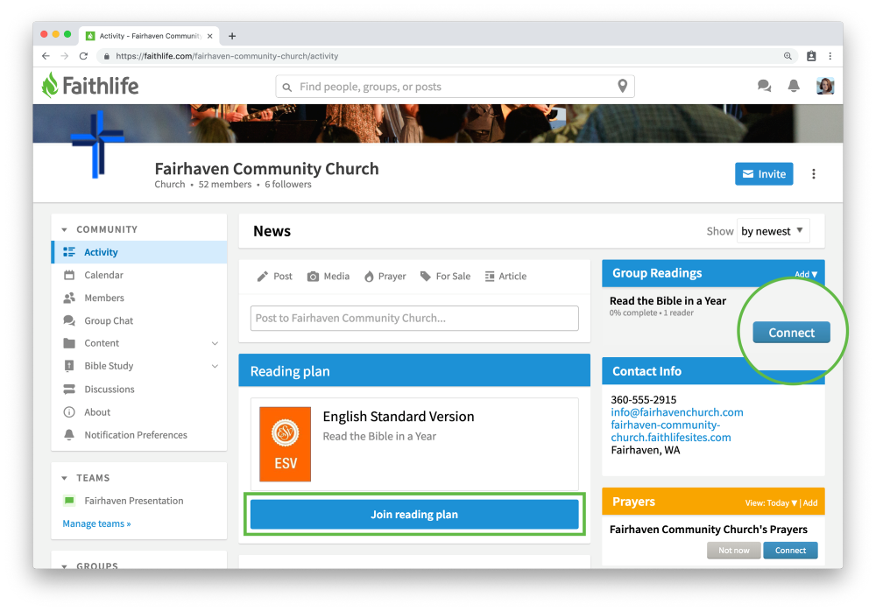](https://support.faithlife.com/hc/en-us/articles/360012919151-Read-the-Bible-with-Your-Church)
2. Once you do so you should see the following menu:

**Group Readings**

[**Psalm 16:1–11**](https://faithlife.com/account/readingplans/d6a55bd651f043eb921d1a991e33956d/startReading?sessionDate=2020-03-25&item=0)

**14 Days on Hope**

**Today Quit**

1. Click on the Bible passage text link (highlighted in green). This will take you to a Faithlife site that gives you access to the full electronic Bible passage.
2. This is what your page should look like. You can change the Bible translation (inside the red circle). You can keep your own personal notes under the tab that looks like a text message box (inside the green circle).



For those of you who didn’t hear the announcement at the beginning of the 3.22.20 Worship Service live stream, here is a recap:

We continue to be a giving church. Some of you are out of work or may be out of work soon. Deacon Don Powers and our Benevolence Committee remain active in assessing and responding to needs presented to them.

People have inquired about how to give during this time. Some are sending their tithes and offerings through the mail delivered by the Postal Service. We still receive and process mail. An increasing number of you are giving online. This is the preferred way to give. It is simple, easy, and safe. To give this way, go to our website [fbjc.org](http://fbjc.org). Click on the “Donate Now” tab and follow the prompts for online giving. Another way to do this is to download the *Easy Tithe* app to your cellphone. If you have any questions about online giving, contact Deacon John Allen. His email address is on the contact page of our website. He will guide you through the process.

We desire to serve you during this time. Please take advantage of these means of assistance and also of ministering to one another. If you have any questions or need assistance with Faithlife, please email Pastor Chris at [pastorchris@fbjc.org](mailto:pastorchris@fbjc.org).

Pastor Chris Terry

*Associate Pastor*

First Baptist Church of Johnson City