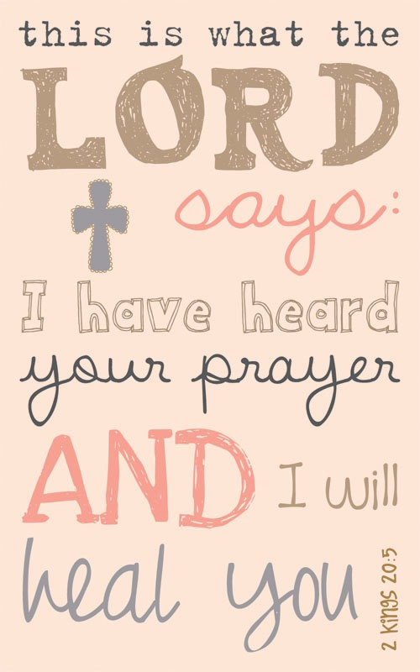
Prayer Request

Let’s pray for each other…
Barb Starkey
Ed Stewart
Peggy Johnson
Unsaved

Let’s pray for our Family & Friends…
Bella Snyder (Tarina Morris’s Great Niece)
Tom Duncan – Cancer
Teresa Gilbert (Marie Howell’s Daughter) – Cancer/Chemo
Joe Hurley (LaVerne Yocum’s brother) – pacemaker
Richards Hicks (Bill & Barb Starkey’s Son in law) – Cancer Treatments
Michael Miedle (Diann Wades Cousin) – Cancer
Butch Torman (Tabatha Day’s Father) – heart transplant
Deaner Isaacs (Requested by Tabatha Day)
Trish Dietzen (Friend of Karen Allen) – Cancer
Aaron Cisar – Chemo Treatments
Randy Randolph (Friend to Natalie Allen)
Drew Cecil (Friend of RJ Utt) – Cancer Treatments in Morgantown/doing better
Amelia “Millie”Mount (Decinda Davis’s 3 year old Niece) – Cancer/Chemo
Matthew Tarone (Ernie & Karen’s Great Nephew) –
Eye issues
John Howell (Carolyn Howell’s Son)
Jason Moser (Dennis Ritchie’s Son in Law) – Cancer treatments
Jayden Poyser – (Young boy from New Martinsville School) – Fighting Cancer
Carolyn Jackson (Debbie Bertrand’s Aunt) – Lung Cancer, treatment not working
Grace Allen (Ernie Allen’s Mother)
Roger Midcap – Leukemia

Let’s pray for those who are unable to worship among us…
(We need to visit these individuals and send them cards to let them know we are thinking of them.)
Ellen Howell
Ruth McIntire
Donna Bartlett (in nursing home)
Michael Rush - Diabetes
Doretta Rush - Shoulder Issues

Let’s pray for those who are serving in the military…
Rae VanCamp
Alex VanCamp
Allen Blackwell

Praise Report
Let’s Thank God for our answered prayers…
Pam Locke – Cancer Free
Jed Wright – Remission
Penny Day (Tabatha Day’s Mom) – Cancer Free
Katie Foley – 18 Months Sobriety
Jesse Glow – 9 Months Sobriety

