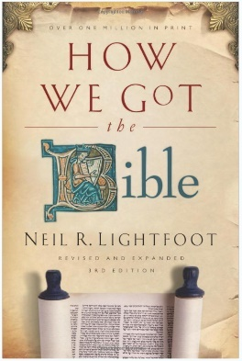
How We Got the Bible
By Neil R. Lightfoot

About the Author:
Dr. Lightfoot is known for his books and scholarly articles. His books include: How We Got the Bible (3rd edition, revised and expanded), Lessons From the Parables, Jesus Christ Today: A Commentary on the Book of Hebrews, The Role of Women: New Testament Perspectives, and Everyone's Guide to the Book of Hebrews. His videos and filmstrips include How We Got the Bible, Now That I Am a Christian, and Can We Believe the Bible? In addition, he has served as Greek-text editor and a translator of the The International Children's Version (NT), The Word: The New Century Version (NT), and the The Everyday Bible.
Dr. Lightfoot held the B.A. and M.A. Degrees in Philosophy from Baylor University, and the Ph.D. degree in New Testament from Duke University. In 1978, he received the "Trustee's Award, Outstanding Teacher of the Year," Abilene Christian University. In 1986, He was Senior Associate of Westminster College, Cambridge University, Cambridge, England and also served as Distinguished Scholar in Residence.
His life-long mission was to teach the Word and prepare others to share the Gospel.

“It is reassuring at the end to find that the general result of all these discoveries and all this study is to strengthen the proof of the authenticity of the Scriptures, and our conviction that we have in our hands, in substantial integrity, the veritable Word of God.”
– Sir Frederic Kenyon

1 Peter 3:15 But in your hearts revere Christ as Lord. Always be prepared to give an answer to everyone who asks you to give the reason for the hope that you have. But do this with gentleness and respect, 16 keeping a clear conscience, so that those who speak maliciously against your good behavior in Christ may be ashamed of their slander.
The Greek word translated as "make a defense," or "give an answer" is apologian, from the root word apologia. This is not related to the English word "apology," where one expresses regret or remorse. Rather, the term means a justification, or an "answer back," or a reason. This is the source of the terms "apologetics" and "apologist," which refer to a rational defense of the Christian faith.

Chapter 1: The Making of Ancient Books

__________ and ____________ did the books of the Bible have their origins?
How have these books been _______________ and _______________ to us?
The starting point of our Bible is preceded and determined by another story-the history of ancient ________________ and ________________.
Early Writing
The ______________ is a very old book, but it is by now means the oldest book in the world.
What we do know is that, as attested by an abundance of clay tablets, writing was widespread in Mesopotamia at least by ______________ B.C.
We know also that _____________ text reach farther back and have survived in hieroglyphs on _______________, _______________, and _______________.
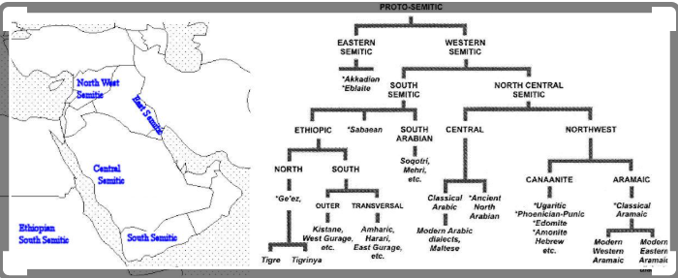
The next logical step would have been an ______________ script, but the Egyptians never took this step.

Ancient Mesopotamia 101

The first alphabet came from somewhere between Egypt and Mesopotamia in about 1750 B.C.
Critics formally held that writing was unknown in the days of __________ and therefore that _____________ could not have been the author of the first five books of the Bible.
We now know that writing was practiced many centuries before Moses and that an alphabetic script was in use in the vicinity of Sinai.
All this means it can no longer be assumed that it was ______________ for Moses to have written the books ascribed to him.
Writing Materials
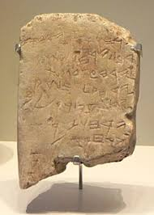
- Stone – Gezer Calendar

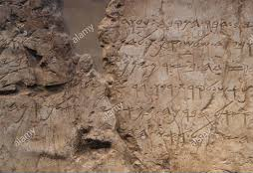
Siloam Inscription 700 B.C. Tells the story of King Hezekiah when he had a tunnel built to convey water into Jerusalem. This can be found in 2 Kings 20:20 and 2 Chron. 32:30

Moabite Stone – was erected by King Mesha of Moab to commemorate his revolt against Israel found in 2 Kings 3:4-27.
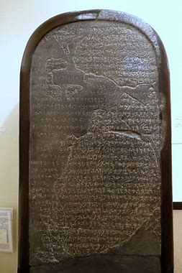
- Clay Tablets
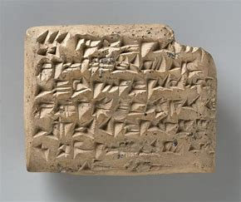
Jeremiah 32:14 ‘This is what the Lord Almighty, the God of Israel, says: Take these documents, both the sealed and unsealed copies of the deed of purchase, and put them in a clay jar so they will last a long time.
The chronicles of a number of kings mentioned in the Old Testament have been preserved on clay tablets. Ezra 4:10
- Wood and Wax
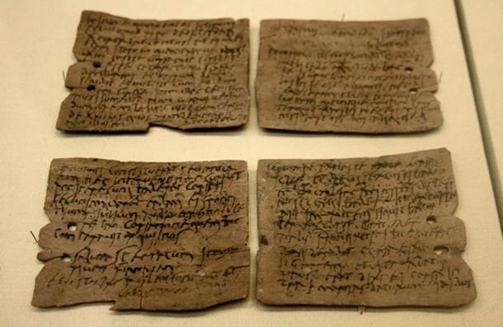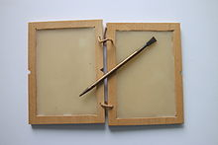
Isaiah 30:8 Go now, write it on a tablet for them, inscribe it on a scroll, that for the days to come it may be an everlasting witness.
Habakkuk 2:2 Then the Lord replied: “Write down the revelation and make it plain on tablets so that a herald may run with it.”
- Metal – Gold, Silver, Copper, and Bronze

Exodus 28:36 “Make a plate of pure gold and engrave on it as on a seal: holy to the Lord.
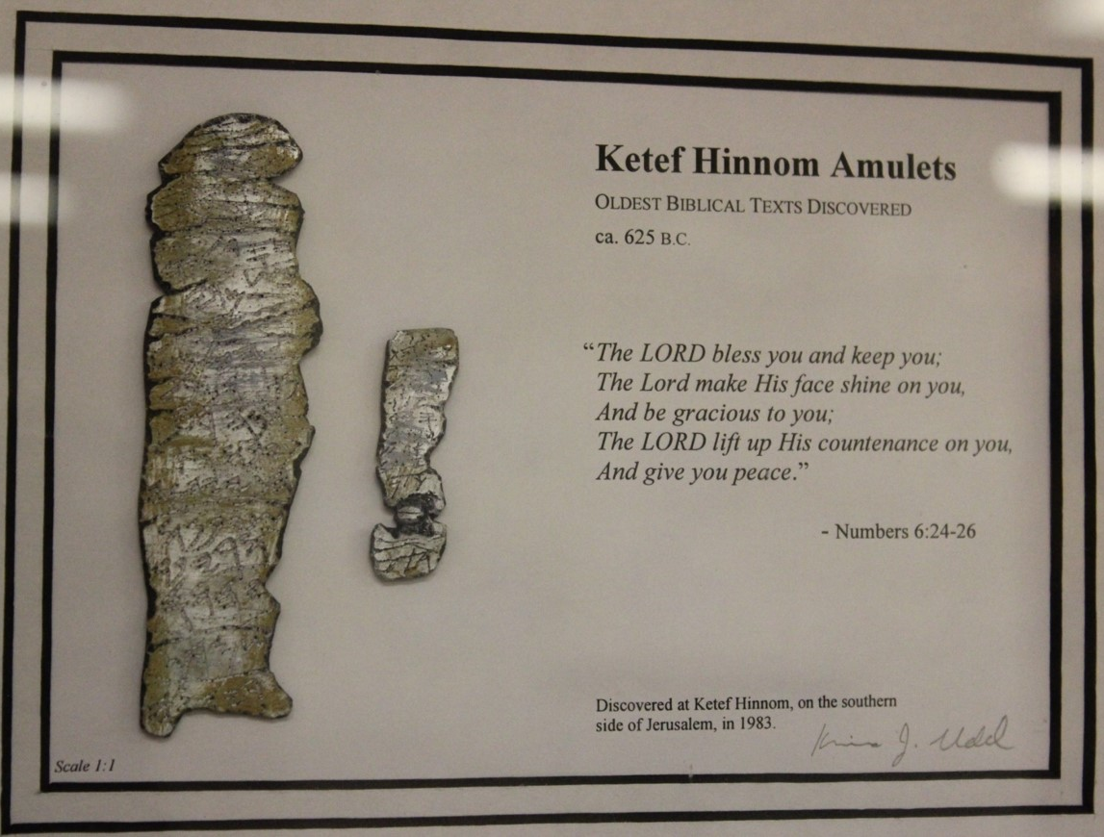
Numbers 6:24-26
- Ostraca – a piece of potter used as a writing surface.
Discovered in 1935 AD from an official archeological dig these ostraca were the written records of communications between the city of Lachish and the king in Jerusalem at the time Nebuchadnezzar attacked Jerusalem 605-587 BC.
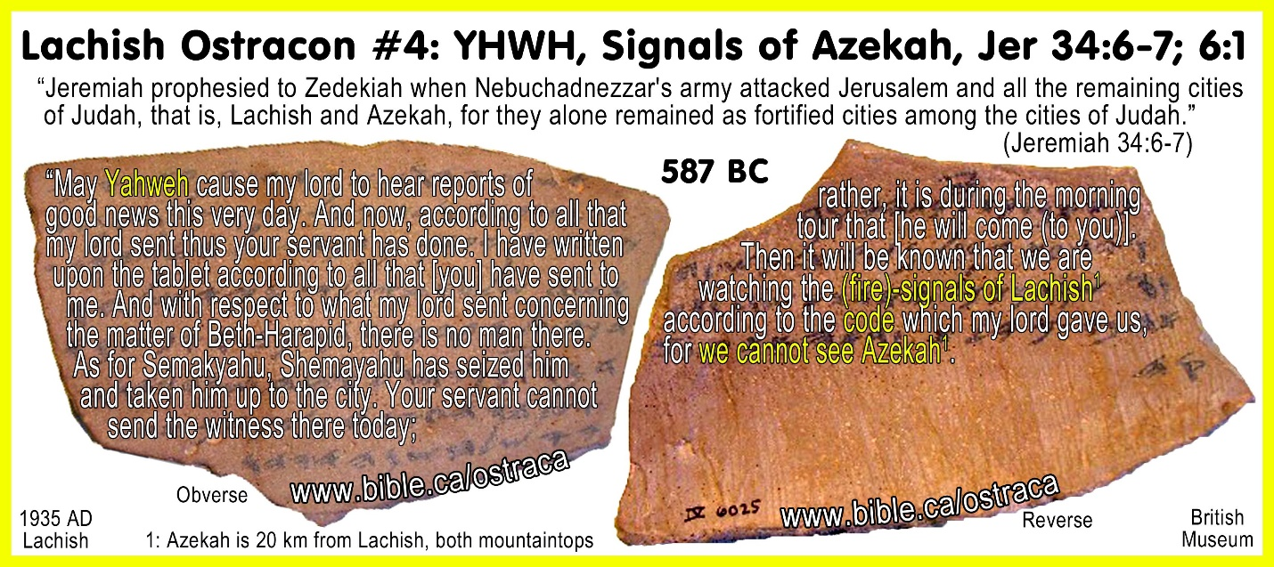

- Papyrus – Paper
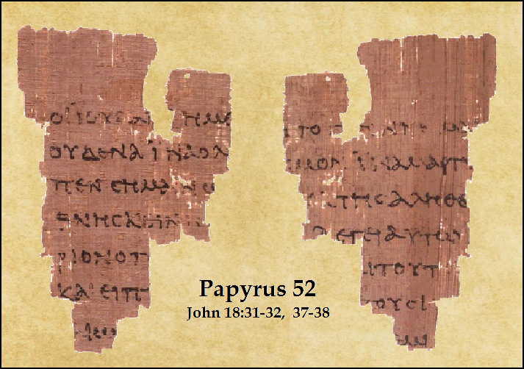
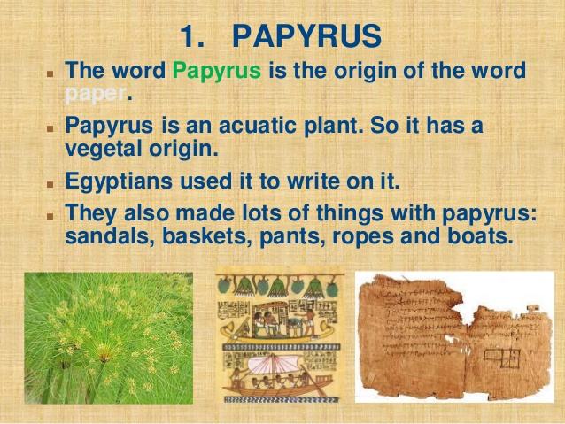

- Leather and Parchment – Made of animal skin.
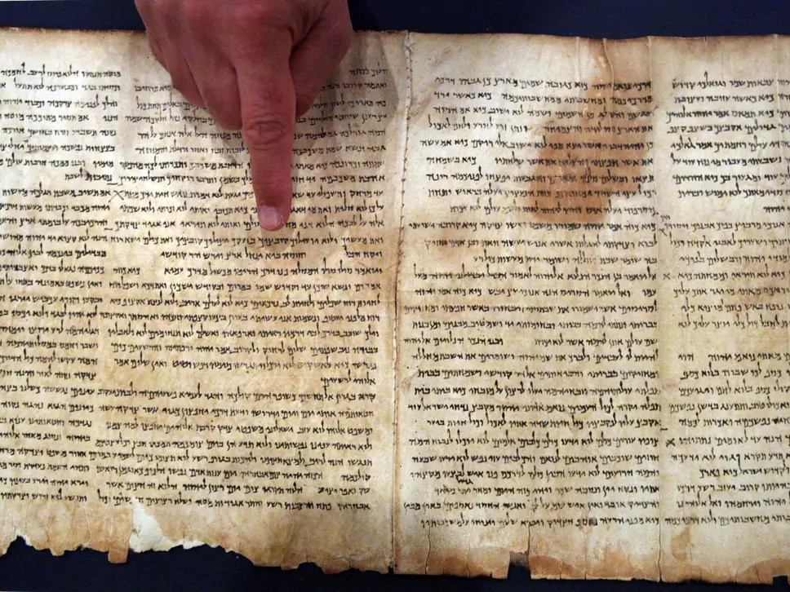
The most important writing material during the Old Testament times was leather. When the New Testament was written, papyrus was used.

- Why is it important to know the origins of the Bible?

- How does history of writing impact the authorship of the first 5 books of the Bible?

- What is another name for the first 5 books of the Bible?

- What are some of the main materials used in ancient times of writing?

- What is the relevance of this information to my walk with Christ?

