How We Got the Bible
By Neil R. Lightfoot

The Birth of the Bible

Introduction
The Bible is a collection of books, which is indicated whenever we use the term Bible. The term, as we have seen, is derived from biblia, literally “the books.” It is a treasure-house of sacred books which has grown through the centuries until it has attained is present stature.

The Codex
Codex - an ancient manuscript text in book form.
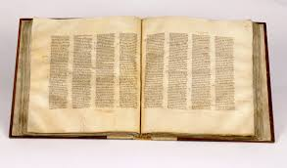
Whenever the use of papyrus and leather prevailed, for many centuries the form of the book was the roll or scroll. In the case of the papyrus, the roll was made by gluing the sheets end to end. Some of the most impressive scrolls ever discovered in archaeology were known as the Dead Sea scrolls, which were uncovered at the site of Qumran near the Dead Sea in Israel. The scroll of Isaiah was 24 feet long and contains 17 sheets of sheepskin which was joined together by threads of linen.
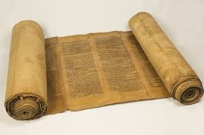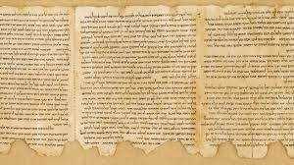
Rev. 5:1 Then I saw in the right hand of him who sat on the throne a scroll with writing on both sides and sealed with seven seals.

The Early Form of the Bible
According to the Bible, the first form of communication by God was His spoken word, oral. The first person mentioned in the Bible as writing anything is Moses.

Exodus 17:14 Then the Lord said to Moses, “Write this on a scroll as something to be remembered and make sure that Joshua hears it, because I will completely blot out the name of Amalek from under heaven.”

Exodus 34:27-28 27 Then the Lord said to Moses, “Write down these words, for in accordance with these words I have made a covenant with you and with Israel.” 28 Moses was there with the Lord forty days and forty nights without eating bread or drinking water. And he wrote on the tablets the words of the covenant—the Ten Commandments.

Other events were recorded by the successor of Moses, Joshua, “in the Book of the Law of God.” This became the practice of other men of God who wrote both history and prophecy.

Josh 24:26 And Joshua recorded these things in the Book of the Law of God. Then he took a large stone and set it up there under the oak near the holy place of the Lord.

For the new covenant church, the events of the life of Jesus were oral accounts, but as years passed eyewitness accounts became few and insufficient. Demand for authoritative written narratives were in demand so Matthew, Mark, Luke, and John sent out their witness to Jesus.

John 20:30-31 31 Jesus performed many other signs in the presence of his disciples, which are not recorded in this book. 31 But these are written that you may believe that Jesus is the Messiah, the Son of God, and that by believing you may have life in his name.

The Form of Our Bible Today
Our Bible today is divided in two major sections known as the Old Testament and the New Testament. The term “testament” is an unfortunate translation (Greek, diatheke) and would be better rendered as “covenant.”

Old Covenant

English Bible
5 books of the Law (Gen. to Duet.)
12 books of History (Joshua to Esther)
5 books of Poetry (Job to Song of Sol.)
17 books of Prophets (Isaiah to Mal.)
39 Books Total for OT

Hebrew Bible
5 books of the law (Gen. to Duet.)
6 books of Former Prophets
15 books of Latter Prophets
13 books of Writings
39 Books Total for OT

The New Covenant
5 books of History (Matthew to Acts)
21 books of Doctrine (Romans to Jude)
1 book of Prophecy (Revelation)
27 Books Total for NT

*The New Testament was written in a comparatively short period of time(A.D. 50 – 100).

The Languages of the Bible
The Bible was written in 3 languages: Hebrew, Aramaic, Greek
Almost all the OT was written in Hebrew. Aramaic was also used in the OT. (Nehemiah 8:8)
The amazing Dead Sea Scrolls have produced a little fragment of this in Daniel 2, in which verse 4 of the chapter the Hebrew writing stops, and the Aramaic begins exactly as our text reads two thousand years later.

In Praise of Ancient Scribes
In Mesopotamia and in Egypt, the trained scribe was highly prized. In Palestine, professional scribes were responsible for writing and copying most Hebrew documents. In making multiple copies, scribes wrote in a writing room or “scriptorium,” listening to the reader as he read aloud from his text.

Discussion Questions
- What is a codex? How does it compare with the book in roll form?
- Who is mentioned in the Bible as being the first author of anything?
- About what time were the books of the New Testament written? How does this compare to the Old Testament?
- Are the books the same in the Hebrew Bible and English Bible?
- What are the 3 main divisions of the New Testament?
- Name the 3 original languages in which the Bible was written.
- In what language was the New Testament written in?
- What language did Jesus speak?
- What role did the scribes play to create the Bible?

