How We Got the Bible
By Neil R. Lightfoot

Manuscripts of the New Testament

Introduction
The New Testament books were undoubtedly written on papyrus sheets which, with constant use, might not have lasted a decade. So not long after the New Testament was written, the original autographs perished. Early Christians were prompted to make copies of these precious apostolic messages. These copies of the New Testament in Greek are known simply as “manuscripts.” (The word “manuscript” denotes anything written by hand, but by general consent in connection with the Bible the term is restricted to the documents of the original tongues. Thus, a New Testament manuscript is a Greek manuscript.)

2 Major Types of Manuscripts
When the New Testament was first written, both uncial and cursive styles of handwriting were in use. The various letters of the New Testament were probably dictated (Rom. 16:22;1Peter 5:12; Gal 6:11)

Uncials – the earliest and most important manuscripts written in capital letters. A New Testament uncial is a section of the New Testament in Greek or Latin majuscule letters, written on parchment or vellum. This style of writing is called Biblical Uncial or Biblical Majuscule.

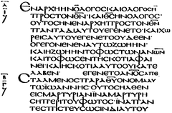

Cursives or Minuscules – hand written book in small letters that often were written cursively.

Romans 16:22 I, Tertius, who wrote down this letter, greet you in the Lord.

1 Peter 5:12 With the help of Silas, whom I regard as a faithful brother, I have written to you briefly, encouraging you and testifying that this is the true grace of God. Stand fast in it.

Gal. 6:11 See what large letters I use as I write to you with my own hand!

The Importance of Uncials
The oldest vellum manuscripts are complete or almost complete copies of the New Testament and have practically all the Old Testament. These old copies are 3 in number and are known as the Vatican, the Sinaitic, and the Alexandrian Manuscripts. These manuscripts date back to A.D. 300-450.

The Vatican Manuscript (B) – This fourth-century manuscript is acknowledged widely as being the most important witness on the text of the New Testament and has resided in the Vatican Library in Rome since 1481. The Vatican Manuscript is a rare gem in that it contains in Greek almost all the Old and New Testaments.
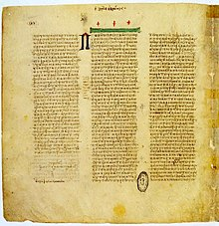

The Sinaitic Manuscript (Aleph) – Just as important as the Vatican Manuscript, it was discovered by the great textual critic Constantin Tishendorf at St. Catherine’s Monastery on Mount Sinai.
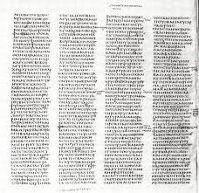

The Alexandrian Manuscript (A) – It is known as the Alexandrian Manuscript because it has been in Alexandria for several centuries. This is the only Greek manuscript that includes 1 Clement and portions of 2 Clement at the end of the New Testament.
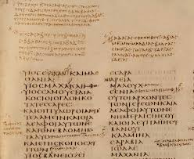

- What is a manuscript?
- Distinguish between uncials and minuscules.
- What are the names of the 3 great vellum uncials?
- How does the Vatican Manuscript rank in importance?
- What books does the Alexandrian Manuscript have that the others do not?

