How We Got the Bible
By Neil R. Lightfoot

The Sinaitic Manuscript

Introduction
In Exodus 19:20 “The Lord descended to the top of Mount Sinai and called Moses to the top of the mountain. So Moses went up.” This is where the Bible tells us that God spoke the Ten Commandments.
Jebel Musa, the “mountain of Moses” has been identified as the site where Moses received the Law.
Monastery of St. Catherine was built on Mount Sinai in about A.D. 550 as a fortress-a part of Emperor Justinian extensive defense system. But it was also built for the safety of monks in the area who were being raided by Saracen.

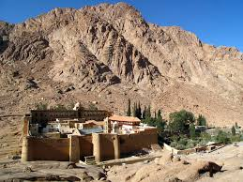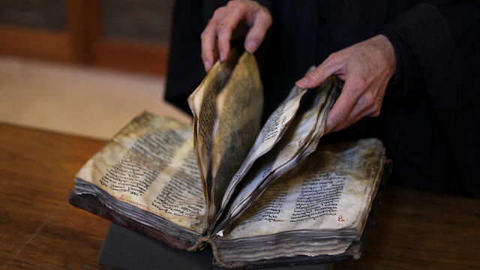

The Sinaitic Manuscript (Aleph) – Just as important as the Vatican Manuscript, it was discovered by the great textual critic Constantin Tischendorf at St. Catherine’s Monastery on Mount Sinai.

Constantin von Tischendorf
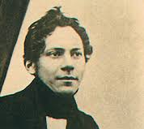
As a young man at the age of 29, Tischendorf arrived at Sinai in 1844. He was not there as a religious pilgrim but as a New Testament scholar in search of the manuscripts of St. Catherine’s. He had resolved to devote himself to the study of the New Testament text and in his words “to reconstruct, if possible, the exact text, as it came from the pen of the sacred writers.” In 1841 Tischendorf had published his first critical edition of the Greek New Testament. In Paris, Tischendorf was successful where all previous scholars had failed: he deciphered and published the celebrated Ephraem Manuscript. In 1834-1835 potassium ferricyanide was used to bring out faded or eradicated ink, and Constantin von Tischendorf made his reputation when he deciphered the exceedingly difficult to read texts.

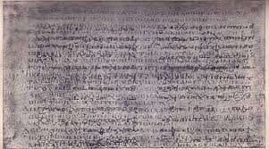

In 1845 Tischendorf returned to his home in Leipzig and in the next year published the forty—three sheets he had obtained from the Monastery. They were parts of the Greek Old Testament, the Septuagint.

Septuagint - a Greek version of the Hebrew Bible (or Old Testament), including the Apocrypha, made for Greek-speaking Jews in Egypt in the 3rd and 2nd centuries BC and adopted by the early Christian Churches.

On his last trip, at the age of 45, to the Monastery in 1859, Tischendorf found the remaining part of the Old Testament and the New Testament complete manuscript along with the Epistle of Barnabas and part of the Shepherd of Hermas. Tischendorf had set out to reconstruct the text of the New Testament, using the very best manuscripts at his disposal. With the help of two assistants who knew Greek, 110,000 lines were meticulously copied and checked letter for letter. Tischendorf and his helpers completed the enormous project in two months. He later, with the Czar’s approval, decided to make an exact reproduction of the manuscript by printing. In the Spring of 1862, 300 copies were printed and presented to the Czar who in turn sent many as gifts to scholars and libraries.

Tischendorf’s goal was to “clear up…the history of the sacred text” and to recover that text “which is the foundation of our faith.”

The Manuscript Today
On prominent display in the British Library (formerly part of the British Museum) is the Sinaitic Manuscript. Of what must have originally comprised about 730 leaves, 393 remain, 245 of the Old Testament and 148 of the New Testament. The Sinaitic Manuscript is the oldest complete manuscript of the New Testament that exist today.

Recent Developments
Two recent developments have taken place concerning the Sinaitic Manuscript.
- In 1862, a Greek named Constantine Simonides claimed he had written it in the year of 1840, but years before, in 1856, Tischendorf had unmasked Simonides as a forger.
- On 26 May 1975 a hoard of manuscripts and art treasures was uncovered at St. Catherine’s after a fire had gutted a certain area of the monastery. Removal of the dirt revealed more than a dozen leaves missing from Sinaitic Manuscripts that had been buried 200 years earlier due to a ceiling that had collapsed. In addition, something like four thousand other manuscripts, including fragments, have been recovered. Not all of them are Biblical, but most of them were written in Greek and other languages.

Discussion Questions
Who was the scholar that discovered the Sinaitic Manuscript?
How was he Sinaitic Manuscript discovered?
Where is the Sinaitic Manuscript today?
How many copies were made as a gift?
What are the 2 recent developments that have taken place.

