How We Got the Bible
By Neil R. Lightfoot

Other New Testament Manuscripts

Introduction
Nothing is more thrilling than for one to look with one’s own eyes and to ahold with one’s own hands some manuscript of the New Testament. The many New Testament manuscripts are scattered all over the world. They are in great national libraries and museums, in the prominent universities, in the many libraries of monasteries and cathedrals, an in the special acquisitions of private collectors.

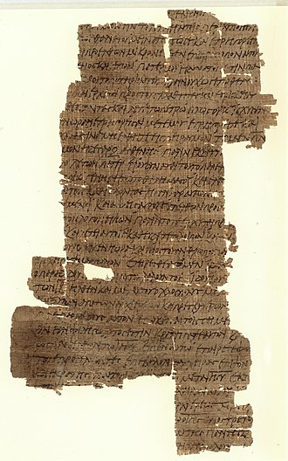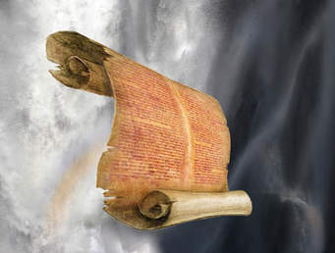

We have learned that the 3 most important manuscripts are those of the uncial group.
- Vatican
- Sinaitic
- Alexandria
This is not to leave the impression that all other manuscripts and witnesses are of little value. Indeed, without the many other textual authorities we could not evaluate properly these three great uncials.

Two Fifth-Century Uncials
The Codex of Ephraem (C) - In the Middle Ages, it was often difficult to find writing materials, they would wash or scrape-off the ink of used parchment, and then use the scraped-off parchment as if it were new. This kind of manuscript is known technically as a palimpsest, a Greek term that has passed into English and literally means “scraped again.”

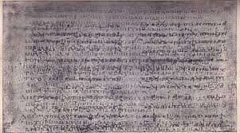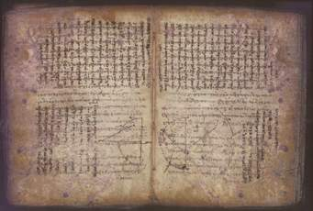

The Codex of Ephraem is and outstanding palimpsest manuscript with an interesting historical background. As originally written, the Codex of Ephraem was a manuscript of both Old and New Testaments, but for some reason many of its leaves were torn off and lost.

In 1840 Tischendorf, at the age of 25, he began the task of deciphering the codex. There were any skeptics, but in 1843 he published the Old Testament portion and in 1845 he published the New Testament portion. The codex is not complete and many of the leaves are missing from both the Old and New Testament.

The Codex Bezae (D) – The codex was in the hands of Protestant reformer, Theodore Bezae, for more than 20 years, but he presented it to Cambridge University Library in 1581. Codex Bezae is in many ways a different kind of manuscript. It is the earliest example of a bilingual manuscript; that is, it is written in two languages, with Greek text on the left side of the page and Latin text on the right.
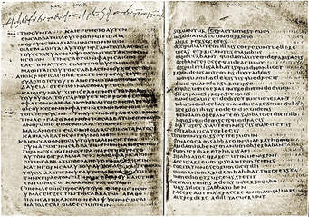

It has been looked upon with suspicion because omission and additions at times puts it in a class by itself. Again, and again it departs from established text. Codex Bezae and a few other textual witnesses are the chief representatives of a type of text that is commonly called “Western.” Altogether about 280 uncials are now listed.

Other Uncials
New Testament manuscripts, depending on their similarities, are generally divided into three groups or types of text: Alexandrian, Western, and Byzantine.

The Codex Claromontanus – came from Clermont France and is a sixth-century manuscript containing the letters of Paul and Hebrews. It is similar to Codex Bezae and once belonged to Theodore Bezae. It is written in both Greek and Latin, and its text type is Western. It was edited by Tischendorf.

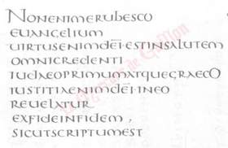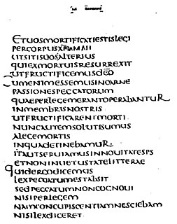

The Codex Laudianus (E) – Take the name after Archbiship Laud. It is dated at the end of the sixth century, written in Greek and Latin, it contains the Book of Acts (with omissions at the end). Its Greek text is mostly in agreement with the Byzantine form of text.
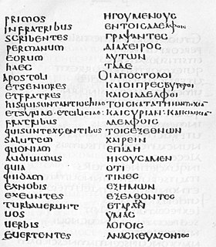

The Codex Regius (L) – Is an eighth-century codex of the Gospels and has an Alexandrian type of text, often agreeing with the Vatican Manuscript.

The Freer Washington Manuscripts – was obtained in 1906 by Mr. Charles L. Freer of Detroit and contained 6 Biblical Manuscripts that dated from the 3rd to 6th centuries. One manuscript (Codex I) contains a collection of Paul’s letters from 1 Corinthians through Hebrews, with Hebrews being placed after 2 Thessalonians.

Minuscule Manuscripts
At present there are 2,800 minuscule known manuscripts and they make up the majority of the manuscripts that exist today. They date back to the 9th century and form of text is Byzantine. Listed below are a few of the small-letter manuscripts that are important either from a textual or historical standpoint.
- Minuscules 1 & 2 – Gospel manuscripts of the 12th century
- Minuscule 13 – 12th or 13th century. One of a dozen manuscripts of the “Family 13” and is famous for the adulterous woman passage found in John 7:53 – 8:11.
- Minuscule 33 – 9th century. Contains the Gospels, Acts, and Epistles. Because of its good text, it has long been called “the Queen of the Cursives.”
- Minuscule 61 – 15th or 16th century. Was the first manuscript found in support of the Three Heavenly Witnesses passage in 1 John 5:7-8.
- Minuscule 565 – copy of the 19th century Gospels. It is written in gold and silver letters on purple vellum.
- Minuscule 1739 – 10th century manuscripts of Acts and the Epistles. It goes back to the fourth century, having a text similar to the Vatican Manuscript.

The Lectionaries
Among the New Testament manuscripts is a group of materials know as “lectionaries.” The term “lection” refers to a selected passage of Scripture designed to be read in public worship services, and thus a lectionary is a manuscript especially arranged in section for this purpose.

Summary
Altogether there are 5 outstanding uncials: the Vatican, the Sinaitic, the Alexandrian, the Ephraem palimpsest manuscript, and Codex Bezae. Of these, the Vatican and Sinaitic Manuscripts, with the help of the other witnesses, supply the textual foundation for the New Testament. New Testament manuscript text can be grouped in 3 types: the Alexandrian, Western, and Byzantine.

For Discussion
What is a palimpsest?
What is a lectionary?
What are the 3 groups in which the New Testament manuscripts can be divided?

