How We Got the Bible
By Neil R. Lightfoot

Ancient Versions: The Old Testament

Introduction
The most important materials in the establishing of a text are those that are found in the original language of the text. We are referring to the ancient versions or translations of the Old Testament. Other materials often can cast much light on the text. First, the versions tell us something of the kind of text in use prior to the time of the Massoretes, for some of them go as far back as several centuries B.C. Second, the versions, when used with discretion, can clarify or complement the Massoretic Text when it appears to be defective. Third, the versions very often are parallel with the Massoretic Text and give it increased credibility.
The most important ancient versions are Septuagint, the Aramaic Targums, the Syriac, and the Latin.

Samaritan Pentateuch
The Samaritan Pentateuch is not a translation but is a form of the Hebrew text itself. Its beginnings can be traced back to about 400 B.C. when the Samaritans separated themselves from the Jews and built their sanctuary on Mount Gerizim. The Samaritan Pentateuch presents a problem in that it bears some 6000 variants that have to do with spelling and grammatical differences and similar small details. Yet overall there are few major differences between the Hebrew and Samaritan Pentateuchs which means that toa a high degree the Samaritan Pentateuch confirms the traditional Hebrew text.
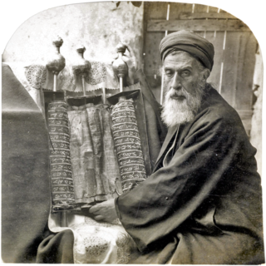

Aramaic Targum
After the period of the Jewish exile in Babylon, Aramaic became the spoken language of the Jews. In order for the people to understand the reading of the Scripture in public worship, it was necessary for it to be translated or paraphrased in Aramaic. The word that refers to a translation is targum.
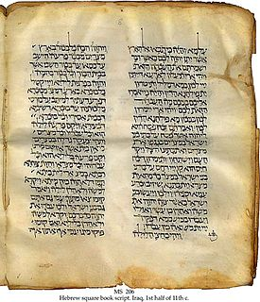

Syriac Peshitta
Although there were several Syriac versions of the New Testament, mainly one has survived in the Old Testament, the Peshitta, that is, the simple version. In its earliest form the Peshitta is in close agreement with the Masoretic Text and it is an important tool for textual criticism of the Old Testament.
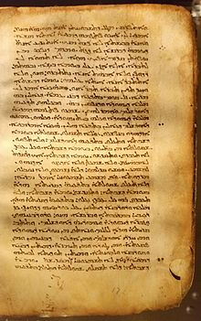

Latin Vulgate
With reference to the Latin versions, we have seen that there are two main types, the Old Latin and the Vulgate. The Old Latin dates back to about A.D. 15, but it has definite limitations because it is based on the Septuagint. The Latin Vulgate, on the other hand, is more valuable because it goes back to the original Hebrew.
Jerome had been commissioned to revise the Old Latin. The more Jerome learned Hebrew the more he was convinced that the ultimate authority for any Old Testament book could be nothing but the Hebrew. He began a fresh translation of the Old Testament directly from the Hebrew and spent about 15 years in putting it into Latin.
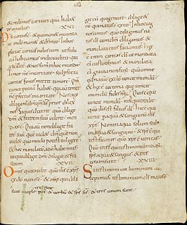

Septuagint
- Considered one of the most important Bible translations ever made, it is the Hebrew Old Testament translated into Greek.
- It’s Greek name is “according to the seventy”, but we know it by it’s Latin name from the Latin septuaginta, “70”.
- Letter of Aristeas
  - A tedious and lengthy letter now arranged in more than 300 verses
  - Aristeas, an Alexandrian Jew is writing a ltter to his brother Philocrates telling him what took place at the court of Ptolemy II (285-247 B.C.).
  - The king asks Demetrius, his librarian, to have the Jewish Law translated and added the royal collection of books. A letter is sent to Eleazar (the Jewish high priest) to ask for help with the translation.
  - Aristeas describes everything in detail, even the details of the temple, the priests, the countryside etc.
  - 72 elders, 6 from each of the 12 tribes are selected as translators and dispatched to Egypt. Aristeas lists the names of the translators.
  - After being vetted by the king with questions to prove their skill with a banquet of 7 days, they completed this work in 72 days.
  - Due to the tone and other historical mentions in this letter, it generally considered by the scholastic community as fiction or unreliable.
  - While we can’t say with certainty this really happened like this, we do believe there is some truth in these events on how the Jewish Law was translated into Greek.
- We have no information on how the remainder of the Old Testament was translated from Hebrew into Greek but we are practically certain that before the dawn of the Christian era, and perhaps well before, the entire Old Testament was accessible in Greek.
- While there are numerous variations between the Septuagint and the Hebrew text, the majority are minor. It’s not usually mentioned how often the Septuagint supports the Hebrew.
- It was the Bible used and quoted by the early church

