How We Got the Bible
By Neil R. Lightfoot

The Text of the Old Testament

Introduction
Again, it is important to stress the importance of the Greek text, for without the words of the Greek text we are left without a foundation for our English translation. There can be no reliable English version unless there is an accurate Greek text. But we have seen that no serious objection can be laid against the Greek text, which means that our faith, based on the New Testament message, stands secure.
In regard to the Old Testament, the principles followed in the New Testament text largely apply to the Old. There remains a large gap of centuries between the time of the ancient scrolls and our earliest Hebrew manuscripts.

The Nash Papyrus -2nd Century B.C.
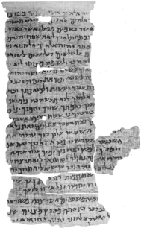

The Dead Sea Scrolls (4Q17 – 4QExod-Lev^{f}) – 250 B.C.
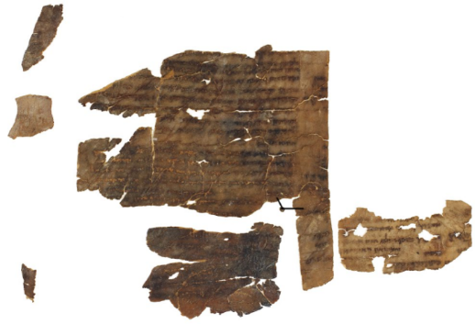

https://www.youtube.com/watch?v=xUwLDzs91CI

The Silver Ketef Hinnon Scrolls
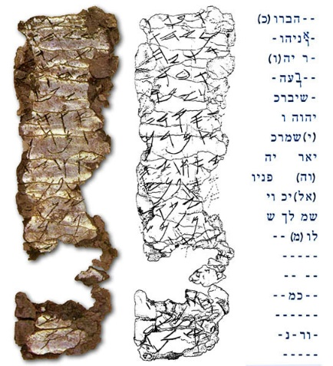

The Hebrew Manuscripts
- The Aleppo Codex - First in rank among the Hebrew manuscripts. It derives its name from a city in Syria where it had long been located. A beautiful written codex of the entire Hebrew Bible finished sometime in the 10th century. Unfortunately, it is no longer complete as large sections were destroyed in Arab riots against the Jews in 1947.
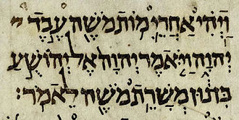

- The Leningrad Codex – It is of equal rank as the Aleppo Codex and now the oldest complete manuscript of the Hebrew Bible. It was written in Cairo in the year 1010.
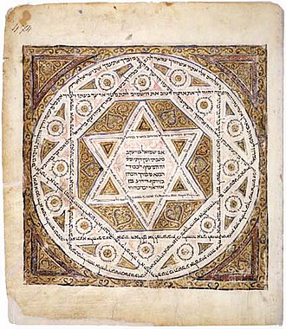

Both manuscripts are outstanding representatives of the famous Ben Asher family of scribes who lived at Tiberias in Palestine. The form of text used in these manuscripts are “Massoretic
Text.”

- The Cairos Codex – Manuscripts of the Former and Latter Prophets was written by Moses ben Asher in 895.
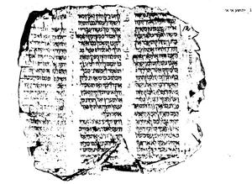

- The Leningrad Codex of the Prophets – Written in 1916, this manuscript includes Isaiah, Jeremiah, Ezekiel, and the Minor Prophets. The was not originally the work of Ben Asher.
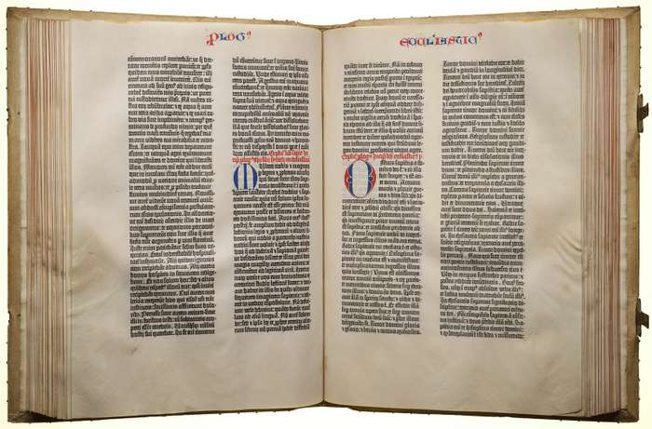

- British Library Codex of the Pentateuch – Contains most of the Pentateuch and is an important witness to the text.
There are more Hebrew manuscripts, but the ones mentioned above are the most important. One may wonder why copies of the Hebrew Bible are late in comparison with the New Testament materials, especially when we recall that the Old Testament was completed several centuries before the first New Testament book was written. From the Jewish standpoint, any manuscript that had been carefully copied and carefully checked with an authentic exemplar was accurate as any other copy. In some respects, the newer copy was even preferable to the older one, which would be more easily subject to wear and tear.

What happened to the older manuscripts?
The Jewish scribes looked upon their copies of the Scriptures with an almost superstitious respect. This led them to give ceremonial burial to any of their text that were damaged or defective. Their motive was to prevent the improper use of the material on which the sacred name of God had been inscribed. Before burial, however, faulty manuscripts were hidden away in a “genizah” (from Aramaic genaz, to hide), a kind of storeroom for manuscripts that were unusable. These acts have deprived us of early Hebrew manuscripts.

Early Scribal Activity
From earliest times, the Jewish scribes devoted themselves to the acdurate transmission of the Biblical text. Thus there arose schools of profressional scribes (1 Chron. 2:55), men who were trained in the art of writing, who were specialist in the law, and who were the supreme guardians of the text. The text was considered unalterable, so the scribe would put dots on the text that need review or correction.
- Massorah – the Jewish religious tradition for gaurding the text
- Massoretes – scribes who transmitted the text, on the basis of their aurhoitative tradition
  - Best know for their system of vowels and accents wich they devised for the Hebrew text, thus the Old Testament was first written without vowels. They were textual critics of the first rank.
The Massoretes, who go back to about A.D. 500, succeeded the earlier scribes. The Massoretes of Tiberias were the most importantant of the Massoretes, and the Ben Asher family of Tiberias, with whom several of the model codices are associated, are especially renowned.

Present Status of Our Text
Our earliest Hebrew manuscripts date no farther back than the 9th century which leaves a rather wide separation of centuries between the original Old Testament autographs and our manuscripts today. We need not be alarmed as the Jewish scribes took extreme care in making copies of the Scriptures. And writings that were not considered perfect were either buried or burned.

The Dead Sea Scrolls
In March of 1948 an Arab boy and his companion were looking for a lost goat in the vicinity of the Dead Sea. As they were looking for the goat, they stumbled across a cave where they found jars containing several old leather rolls with writing on them. Although they thought the rolls were of little value, they took them to Bethlehem where they were purchased by Metropolitan Mar Athanasius Yeshue Samuel of the Syrian Orthodox Monastery of St. Mark in Jerusalem and in part by Professor E. Le. Sukenik of the Hebrew University in Jerusalem.

Qumran Caves – Inhabited around 2nd century B.C. to 1st Century A.D.
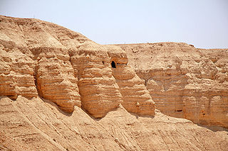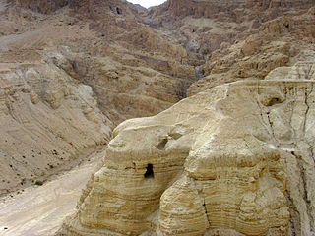

7 rolls were in the original findings
- A book of Isaiah with 54 columns of text written on a leather scroll and were about 25 feet long
- A Manual of Discipline, a rule book which governed the Jewish sect
- A commentary of the book of Habakkuk
- A work of the unknown contents, which later became know as the “Genesis Apocryphon”
- A part of the book of Isaiah
- A work entitled “The War of the Sons of Light with the Sons of Darkness”
- A collection of Thanksgiving Hymns
All seven of these scrolls are now displayed in a museum especially built in Jerusalem for their preservation – The Shrine of the Book
Ten additional caves were found with documents, but most of them only contained fragments of the Old Testament. In all about 800 scrolls, including thousands of fragments, have been uncovered. Some still await publication or evaluation or both.

1QIsª – the great Isaiah scroll dated at 100 _{B.C.} and is a complete copy of the Book of Isaiah written in Massoretic text.
1QIs^{b} – contains chapters 41-59 of the Book of Isaiah and dates to the 1st century B.C.

Summary
The most remarkable part of these findings is how the text of the scrolls and our text today agree.

