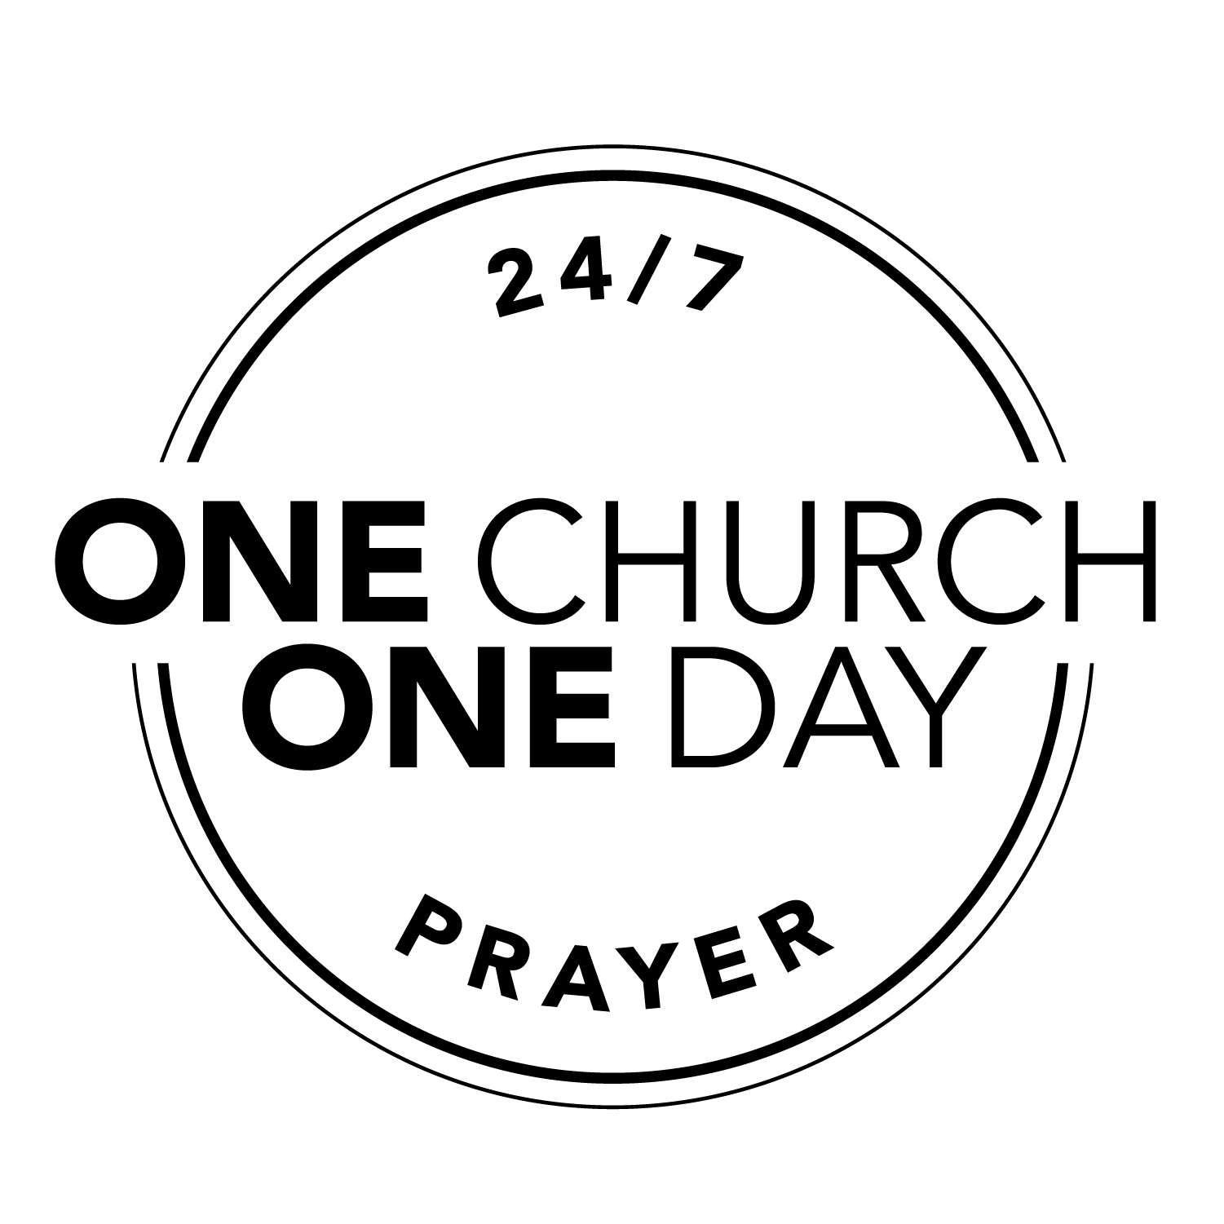

Community Prayer Guide August 2020

Do not be anxious about anything, but in every situation, by prayer and petition, with thanksgiving, present your requests to God. And the peace of God, which transcends all understanding, will guard your hearts and your minds in Christ Jesus. Philippians. 4:6-7

Church
Pray for Jesus followers to bring love, peace and wise solutions to all areas of our local community.
Pray for God’s love and wisdom for pastors/leaders as they discern how to lead in this season.
Pray for God’s people to wisely discern the times and follow God’s leading vs. reacting emotionally.
Pray for reconciliation, love and strong friendships to grow among pastors of all ethnicities.
Education
Pray for wisdom and peace to guide school leaders and families as they prepare for adjustments this fall.
Pray for encouragement, refreshing, and creative strategies for all educators.
Pray for wisdom in the state government for allocating funds and for effective school guidelines.

Government
Pray for the Lord’s wisdom to be given to national, state, county and city leaders.
Pray for the public to receive & hear clear facts from our local government vs. hearing inaccurate information.
Pray for leaders to have empathy and understanding to recognize injustice and then to bring solutions.
Pray for grants to be used wisely to implement solutions & increase services for the mental health crisis.
Business
Pray for local business leaders to have perseverance, wisdom and hope to navigate this season.
Pray for God to raise up business advocates and coaches to support and strengthen business leaders.
Pray for local businesses to rebuild, rehire employees and become profitable again.

May the God who gives endurance and encouragement give you a spirit of unity among yourselves as you follow Christ Jesus, so that with one heart and mouth you may glorify
the God and Father of our Lord Jesus Christ. Romans 15:5-6
A new command I give you: Love one another. As I have loved you, so you must love one another. By this all men will know that you are my disciples, if you love one another.
John 13:34
Arts
Pray for the Oregon Christian Writers Conference to be fruitful in equipping writers for kingdom impact.
Pray for isolated artists to find connection, encouragement and new inspiration through relationships.
Pray for God's wisdom and provision over local theaters & galleries, for peace & safety as venues reopen.
Family
Pray for God to strengthen marriages with joy, agape love, and good communication.
Pray for families to engage in healthy activities, relationships and resources that strengthen them.
Pray for families as they prepare for a unique school season: God’s guidance, provision, and peace.
Health Care
Pray for God to provide a vaccine, and/or other effective treatment for COVID-19.
Pray for an abundance of PPE for our community’s health care providers (HCPs).
Pray for HCPs to have God’s wisdom, strength, perseverance and good health.
Pray for HCPs to provide wise leadership that promotes health and good stewardship of local resources.
Police and Fire Departments
Pray for our community to have accurate knowledge, confidence and peace about how local law enforcement
operates with higher standards and different policies compared to many other cities.
Pray that all First Responders will be “ambassadors of peace” and then bring peace to every situation.
Pray for the encouragement, wisdom, peace and safety of those serving in our police and fire departments.
Media
Pray for hope filled stories to be highlighted in all local media.
Pray for genuine God-transformation stories to be broadcasted and celebrated locally.
Pray for local media leaders to have clear vision to bring fair and accurate reporting through all types of media.

Sports
Pray for God’s guidance and wisdom for the high school/college leadership to navigate restarting athletics.
Pray for the Lord’s strategies for all who oversee youth sports & camps: Kid Sports, YMCA, and others.
Pray for coaches to be strengthened and have wisdom to lead teams in this season.

I urge, then, first of all, that petitions, prayers, intercession and thanksgiving
be made for all people. 1 Timothy 2:1

Find answers to prayer on our website: onehopenetwork.org/testimonies.

