Christianity – Simple or Complicated? #11
The beatitudes – A Third Interpretation
“Follow Me” #4

From Last Week

Earlier in this study of The Beatitudes, we suggested that
Jesus uses them as an introduction to The Sermon On the Mount. Is something more happening?

Last week, this is what we began to do. First, we listened as Jesus’ described what it means to be blessed by God.
Second, we looked at snapshots from his life. We applied this experiment to the first four Beatitudes.
What did we learn?
We learned that, yes, The Beatitudes are the introduction to The Sermon On the Mount. But more importantly, way more importantly, they are the beginnings of Jesus introducing himself.
In The Beatitudes, Jesus is promising to show us what it means to be a human being in a fallen and broken world. What it looks like to be poor in spirit, to mourn, to be meek, and to hunger and thirst after righteousness.
If you missed class last week, or want to review it, use the following link…
https://www.youtube.com/watch?v=0hmeqpRDYas&t=843s

We have four Beatitudes left.
Are you ready? Here we go!
Matthew 5 – (NIV)
7 Blessed are the merciful,
for they will be shown mercy.
John8: ² At dawn he appeared again in the temple courts, where all the people gathered around him, and he sat down to teach them. ³ The teachers of the law and the Pharisees brought in a woman caught in adultery. They made her stand before the group ⁴ and said to Jesus, “Teacher, this woman was caught in the act of adultery. ⁵ In the Law Moses commanded us to stone such women. Now what do you say?” ⁶ They were using this question as a trap, in order to have a basis for accusing him.
But Jesus bent down and started to write on the ground with his finger. ⁷ When they kept on questioning him, he straightened up and said to them, “Let any one of you who is without sin be the first to throw a stone at her.” ⁸ Again he stooped down and wrote on the ground.
⁹ At this, those who heard began to go away one at a time, the older ones first, until only Jesus was left, with the woman still standing there. ¹⁰ Jesus straightened up and asked her, “Woman, where are they? Has no one condemned you?”
¹¹ “No one, sir,” she said.
“Then neither do I condemn you,” Jesus declared. “Go now and leave your life of sin.”
A quick reminder before this next snapshot. – The night before he was killed, Jesus told Peter that he would deny him three times. Peter said it could never happen . A few hours later, Peter did exactly what Jesus had predicted. All through Jesus’ suffering and death, and for many days after the resurrection, Peter lived with the heavy burden of his failure. Then one day, after breakfast on the beach, this happened…
John 21: ¹⁵ When they had finished eating, Jesus said to Simon Peter, “Simon son of John, do you love me more than these?”
“Yes, Lord,” he said, “you know that I love you.”
Jesus said, “Feed my lambs.”
¹⁶ Again Jesus said, “Simon son of John, do you love me?”
He answered, “Yes, Lord, you know that I love you.”
Jesus said, “Take care of my sheep.”
¹⁷ The third time he said to him, “Simon son of John, do you love me?”
Peter was hurt because Jesus asked him the third time, “Do you love me?” He said, “Lord, you know all things; you know that I love you.”
Jesus said, “Feed my sheep. ¹⁸ Very truly I tell you, when you were younger you dressed yourself and went where you wanted; but when you are old you will stretch out your hands, and someone else will dress you and lead you where you do not want to go.” ¹⁹ Jesus said this to indicate the kind of death by which Peter would glorify God. Then he said to him, “Follow me!”
Luke 23: ³³ When they came to the place called the Skull, they crucified him there, along with the criminals—one on his right, the other on his left. ³⁴ Jesus said, “Father, forgive them, for they do not know what they are doing.” And they divided up his clothes by casting lots.
Is this how it looks to be merciful?

⁸ Blessed are the pure in heart,
for they will see God.
Matthew 3:¹³ Then Jesus came from Galilee to the Jordan to be baptized by John. ¹⁴ But John tried to deter him, saying, “I need to be baptized by you, and do you come to me?”
¹⁵ Jesus replied, “Let it be so now; it is proper for us to do this to fulfill all righteousness.” Then John consented.
Matthew 4:⁵ Then the devil took him to the holy city and had him stand on the highest point of the temple. ⁶ “If you are the Son of God,” he said, “throw yourself down. For it is written:
“‘He will command his angels concerning you,
and they will lift you up in their hands,
so that you will not strike your foot against a stone]” (Psalm 91:11-12)
⁷ Jesus answered him, “It is also written: ‘Do not put the Lord your God to the test.’[” (Deuteronomy 6;16)
Is this how it looks to be pure in heart?

9 Blessed are the peacemakers,
for they will be called children of God.
John 13:1 It was just before the Passover Festival. Jesus knew that the hour had come for him to leave this world and go to the Father. Having loved his own who were in the world, he loved them to the end.
² The evening meal was in progress, and the devil had already prompted Judas, the son of Simon Iscariot, to betray Jesus. ³ Jesus knew that the Father had put all things under his power, and that he had come from God and was returning to God; ⁴ so he got up from the meal, took off his outer clothing, and wrapped a towel around his waist. ⁵ After that, he poured water into a basin and began to wash his disciples’ feet, drying them with the towel that was wrapped around him…
¹² When he had finished washing their feet, he put on his clothes and returned to his place. “Do you understand what I have done for you?” he asked them. ¹³ “You call me ‘Teacher’ and ‘Lord,’ and rightly so, for that is what I am. ¹⁴ Now that I, your Lord and Teacher, have washed your feet, you also should wash one another’s feet. ¹⁵ I have set you an example that you should do as I have done for you.
Luke 23: ³³ When they came to the place called the Skull, they crucified him there, along with the criminals—one on his right, the other on his left.
³⁹ One of the criminals who hung there hurled insults at him: “Aren’t you the Messiah? Save yourself and us!”
⁴⁰ But the other criminal rebuked him. “Don’t you fear God,” he said, “since you are under the same sentence? ⁴¹ We are punished justly, for we are getting what our deeds deserve. But this man has done nothing wrong.”
⁴² Then he said, “Jesus, remember me when you come into your kingdom.”
⁴³ Jesus answered him, “Truly I tell you, today you will be with me in paradise
Is this how it looks to be a peacemaker?

10 Blessed are those who are persecuted because of righteousness,
for theirs is the kingdom of heaven.

Since we have already looked at numerous snapshots of Jesus suffering for righteousness, how about a short but powerful word from Paul?

2 Corinthians 5: ²¹ God made him who had no sin to be sin for us, so that in him we might become the righteousness of God.

What does it look like…
to be persecuted for righteousness?

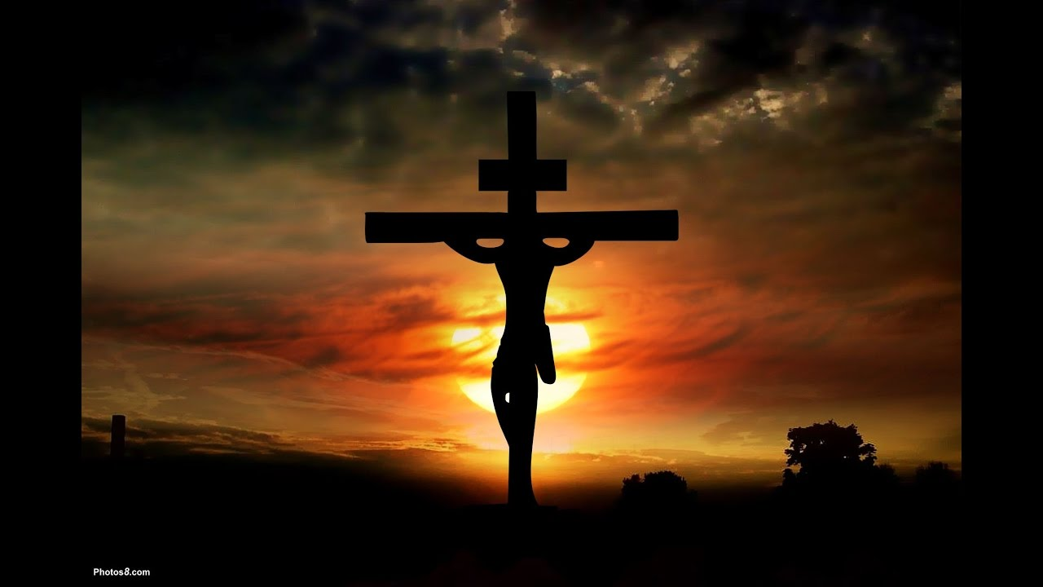

And when I think
That God, His son not sparing,
Sent him to die,
I scarce can take it in.
That on the cross,
My burden gladly baring,
He bled and died
To take away my sin.
Then sings my soul,
My Savior God, to Thee.
How great Thou art!
How great Thou art!
Then sings my soul,
My Savior God, to Thee
How great Thou art!
How great Thou art!

