To Our First Baptist Church Members and Friends
Time really flies by, it is that time again for our Samaritan’s Purse
“Operation Christmas Child”
Drive for this 2020 year.
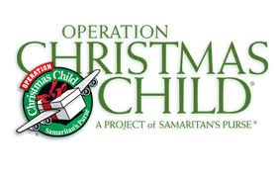
We are ready for this year’s drive and hope you are too! The drive this year will be a little different because of the state of working around, meeting the COVID 19 guidelines set forth to keep us all safe and that’s important.
The needs of giving and helping others are still a priority at First Baptist. Many children all over the world look forward to that special time of receiving the Operation Christmas Child boxes with enclosed literature, spreading to them the “Gospel” of Jesus Christ. We especially don’t want the children to be disappointed this year.
We know this is a hard time for everyone during this pandemic. We have decided to ask, for those who can, to give donations: $20 dollars to purchase items to at least help fill 75 boxes and help pay shipment per box. The Women’s Ministry will continue to add the desired major items to each box like wash cloth, soap, tooth brush and holder. If you have already been shopping for your items that is wonderful and your donation is your items. For those, who love to and want to individually fill out your boxes, by all means, do so. The boxes will be available for you with those major items. Members of the ministry will gather all donations of items and money by the end of September. The 27th of September will be the deadline to give us time for small, social distance groups to fill the boxes for turning them in by November 16th.
As always, we are so thankful of the efforts, you always do, to make this a successful project!

