Family Bible Study

The Good Samaritan Lesson 2

Luke 10:25-37
This study is intended to spark a conversation with your family. Don’t exclude anyone, young or old, from this study. Everyone gets to speak, share, ask, and suggest. You’ll notice I have some coloring pages for your younger kids because they usually can sit still longer if they are occupied. Don’t assume they aren’t listening and don’t forget to ask them questions. Total understanding is not the goal of this class but a readiness to engage the word together. Start every class with a prayer then pay attention to the promptings. If you guys have questions you need help with, write it down, we will ask for questions at different times during the study.
Section 1 (10 min)
What are your thoughts when you read these laws?
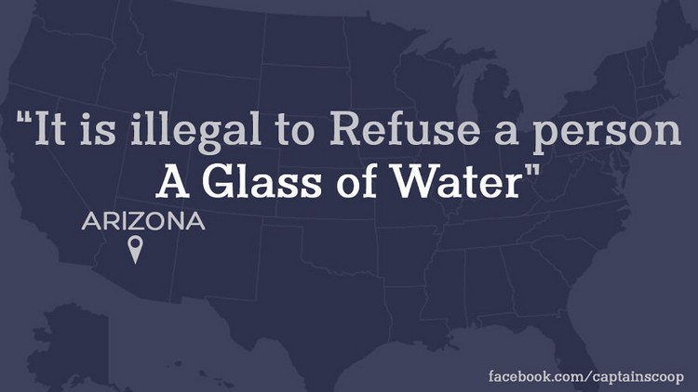
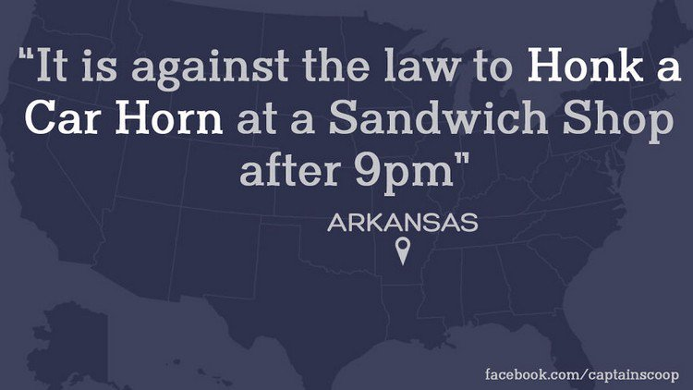

Section 2 (15 min)
Last week we discussed living life in light of eternity, how long is eternity?

Remember the question being ask of Jesus is, "what must I do to inherit eternal life?"

How would you answer that question?

Luk 10:26-28 "What is written in the Law?" he replied. "How do you read it?" (27) He answered, "'Love the Lord your God with all your heart and with all your soul and with all your strength and with all your mind'; and, 'Love your neighbor as yourself.'" (28) "You have answered correctly," Jesus replied. "Do this and you will live."
Suggested activity: If you could make any law you wanted to what law would you make and why?
What can we learn about “the law” in scripture? Look at the following verses, write something about “the law” from that text:
Romans 7:12 ________________________________________________________________
Luke 16:17 __________________________________________________________________
1 Tim 1:8-10 _________________________________________________________________
John 1:17 ____________________________________________________________________
James 2:10 ___________________________________________________________________
Rom 10:4 ____________________________________________________________________
Matt 5:17 ____________________________________________________________________
Rom 8:3 _____________________________________________________________________
What did you learn about “the law” from these scriptures?
_____________________________________________________________________________
Revisit John 1:17 how does Jesus view “the Law”?
_____________________________________________________________________________
Session 3 (15min)
Luk 10:26-28 "What is written in the Law?" he replied. "How do you read it?" (27) He answered, "'Love the Lord your God with all your heart and with all your soul and with all your strength and with all your mind'; and, 'Love your neighbor as yourself.'" (28) "You have answered correctly," Jesus replied. "Do this and you will live."
What does Love mean?
_____________________________________________________________________________
Does the Bible tell us what it means to love God?
_____________________________________________________________________________
Consider these passages about what loving God means:
1 John 5:3 ____________________________________________________________________
2 John 1:6 ____________________________________________________________________
1 John 4:19 ___________________________________________________________________
John 14:15 ____________________________________________________________________
What is the conclusion? _________________________________________________________
What does it mean to love your neighbor as yourself?
_____________________________________________________________________________
Why would Jesus answer this way?
_____________________________________________________________________________
Who is your neighbor?
_____________________________________________________________________________
Final wrap-up
Do you love God with all your heart, soul, strength, and mind? Can you do better?
_____________________________________________________________________________
Do you love your neighbor as yourself? Can you do better?
_____________________________________________________________________________
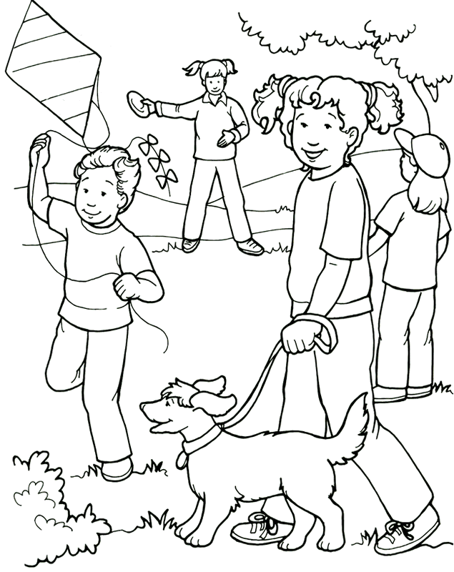
Love one another as I have loved you.
From Thru-the-Bible Coloring Pages for Ages 4-8. © 1986,1988 Standard Publishing.
Used by permission. Reproducible Coloring Books may be purchased from
Standard Publishing, www.standardpub.com, 1-800-323-7543.

