Family Bible Study

The Good Samaritan Lesson 5

Luke 10:25-37
This study is intended to spark a conversation with your family. Do not exclude anyone, young or old, from this study. Everyone gets to speak, share, ask, and suggest. You will notice I have some coloring pages for your younger kids because they usually can sit still longer if they are occupied. Do not assume they aren’t listening and don’t forget to ask them questions. Total understanding is not the goal of this class but a readiness to engage the word together. Start every class with a prayer then pay attention to the promptings. If you guys have questions you need help with, write it down, we will ask for questions at different times during the study.
Section 1 Today you will stay in your group as long as you need to, I don’t want to stop good conversations or discussions. Please take your time return to the class when you finish the section.
Icebreaker:
To illustrate what it feels like to be tested ask your group the following questions: (you can choose a different one for each person in your group)
- What color is a mirror?
- Is it actually possible to waste time?
- If anything is possible is it possible for anything to be impossible?
- Why is it that rain drops but snow falls?
- Is water wet?
Read the Story: Luke 10:25-37
Remember:
What was the goal of the expert in the law?
_______________________________________________________________________________
Did you feel tested earlier when asked those questions?
What questions are asked?
- __________________________________________________________________________
- __________________________________________________________________________
- __________________________________________________________________________
- __________________________________________________________________________
- __________________________________________________________________________

Today we will focus on the questions, “who is my neighbor”.
Jesus tells a story that has many characters name them.
- __________________________________________________________________________
- __________________________________________________________________________
- __________________________________________________________________________
- __________________________________________________________________________
- __________________________________________________________________________
- __________________________________________________________________________
Which of these people would be considered your neighbor?
_______________________________________________________________________________
Which of these characters do you dislike? Why?
_______________________________________________________________________________
Which one(s) do you like? Why?
_______________________________________________________________________________
Return to class when you are finished
Did Jesus answer the question that was asked?
______________________________________________________________________________
How did Jesus answer the question?
_______________________________________________________________________________
Do you understand why Jesus answered the question the way he did?
______________________________________________________________________________
What does he mean when he says, “go and do likewise”?
_______________________________________________________________________________

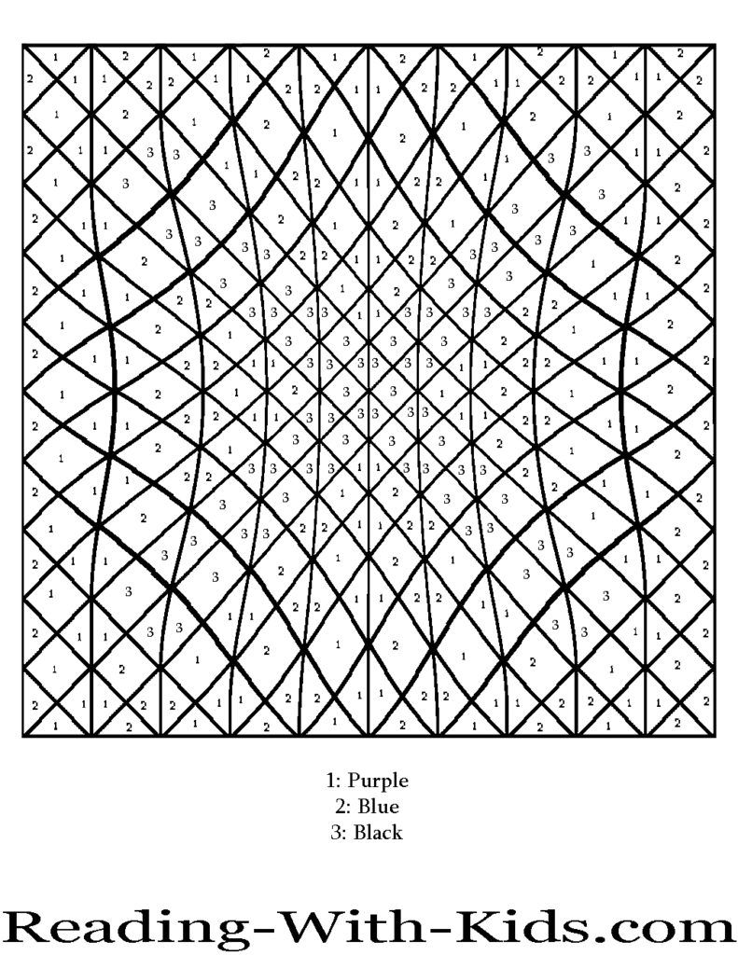
1.Purple 2. Blue 3. Black

