CHAPEL HAPPENINGS – November 13, 2020

FAITH AND PROMISE SUNDAY- NOVEMBER 15TH

This year is fast coming to a close and a new year will soon be upon us. Many necessary changes in our Chapel operation have occurred during the pandemic, resulting in extra expenditures. The information below is our current budget situation:

2020 Chapel Financials

Summary OCT (YTD)
Offerings $6,728 $231,239
Need $41,470 $254,710
Difference ($34,742) ($23,471)

As you can see, we have quite an income shortfall. We are doing lots of wonderful things, both in-house and on-line, to enrich your worship experience.

Please prayerfully consider what you pledge to the Chapel through your Faith and Promise giving. We pray you plan to fulfill your promise this year and consider increasing it next year.

FOR YOUR SAFETY…

The Chapel will be sanitizing the sanctuary before and after services on Saturday, Sunday and special events with ultraviolet lighting. It will be done in off hours since these lights can cause eye damage if protective glasses are not used. Please, for your safety, do not enter the sanctuary if you see blue lights on!

LOU WARLICK MEMORIAL SERVICE
Thursday, November 19th, 10 am.
A NEW CHAPEL ENTRY SYSTEM

There is a new lock system on the front door of the sanctuary. The Chapel is pleased to provide individual access to the sanctuary for meditation and prayer Monday through Friday, 7AM to 7PM. Contact the Chapel office (772-288-5194) to obtain an individual code; we suggest it be your MSCC member number. Please follow all Covid-19 protocols of social distancing, wearing masks and using our hand sanitizing stations.

ECUMENICAL CHAPEL THANKSGIVING PRAYER SERVICE
November 26th, 9:30 am

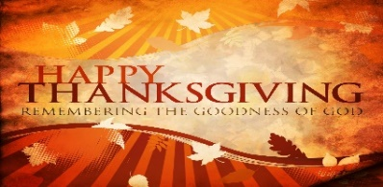

WHITE DOVE TREE IN CHAPEL LOBBY
Choose a dove Sundays – 9-11 am; Wednesdays – 9am-12pm; Fridays – 1-4 pm

The Doves are numbered. Your name and the child’s name must be recorded by the committee before taking. Help make a child’s Christmas extra-special this year.

SPEAKER SERIES - Tuesday, November 17th, 7 pm

Dr. Ianinni will be speaking and answering questions on the Covid-19 virus at the Chapel. This talk will be recorded and available on-line at marinersandschapel.org.

