CHAPEL HAPPENINGS
March 26, 2021

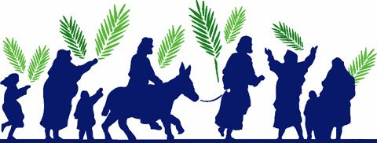

Palm Sunday Service - March 28th, 9:30 am

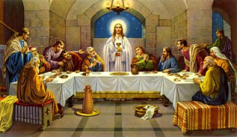

Maundy Thursday Ecumenical Service – 1:30 pm

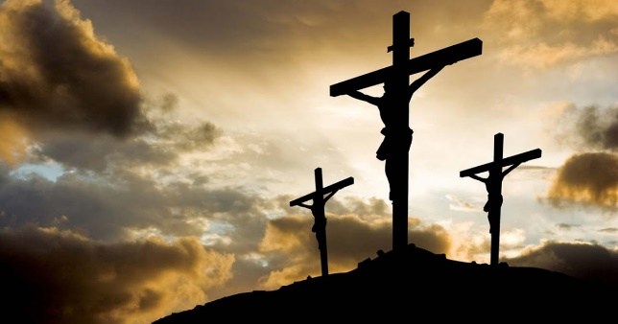

Good Friday Ecumenical Service – 1:30 pm

“For God so loved the world that He gave His only begotten Son, that whosoever believeth in Him should not perish, but have everlasting life.” John 3:16

No Saturday Mass, April 3rd *

He is risen indeed!

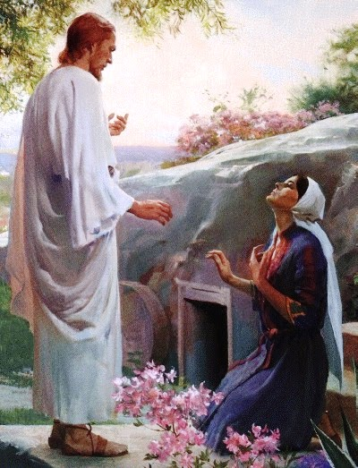

Easter Sunday Services

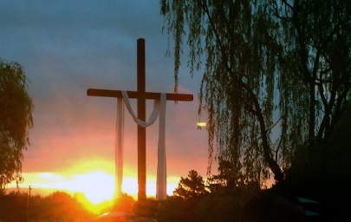

Sunrise Service – 7 am behind the chapel, lakefront

Protestant Worship – 9 am (note time change)

Catholic Mass – 12 noon

The Chapel beautification committee would appreciate any donations of orchids to hang in the palm trees on the Chapel grounds.

