CHAPEL HAPPENINGS
May 7, 2021

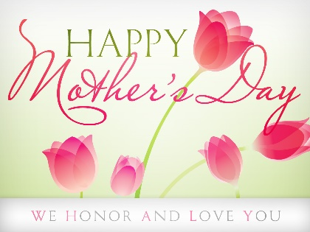

Hobe Sound Bible College Choir

Mother’s Day
Sunday, May 9th, 9:30 am

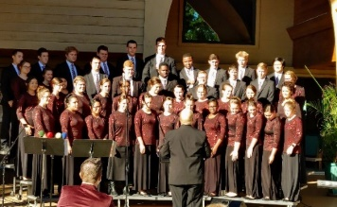

Most of us are familiar with the wonderful music of this talented group of singers. Enjoy them indoors at the Chapel, in chairs outside or in your golf cart. Masks required please…

The Chapel Library is open to the whole community from 8am to 5 pm daily. Choose a book, read it and return it…no sign out necessary.

SPECIAL END OF THE SEASON GOLF EVENT!

WHEN: Saturday, May 8th

WHERE: Golf Driving range

ACTIVITIES: No Cost

4:00 PM – Golf Skills Competition
(Details and Sign up outside Pro Shop)
Prizes: Golf shop gift certificates

5:00 PM – The Dennis Walters Golf Show
(Google Dennis Walters Golf Show)

6:30 PM – Happy Hour and special dinner at Sand Bar Cafe
1 hour 1/2 price drinks for Event attendees only

HOSTED BY: Chaplain Gary Carr, Golf Professionals and our Food Service

RSVP – 283-0202 for dinner reservations and to indicate your attendance for the “Show”.

This is the last big social event of the season sponsored by the Chapel. Don’t miss this inspiring talk and demonstration by paraplegic golfer, Dennis Walters. See you on the range!

