CHRIST CHURCH
of Exeter

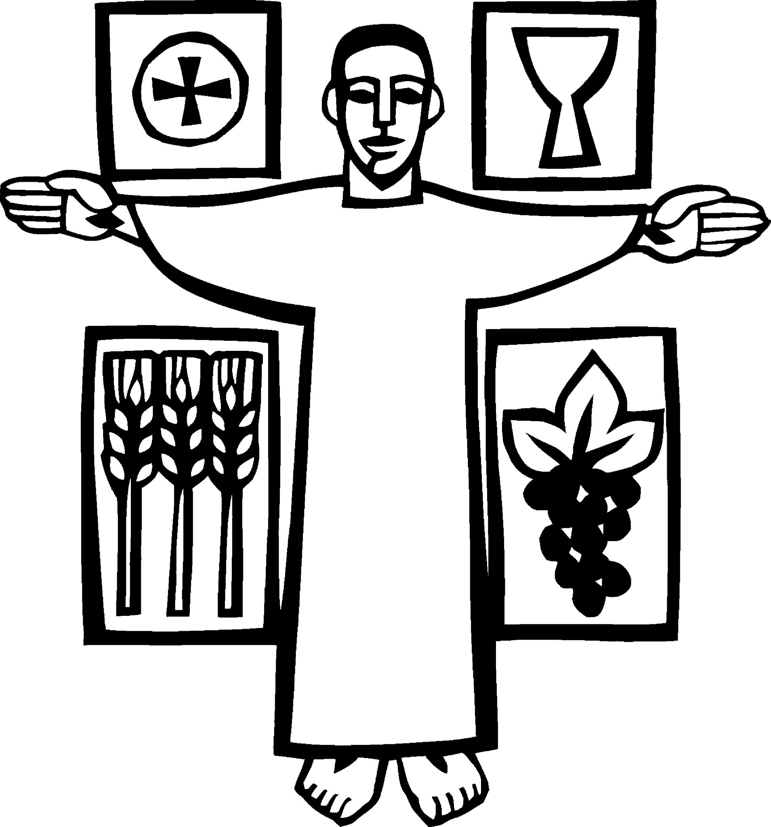
___________________________________________

Live
joyfully in faith

Connect
with God and one another

Serve
the local and global community
______________________________________

August 8, 2021
The Eleventh Sunday after Pentecost
8:00 and 9:30 am
www.christchurchexeter.org

Reflections on Today’s Readings

We continue to hear Jesus’ discourse on the bread of life today. Continuing last week’s theme of Jesus himself as the source of nourishment for our new life in him, a further level of meaning is introduced. This was astounding to Jesus’ hearers (and would be to us if we were not already so used to it), for he is not simply speaking of a “spiritual” communion with him. He is speaking of his own flesh, his own life. He is the food of eternal life.

The first reading tells of Elijah the prophet fleeing through the wilderness. He is starving and begs God to let him die. But God instead provides food for him in the wilderness and Elijah is able to complete his pilgrimage to the mount of God.

Today’s reading from the Letter to the Ephesians continues from last week’s discussion of our unity in the Spirit, to the new way of living which is the result of that unity, and to its deepest and most profound implication: namely, our new life is one identity, both as individuals and as a people, with Jesus himself. What he is, we are becoming.

In the Eucharist we take the material things of this world and, in giving thanks over them, we offer them to be taken up into the life of God. And this is true also of our selves who are represented by the bread and wine. We are part of a people whose story goes back to the ancient Hebrews: a people who have at the center of our existence God calling us to be bearers of the divine presence in the world.

From The Rite Light: Reflections on the Sunday Readings and Seasons of the Church Year. Copyright © 2009 by Michael W. Merriman. Church Publishing Incorporated, New York.

Welcome to Christ Church: If you are visiting for the first time, please fill out the welcome cards in the pews and hand it to a member of the clergy after the service. Welcome bags available in the narthex entry hall.

Guidelines for Gathering Indoors from the Diocese:
* Given high rates of vaccination among our church members, the availability of vaccination to
everyone age 12 and older, and the low rates of COVID19 across New Hampshire, we are following
the guidance of the Diocese to no longer impose requirements around masks, distancing, singing, or
distribution of Holy Eucharist.
* Masks are optional indoors and it should be clear that masks are welcome for those who prefer
them. We want to establish a culture where people are comfortable wearing masks, for any reason.
* We may now offer wine in the common cup. Intinction -- dipping the wafer into the wine -- will not
yet be offered. It should be understood that communion in one kind (bread/wafer only) is entirely
appropriate and sufficient to experience the Real Presence of our Risen Lord. We want to foster a church culture where people are comfortable crossing their arms on their chests as the wine is
distributed, for any reason.

An Alms Basin (offertory plate) will be placed near the baptismal font each Sunday and brought forward during the offertory just before the Eucharistic Prayer begins. For now, we are foregoing the practice of “passing the plate.” Offertory envelopes are available in the entranceway Narthex.

Prayer Concerns: If you wish for continued prayer, please notify the church office. (Names are updated monthly)

The Healing team is available to offer healing prayers during the Eucharist, at the side of the church. Please tell your healing minister if you have a specific prayer need and if you would like a laying on of hands, just prayers or both.
Join our Faithlife Online Community and stay connected: Get started today by visiting Faithlife.com with your PC or Mac by creating an account with your email. It will invite you to find the Christ Church Exeter group. You can also download a free app for your phone. Faithlife is a way for you to stay up-to-date on upcoming parish events, learn more about opportunities to serve, share prayer requests, deepen your faith and connect in small groups. You control how often you receive notices and updates.

This week at Christ Church
August 8-14
Monday | Pine Street Players Camp 8:00 am
Tuesday | PSP Camp 8:00 am
Wednesday | PSP Camp 8:00 am
Thursday | PSP Camp 8:00 am
Friday | PSP Camp 8:00 am
Saturday | Memorial Service / Reception Kezar 1:00

A Thought to Focus our Day: Christ has no body on earth now but yours, no hands but yours, no feet but yours. Yours are the eyes through which to look out Christ’s compassion to the world. Yours are the feet with which he is to go about doing good, and yours are the hands with which he is to bless us now.
Teresa of Avila

[9:30 service] Prelude Lied (Song) Louis Vierne

Welcome Page 355 in the Book of Common Prayer

✠ All stand, as they are able, as the bell tolls.

[9:30 service] Hymn 51 We the Lord’s people Decatur Place

Presider Blessed be God: Father, Son and Holy Spirit.
People And blessed be God’s kingdom, now and forever. Amen.

The Collect of the Day

Presider The Lord be with you.
People And also with you.
Presider Let us pray.

Grant to us, Lord, we pray, the spirit to think and do always those things that are right, that we, who cannot exist without you, may by you be enabled to live according to your will; through Jesus Christ our Lord, who lives and reigns with you and the Holy Spirit, one God, for ever and ever. Amen.

The First Reading 1 Kings 19:4-8
Reader A Reading from the First Book of Kings
Elijah went a day’s journey into the wilderness, and came and sat down under a solitary broom tree. He asked that he might die: “It is enough; now, O Lord, take away my life, for I am no better than my ancestors.” Then he lay down under the broom tree and fell asleep. Suddenly an angel touched him and said to him, “Get up and eat.” He looked, and there at his head was a cake baked on hot stones, and a jar of water. He ate and drank, and lay down again. The angel of the Lord came a second time, touched him, and said, “Get up and eat, otherwise the journey will be too much for you.” He got up, and ate and drank; then he went in the strength of that food forty days and forty nights to Horeb the mount of God.

Reader The word of the Lord.
People Thanks be to God.

Psalm 34:1-8 (page 627 in the Book of Common Prayer) (read responsively by verse)

1 I will bless the Lord at all times; *
his praise shall ever be in my mouth.

2 I will glory in the Lord; *
let the humble hear and rejoice.

3 Proclaim with me the greatness of the Lord; *
let us exalt his Name together.

4 I sought the Lord, and he answered me *
and delivered me out of all my terror.

5 Look upon him and be radiant, *
and let not your faces be ashamed.

6 I called in my affliction and the Lord heard me *
and saved me from all my troubles.

7 The angel of the Lord encompasses those who fear him, *
and he will deliver them.

8 Taste and see that the Lord is good; *
happy are they who trust in him!

The Second Reading Ephesians 4:25-5:2
Reader A Reading from the Second Letter of Paul to theEphesians
Putting away falsehood, let all of us speak the truth to our neighbors, for we are members of one another. Be angry but do not sin; do not let the sun go down on your anger, and do not make room for the devil. Thieves must give up stealing; rather let them labor and work honestly with their own hands, so as to have something to share with the needy. Let no evil talk come out of your mouths, but only what is useful for building up, as there is need, so that your words may give grace to those who hear. And do not grieve the Holy Spirit of God, with which you were marked with a seal for the day of redemption. Put away from you all bitterness and wrath and anger and wrangling and slander, together with all malice, and be kind to one another, tenderhearted, forgiving one another, as God in Christ has forgiven you. Therefore be imitators of God, as beloved children, and live in love, as Christ loved us and gave himself up for us, a fragrant offering and sacrifice to God.

Reader The word of the Lord.
People Thanks be to God.
Sequence Hymn 475, vv. 1-2 God himself is with us Tysk

The Gospel John 6:35, 41-51
Gospeler The Holy Gospel of our Lord Jesus Christ according to John
People Glory to you, Lord Christ.
Jesus said, “I am the bread of life. Whoever comes to me will never be hungry, and whoever believes in me will never be thirsty. ”Then the Jews began to complain about him because he said, “I am the bread that came down from heaven.” They were saying, “Is not this Jesus, the son of Joseph, whose father and mother we know? How can he now say, ‘I have come down from heaven’?” Jesus answered them, “Do not complain among yourselves. No one can come to me unless drawn by the Father who sent me; and I will raise that person up on the last day. It is written in the prophets, ‘And they shall all be taught by God.’ Everyone who has heard and learned from the Father comes to me. Not that anyone has seen the Father except the one who is from God; he has seen the Father. Very truly, I tell you, whoever believes has eternal life. I am the bread of life. Your ancestors ate the manna in the wilderness, and they died. This is the bread that comes down from heaven, so that one may eat of it and not die. I am the living bread that came down from heaven. Whoever eats of this bread will live forever; and the bread that I will give for the life of the world is my flesh.”

Gospeler The Gospel of the Lord.
People Praise to you, Lord Christ.

Sermon The Rev. Mark Pendleton

✠ A brief period of silence follows the sermon.

The Nicene Creed (said together) Page 358 in the Book of Common Prayer

We believe in one God,
the Father, the Almighty,
maker of heaven and earth,
of all that is, seen and unseen.
We believe in one Lord, Jesus Christ,
the only Son of God,
eternally begotten of the Father,
God from God, Light from Light,
true God from true God,
begotten, not made,
of one Being with the Father.
Through him all things were made.
For us and for our salvation
he came down from heaven:
by the power of the Holy Spirit
he became incarnate from the Virgin Mary,
and was made man.
For our sake he was crucified under Pontius Pilate;
he suffered death and was buried.
On the third day he rose again
in accordance with the Scriptures;
he ascended into heaven
and is seated at the right hand of the Father.
He will come again in glory to judge the living and the dead,
and his kingdom will have no end.

We believe in the Holy Spirit, the Lord, the giver of life,
who proceeds from the Father and the Son.
With the Father and the Son he is worshiped and glorified.
He has spoken through the Prophets.
We believe in one holy catholic and apostolic Church.
We acknowledge one baptism for the forgiveness of sins.
We look for the resurrection of the dead,
and the life of the world to come. Amen.

Prayers of the People

Let us pray: ​​Creator, Redeemer, Sustainer: you brought us into being, and we cannot exist without you.

Give us the strength we need for today. And the hope we need for tomorrow.

We pray for Christ’s body, your church, and for those who lead and for those who follow. Grant that we not grieve your Holy Spirit with our words or actions. Remind us that we are members of one another. Teach us to be imitators of you.

Silence

Give us the strength we need for today. And the hope we need for tomorrow.

We pray for those in authority across the globe. Infuse them with wisdom and speak peace into their hearts. Expand your vision for the world to every corner of the earth, to every part of your creation.

Silence

Give us the strength we need for today. And the hope we need for tomorrow.

We pray for those who carry burdens of illness, pain, anxiety, or grief. May they draw strength from your presence and comfort from those around who care for them.

We pray for:

Silence

Give us the strength we need for today. And the hope we need for tomorrow.

We pray for those who have died, who are now surrounded by your glory and the songs of angels. Comfort those who mourn with your promise of hope and the resurrected life.

Silence

Give us the strength we need for today. And the hope we need for tomorrow. .

Presider: Almighty and eternal God, ruler of all things in heaven and earth: Mercifully accept the prayers of your people, and strengthen us to do your will; through Jesus Christ our Lord. Amen.

Confession of Sin

The Presider or Assistant says Let us confess our sins against God and our neighbor.

Most merciful God,
we confess that we have sinned against you
in thought, word, and deed,
by what we have done,
and by what we have left undone.
We have not loved you with our whole heart;
we have not loved our neighbors as ourselves.
We are truly sorry and we humbly repent.
For the sake of your Son Jesus Christ,
have mercy on us and forgive us;
that we may delight in your will,
and walk in your ways,
to the glory of your Name. Amen.

Absolution

Almighty God have mercy on you, forgive you all your sins through our Lord Jesus Christ, strengthen you in all goodness, and by the power of the Holy Spirit keep you in eternal life. Amen.

The Peace

✠ The people stand as they are able.

Presider The peace of the Lord be always with you.
People And also with you.

Announcements

The Holy Communion

[9:30 service] Offertory Music I am the Bread of Life Jack Warren Burnham

The Alms Basin is brought forward to the Altar in thanksgiving for the blessings given to us all.

The Great Thanksgiving Page 361 in the Book of Common Prayer

Presider The Lord be with you.
People And also with you.
Presider Lift up your hearts.
People We lift them to the Lord.
Presider Let us give thanks to the Lord our God.
People It is right to give our thanks and praise.

The Presider continues
It is right, and a good and joyful thing, always and everywhere to give thanks to you, Father Almighty, Creator of heaven and earth through your dearly beloved Son Jesus Christ our Lord; who on the first day of the week overcame death and the grave, and by his glorious resurrection opened to us the way of everlasting life. Therefore, we praise you, joining our voices with Angels and Archangels and with all the company of heaven, who for ever sing this hymn to proclaim the glory of your Name: [Said at 8:00, sung at 9:30].

Presider and People
Holy, holy, holy Lord, God of power and might,
heaven and earth are full of your glory.
Hosanna in the highest.
Blessed is he who comes in the name of the Lord.
Hosanna in the highest.

Sanctus S 130
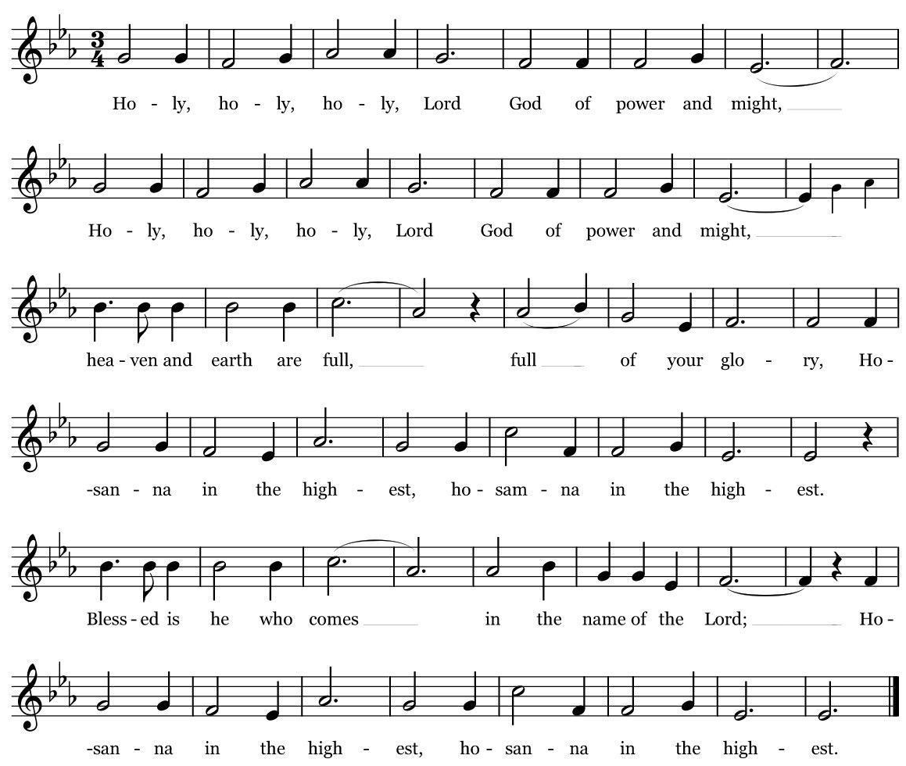
Richard Proulx. All rights reserved. Reprinted under onelicense.net. #A79012

The Presider continues
Holy and gracious Father: In your infinite love you made us for yourself; and, when we had fallen into sin and become subject to evil and death, you, in your mercy, sent Jesus Christ, your only and eternal Son, to share our human nature, to live and die as one of us, to reconcile us to you, the God and Father of all. He stretched out his arms upon the cross, and offered himself in obedience to your will, a perfect sacrifice for the whole world.

On the night he was handed over to suffering and death, our Lord Jesus Christ took bread; and when he had given thanks to you, he broke it, and gave it to his disciples, and said, “Take, eat: This is my Body, which is given for you. Do this for the remembrance of me.”

After supper he took the cup of wine; and when he had given thanks, he gave it to them, and said, “Drink this, all of you: This is my Blood of the new Covenant, which is shed for you and for many for the forgiveness of sins. Whenever you drink it, do this for the remembrance of me.”

Therefore we proclaim the mystery of faith:

Presider and People
Christ has died.
Christ is risen.
Christ will come again.

The Presider continues
We celebrate the memorial of our redemption, O Father, in this sacrifice of praise and thanksgiving. Recalling his death, resurrection, and ascension, we offer you these gifts. Sanctify them by your Holy Spirit to be for your people the Body and Blood of your Son, the holy food and drink of new and unending life in him. Sanctify us also that we may faithfully receive this holy Sacrament, and serve you in unity, constancy, and peace; and at the last day bring us with all your saints into the joy of your eternal kingdom.

All this we ask through your Son Jesus Christ. By him, and with him, and in him, in the unity of the Holy Spirit all honor and glory is yours, Almighty Father, now and for ever. AMEN.

The Presider then continues
And now, as our Savior Christ has taught us, we are bold to say,

People and Presider
Our Father, who art in heaven, hallowed be thy Name, thy kingdom come, thy will be done, on earth as it is in heaven. Give us this day our daily bread. And forgive us our trespasses, as we forgive those who trespass against us. And lead us not into temptation, but deliver us from evil. For thine is the kingdom, and the power, and the glory, for ever and ever. Amen.

The Breaking of the Bread

✠ The Presider breaks the consecrated Bread. A period of silence is kept.

Presider Alleluia. Christ our Passover is sacrificed for us;
People Therefore let us keep the feast. Alleluia

Invitation to Communion

Communion is distributed to those gathered

Instructions for Receiving Communion

You are invited to receive Holy Communion. As you approach the altar from the center aisle (side sections going first), please go to the first available place at the altar rail farthest from the center. You may stand or kneel. Please leave space at the rail between households.

The bread is received in the open palm. You may also take a sip of the wine -- please no intinction.

Gluten-free wafers are available. Please ask the priest at the communion rail to receive.

Those who do not wish to receive Communion are invited to come forward for a blessing, indicated by crossing your arms over your chest.

Communion can also be brought to you in the pews. Please communicate this request to an usher or the clergy.

[9:30 service] Music at Communion

The Post Communion Prayer (Page 365) in the Book of Common Prayer

Presider and People
Eternal God, heavenly Father,
you have graciously accepted us as living members
of your Son our Savior Jesus Christ,
and you have fed us with spiritual food
in the Sacrament of his Body and Blood.
Send us now into the world in peace,
and grant us strength and courage
to love and serve you
with gladness and singleness of heart;
through Christ our Lord. Amen.

The Blessing

[9:30 service] Hymn 527 Singing songs of expectation Ton-y-botel

The Dismissal

Priest Let us go forth in the name of Christ.
People Thanks be to God.

[9:30 service] Postlude The Emperor’s Fanfare Antonio Soler
arranged by E. Power Biggs

The worship is over ✠ The service begins

Participating in Today’s Liturgy: (9:30 am)
Presider: The Rev. David D. Holroyd
Preacher: The Rev. Mark Pendleton
Lector: Dick Ingram (8:00); Danielle Larson-Clark (Reader) (9:30)
Welcome Team/Usher: Christopher Sera
Director of Music: Maggie O’Neill
Organist: Bruce Adami
Live Streaming Coordinator: Joe DiPalermo
Flower Delivery: Lissa Simard
Altar Flowers given: in memory of Audrey Castle by her family.

Announcements:

The guest organist today: Philip Pampreen is a master’s student at Indiana University studying mathematics. In 2021, he received a mathematics degree and an organ degree there under the tutelage of Chris Young. Growing up in New Hampshire, Philip was homeschooled from 7th grade through high school to focus on music. In December 2018, Philip performed two recitals in Vienna, Austria at Melk Abbey and St. Peter’s Church. After being designated a Rising Star by the New Hampshire AGO in May of 2018, he was invited to Methuen to give a solo recital the following month. In the summers of 2017 and 2018 Philip coordinated, directed, and performed in the annual benefit concert for the Options pregnancy resource center. In April 2020, Philip returned to Methuen to complete his degree recital due to cancellation of on-campus venues. He was the only student in the Jacobs school of music to livestream his degree recital during the spring 2020 semester, and he gave another recital at Methuen in May 2020.

Amory Kezar Celebration of Life… there will be a service to celebrate the life of Amory Kezar next Saturday, August 14, at 1:00 p.m. A reception in the Parish Hall will follow the service.

A Note on Privacy and Live Streaming: Now that we have begun to live stream the main service on our YouTube channel, our practice is to not video worshippers during the distribution of communion. The camera is reset to the cross over the altar.. The camera can pick up the backs of the heads of those in the front pews, and at times those in the side pews. If you do not want to be seen by the camera, please sit in any of the five (5) center back pews. The aim of our live streaming is to focus on the altar and the lectern and not to broadcast who is coming to church.

CHRIST CHURCH
43 Pine St., Exeter, NH 03833
Phone: (603) 772-3332 E-mail: office@christchurchexeter.org

Office Hours: Mon, Tue, Thur 9 am - 12 Noon, Weds 9 am - 4 pm OFFICE CLOSED FRIDAYS

Rector Ext. 12
The Rev. Mark B. Pendleton mpendleton@christchurchexeter.org

Priest Assoc. for Pastoral care Ext. 11
The Rev. David D. Holroyd dholroyd@christchurchexeter.org

Director of Music Ext. 15
Maggie O’Neill moneill@christchurchexeter.org

Organist Ext. 15
Bruce Adami bruce@christchurchexeter.org

Administrative assistant Ext. 11
Darla Watt office@christchurchexeter.org

Bookkeeper
Normand Tremblay

Vestry
Senior Warden Patricia Gianotti
Junior Warden John Gilbert Treasurer Lucia Savage
Clerk Suzanne Fong

Deb Fournier Barbara Beardsley Lauri Ayers
Jeff Neil Shannon Hays Gordon Rehnborg
Christopher Sera Richard Ingram John Cofer

