TITLE: CHOOSE WISELY

AUGUST 15, 2021

Today Message by Craig Minke

Our sermon text comes from Ephesians 5, where Paul exhorts us to spend our time carefully considering the choices and opportunities before us, using prayer and gratitude to tune into God’s guidance.

The 1993 movie Groundhog Day features actor Bill Murray as TV weatherman Phil Connors who becomes snowbound in Punxsutawney, Pennsylvania on Groundhog Day.
- He was assigned for he 4th year in a row to report on the Groundhog Day festival in Punxsutawney
- He is extremely indignant about the assignment he has been given.
- Phil spend his day in a tiny town mocking the festivities and belittling the people who partake in them – generally assuming the celebrations and these people are well below his class.
- The story line continues when a blizzard blows into town and he is forced to spend another night in the town of Punxsutawney
- Phil wakes up the next morning to the sounds of the clock radio to repeat February 2 all over again.
- If that weren’t bad enough, he becomes caught in a time loop where he repeats Groundhog Day (Feb. 2) over and over and over again.
- The original script for the movie indicated that Phil was caught in the time loop for a number of years.
- You might be wondering why Phil Connors would need to remake his choices over and over for ten years.

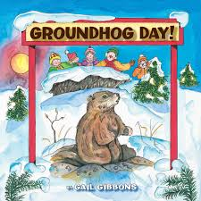

At the beginning of the film, Phil is a narcissist, intent only on serving himself, but after he experiences the negative consequences of his choices (not once, but many times), he begins to modify his behavior and make better choices.

As he relives Feb. 2 again and again, Phil begins to care about the people of Punxsutawney, and he averts a number of disasters (because he knows they are going to happen) to keep them safe.
- For example, in an early scene, a child falls out of a tree and breaks his leg. After that, Phil Connors manages to be under the tree to catch the boy at just the right time.
- In another scene, a man chokes on a piece of steak in a diner, and Phil makes sure he is present right then to save the man by performing the Heimlich maneuver.
- As Phil’s choices become less self-centered and more focused on helping others, he changes, ultimately breaking the “Groundhog Day curse” and moving on to Feb. 3.
Just like Phil Murray, we all have the power to make choices, or to choose how we will respond to other around us.
Having the power to make choices is God’s plan for humanity.
- Free will or free moral agency gives us the ability to choose to love God or not.
- We remember verses like Deuteronomy 30:19,

DEUT 30:19 ¹⁹ I call heaven and earth to witness against you today that I have set before you life and death, blessings and curses. Choose life so that you and your descendants may live,
- Life and death have been placed before us, and while most of our choices don’t directly seem to lead to either of those, we recognize that our choices have consequences.

- The consequences of those choices can be blessings or can feel like curses we put on ourselves or others.

In the letter to the Ephesians, the apostle Paul talks about carefully considering the choices we make.
- Let’s look at the text.

EPH 5:15-20 ¹⁵ Be careful then how you live, not as unwise people but as wise, ¹⁶ making the most of the time, because the days are evil.
¹⁷ So do not be foolish, but understand what the will of the Lord is.
¹⁸ Do not get drunk with wine, for that is debauchery; but be filled with the Spirit,
¹⁹ as you sing psalms and hymns and spiritual songs among yourselves, singing and making melody to the Lord in your hearts,
²⁰ giving thanks to God the Father at all times and for everything in the name of our Lord Jesus Christ. (NRSV)

- What can we notice about this passage?
- The theme of the passage contrasts wisdom and foolishness.
    - Other themes earlier in the fifth chapter include love vs. lust and
    - Light vs. darkness.
    - Bible writers used this technique, called antithetical parallelism, to grab readers’ attention, much like advertising today sometimes relies on exaggerations or extremes to gain an audience.
EPH 5:15-16 ¹⁵ Be careful then how you live, not as unwise people but as wise, ¹⁶ making the most of the time, because the days are evil.
ITS TIME: We need to make a quick mental list of the things WE really value.
- Undoubtedly your list would include your loved ones, your home, your church, and perhaps a few other possessions.
- Would it also include your time?
- Paul’s admonition to live carefully, “making the most of every opportunity,” is a reminder of the preciousness of time. Think about it.
  - If someone takes away your money, you may not like it, but you can earn more money.
  - If someone or something takes away your job or even your house, it might be very difficult, but you can get another job or house.

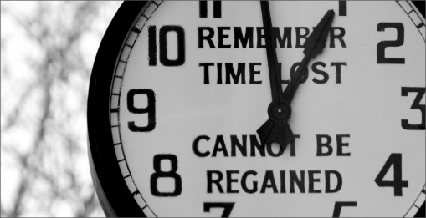

- But if something takes your time and wastes it, YOU CAN NEVER GET IT BACK.
  - Those hours or days are gone, never to be retrieved.
  - That makes time a very valuable thing indeed.
  - What are you doing with the time God has given you?
  - Are you “making the most of every opportunity,” allowing him to use you and your time as he sees fit?

- In the Message translation, verse 15-16 says,
EPH 5:15-16 So watch your step. Use your head. Make the most of every chance you get. These are desperate times!
- Paul is making it clear that we’re to carefully consider our choices.
- We’re encouraged to consider how we spend our time.
- “Do not be foolish, but understand what the will of the Lord is” reminds us that we are presented with opportunities, both for good and evil, and we must choose properly by thinking through the implications of what we do

EPH 5:17 ¹⁷ So do not be foolish, but understand what the will of the Lord is.

Human decision-making is easily influenced. Psychology Today reports that making decisions comes from “the interactions between reflection and emotion.”
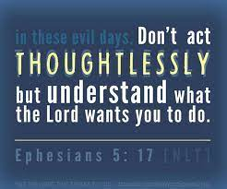
- As you might think, the emotional aspect is more spontaneous and doesn’t always consider the consequences of a choice while the reflective side tempers that, if given adequate time and thought.
- One example of this is the way our emotional side wants dessert, but our reflective side knows that dessert might not help us meet our health goals.
- Because the emotional brain tends to dominate and “flood” our consciousness, we don’t always understand why we do the things we do.
- Becoming more aware of how our choices can be driven by emotion helps us take extra time to allow our reflective side to consider the consequences more carefully.

EPH 5:18-20 ¹⁸ Do not get drunk with wine, for that is debauchery; but be filled with the Spirit,
- The point of this verse is not to avoid drinking alcohol but this verse goes beyond that.
- The most important point here is, WHAT, or WHO is going to be in control of our life.

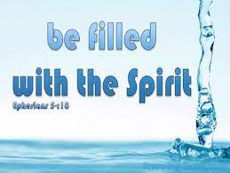
- Either the Holy Spirit is, or something else is.
- And whatever else it may be, it’s a poor substitute.
- Being filled with alcohol can make you lose control and do stupid things.
- Being filled with the Holy Spirit give you self-control (Gal 5:23) and helps you worship God and serve others.

¹⁹ as you sing psalms and hymns and spiritual songs among yourselves, singing and making melody to the Lord in your hearts,
²⁰ giving thanks to God the Father at all times and for everything in the name of our Lord Jesus Christ. (NRSV)
- The effects of alcohol are obvious. What happens when we are under the influence of the Holy Spirit? In these verses, Paul lists three by-products of the Spirit’s influence in our lives:
  - speaking,
  - singing, and
  - giving thanks.
- When the Holy Spirit controls us,
  - we “speak to one another with psalms, hymns and spiritual songs.”
  - We “sing and make music in our hearts to the Lord.” And
  - we “[give] thanks to God the Father for everything, in the name of our Lord Jesus Christ.”

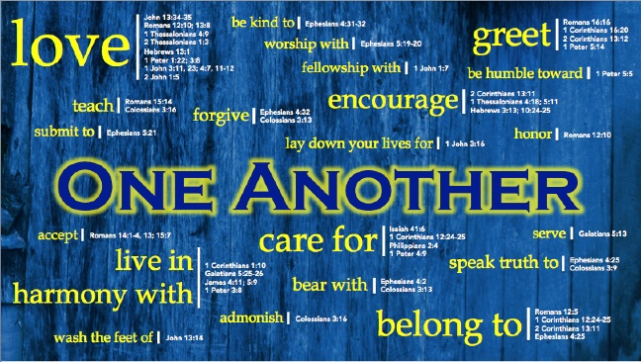
- Paul did not intend to suggest that we only discuss religious matters, but that whatever we do or say should be permeated with an ATTITUDE OF THANKFULNESS to God and ENCOURAGEMENT toward each other.
- Instead of whining and complaining—which our culture has raised to an art form—we are to focus on the goodness of God and his mercies toward us.
- Which is more characteristic of your words and attitudes?
  - Whining and complaining or
  - Focusing on the goodness of God and his mercies.
- The implication is that being in tune with the Holy Spirit GUIDES OUR CHOICES AND CREATES thanksgiving and joy.
- We treasure creation and have eyes wide open to see the goodness of the Father, Son, and Holy Spirit at work in our ordinary circumstances.
- We offer thanksgiving and praise (v. 20) “giving thanks to God the Father at all times and for everything in the name of our Lord Jesus Christ.”

We’re encouraged not to drink too much alcohol, as it leads to an overindulgence in pleasing the self in sensual pleasures.
  - This cheapens our life,
  - impairing our judgment,
  - leading us to making unwise decisions and even affecting our speech.

These verses encourage us to show our reverence for what God has given us:
- the breath of life,
- each other,
- and time on Earth.
- What we do and how we live is how we honor God.
- Numbing ourselves—with alcohol, drugs, lack of empathy, or selfishness—limits our ability to experience the fullness of life filled with the Holy Spirit.

WHAT ARE SOME MORE WAYS WE CAN APPLY THESE SCRIPTURES INTO OUR DAY TO DAY LIVING?
- Carefully consider the consequences of your choices, understanding how easily human beings are driven by emotions.
- This may mean pausing and taking a deep breath before responding in a heated conversation, or
- telling someone you’ll get back to them with a decision so you have time to think about it.

- Prayerfully ask the Holy Spirit to guide you.
- This will take the shape of contemplative prayer, which is more of an unveiling than a list of requests.
- Asking for wisdom, insight, and loving kindness for all keeps the focus on the ultimate outcome of any decision you make rather than the individual steps needed to get there.

- Become aware of how you might “cheapen” your own life or others’ lives.
  - Though drinking too much alcohol might not be an issue, a lack of empathy, kindness, and acceptance of yourself or others rejects the Imago Dei (“image of God”) in each of us.
  - Notice attitudes of comparing yourself with others (Galatians 6:4-6), and strive to remember God’s unconditional love for all.

- Incorporate gratitude for God’s presence in our lives.
  - Recognize ordinary joys,
    - like your morning coffee or tea,
    - a warm bath, or
    - the smile of a loved one
    - The cool breeze after a hot day
    - A kind gesture from others
    - Offer praise to God each day for what’s bringing a smile to your face.

Today’s passage invites us to think deeply about our choices and how we might exercise our God-given right to free will in the most loving way.

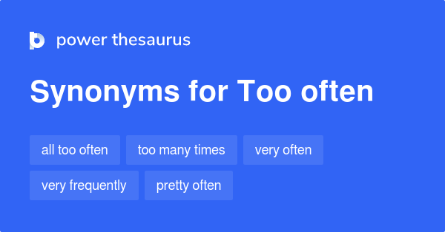

- TOO OFTEN we make our DECISIONS TO HASTILY, without
- TOO OFTEN we do not take time to CONSIDER THE CONSEQUENCES of our actions
- TOO OFTEN we do NOT PRAY FOR WISDOM
- TOO OFTEN we do not notice the blessing that SURROUND US.

- TOO OFTEN we forget that our EMOTIONS can push us to make choices without considering the consequences.
- However, we don’t need to be trapped making the same poor choices over and over, like Phil Connors in Groundhog Day.

- CAREFUL CONSIDERATION OF CONSEQUENCES, PRAYER, SELF-AWARENESS AND GRATITUDE will…
HELP US ENJOY THIS GOD-GIVEN GIFT OF LIFE.

CLOSING PRAYER

Barton, B. B., & Comfort, P. W. (1996). Ephesians (p. 108). Wheaton, IL: Tyndale House Publishers.
Barton, B. B., & Comfort, P. W. (1996). Ephesians (p. 110). Wheaton, IL: Tyndale House Publishers.

