CHAPEL HAPPENINGS
September 14, 2021

New Chapel Season Begins…
Sunday, September 19th, 9:30 am
Come lift your spirit and worship with us
(Indoors, outdoors, and golf cart access – masks please.)

The Chapel office opens September 15th, 9 am

We are looking forward to our new music director, Mr. Douglas Jewett! We hope you will consider joining our singing or bell choirs to musically praise our Lord and Savior. Meet Doug September 16, 4:30 pm at the Chapel. No auditions necessary, all are welcome. Details of rehearsal starting days and times to follow.

Bible Study Groups

Men’s Bible Fellowship –
Each Tuesday starting 9/28 at 8 am

The initial 6 weeks will be led by Dr. Carr in the Chapel board room.
Topic – “Prayer…how to optimize your conversations with God.”
We will continue participation via Zoom. Contact D’Arcy LeClair (dhleclair@gmail.com) to be included in the Zoom meeting.

Ladies Bible Study
Each Monday at 9 am

They will finish “Hoping for Something Better” and then begin discussing “Truthfilled” by Ruth Chou Simmons. If you’re new, please contact Tanya Condello to join on Zoom.

UPDATE FROM THE CHAPEL BEAUTIFICATION COMMITTEE

You may have noticed improvements in the chapel landscape. For the past four years your beautification committee has:

*Pruned back decades of overgrown plants
*Pruned trees and palms
*Improved access to the back of the Chapel for outdoor services and events (added sod)
*Installed new plants across the back of the chapel
*Installed shrubs to hide the ac units adjoining the South Chapel entrance
*Planted bromeliads generously donated by the HOA
*Laid new sod and plantings in the Memorial Garden

Our current project is the removal of plants that obscure the view of the Chapel from the entry by the mailbox. Our goal is to be ready to celebrate the 40th Anniversary of the Chapel in 2023.

Nature reveals to us God’s beauty, presence, glory, power,
wisdom, creativity and most of all His loving care.

Judith Carlson, Tanya Condello, Becky Lovet, Glen McAndrews. Many thanks to all the volunteers who worked so hard.

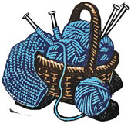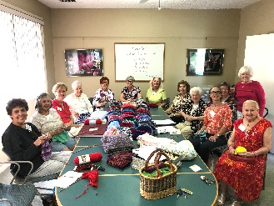

Shawl Ministry

Wednesdays, 1-2:00 pm

Join this very active and productive group in the Chapel Board Room as they create beautiful scarves, shawls, lap robes and baby clothes for those who are disadvantaged or in military service. They are very “close-knit”, enjoying each other’s company as they work, so come for the camaraderie as they labor in love to fill a need. If you are new, please contact Pat Gangloff at patgknitting@gmail.com to tell her you will attend.

Library News

The library at the Chapel is available to the whole community
Open daily from 8am – 5pm

Choose a book or drop off books you would like to donate. Please place returned books in the plastic bin located in the front room of the library. Needed for Chapel Library: Table not to exceed either 42” round or 42" square. Chairs not necessary. Good condition only please. Contact Library Committee at 772 600-5605.

“…as for me and my house, we will serve the Lord.” Joshua 24:15

