CHAPEL HAPPENINGS
October 15, 2021

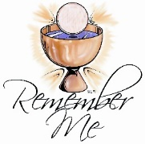
Communion Sunday
October 17th, 9:30 am

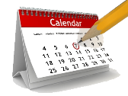

Our first annual fall cleanup – please bring gardening equipment
Saturday, October 16th, 9-10-30

Bob Kung Memorial service
Saturday, October 23rd, 11 am

Friendship Sunday
Sunday, October 31^{st,} 9:30 am

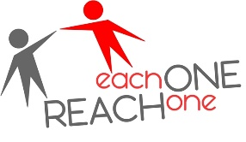

Please invite a friend or neighbor to join you in Chapel this Sunday to experience
God’s love or us all.

Blessing of the Pets
Monday, November 1st, 4 pm at the Chapel

Veterans Luncheon

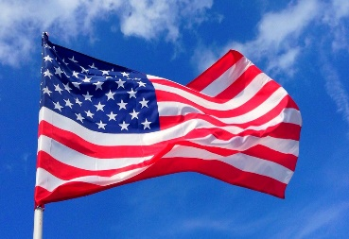

Thursday, November 11th, 11:30am at the Club
RSVP to the club

Learn to Paint from the Very Beginning!
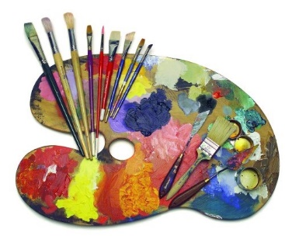

A 4-week class is being offered to teach beginners how to paint in acrylics as they are the most forgiving of all the mediums, though the principles we learn can be applied to oils, pastels or watercolors in future endeavors.

We will create a new painting every week based on the lesson presented in each class.
You will learn how to mix colors. The class is fun, thought-provoking, non- threatening and easy to follow.

Begins Thursday, November 4^{th,} 9:30 am – 12:30 pm
Total cost - $150 (cash or check please) including all your supplies.

The money will be collected at the end of the first class…if you find after the first class that it’s not for you, pay only for the one class.

This class will be taught by Brenda Leigh, a local public artist and muralist, fine art painter, mosaic artist and teacher. She has been a self-supporting artist all her life and is the author of most of the murals and public art pieces you see in Martin County. Her most beloved pieces are the Tree Mosaic in Memorial Park, the Band Shell in the same park, the Mermaid Mosaic at Stuart Beach and the murals in the Cummings Library in Palm City.

SPACE IS LIMITED SO SIGN UP NOW BY CONTACTING SANDY SLOWIK AT Secretsandy1@gmail.com

