CHAPEL HAPPENINGS

September 29, 2021

Friendship Sunday

October 31st, 9:30 am

Invite a friend, neighbor, golf or bridge buddy to attend chapel with you for worship and fellowship.
All are welcome! Social coffee hour after…

Ladies Bible Study
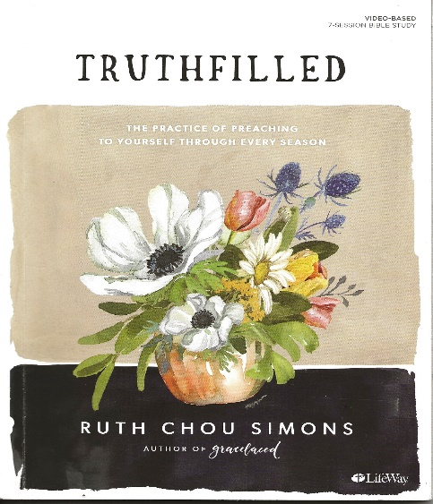

Starts November 1st, 9 am at the Chapel
Classes will be offered in person at the Chapel with Karen Carr and also via zoom with Tanya Condello hosting. Both starting at 9a. All ladies are welcome as we study the book of Colossians.

Please order the study guide online.

Blessing of the Pets (with treats)
Monday, November 1st, 4 pm at the Chapel

Learn to Paint from the Very Beginning!

Challenge yourself!! A 4-week beginners’ class starts Thursday, November 4th, 9:30 am – 12:30 pm, upstairs at the Chapel. Total cost - $150 (cash or check please) including all your supplies. This class will be taught by Brenda Leigh, a local artist. Space is limited so please contact Sandy Slowik at Secretsandy1@gmail.com!

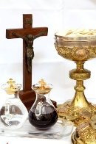

Catholic Mass begins

Saturday, November 6th, 5 pm

