CHAPEL HAPPENINGS
November 12, 2021

Catholic Mass – Saturdays – 5 pm
Sunday Worship – 9:30 am

Special Music

Sunday, November 14th, 9:30 am

Erika Vasallo and Mary Kruger – opera singers, will be guest singers during our worship service. Come join us for this special musical presentation.

WHITE DOVE TREE IN CHAPEL

Choose a Dove
Sundays, 9-11 am and Fridays, 1-4 pm

The Doves are numbered. The Dove’s number, your name and your contact information must be recorded by the committee before taking. Help make a child’s Christmas extra-special this year. If you don’t care to shop, please consider making a donation to Mariner Sands Chapel and write “White Dove” in the memo line and one of our elves will shop for you. The check may be dropped off at the Chapel drop box by the Library door, or left in the Sunday collection plate. Questions?
Contact Michele Ames, 201-602-7657, micheleames@icloud.com or
Sandy Lappen, 860-680-3301, smlappen@gmail.com
Thank you.

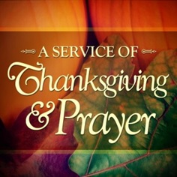

Thursday, November 25th, 9:30-10 am at the Chapel

Calendar Reminders

Mondays –Women’s Bible Study
9 am in the South Chapel with Karen Carr
9 am on Zoom with Tanya Condello

Tuesdays – Men’s Bible Study
11 am in the Board Room

Wednesdays – Shawl Ministry
1 pm in the Board Room

Hand Bell Rehearsals
3 pm in the Sanctuary

Choir Rehearsals
4:30 pm in the upstairs choir Room

Fun Fridays
10 am-12 noon in the Board Room
A fun place for seniors, a break for caretakers

Faith and Promise Sunday
November 14, 9:30 am

