Grace Fellowship Snow Blowing Instructions
Update 11/1/2021
Thank You for your willingness to help keep the snow off the walks around the church! It is greatly appreciated.
To get into the church garage contact the church office for the key code.
We have 2 snow blowers. A new Ariens and a Toro (both are 4 cycle with electric start).
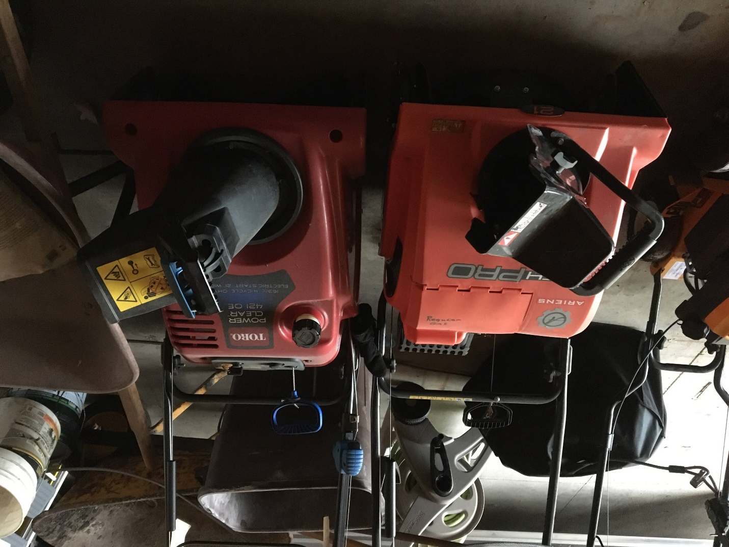In the fall of 2017, we had to start locking our mowers and blowers with a padlock and cable running thru the handle bars so you will have to unlock the cable to get access to the snow blowers. The key is located around and behind the left side of the large garage door (as you walk into the garage) at about head height. PLEASE replace the key when you are finished.
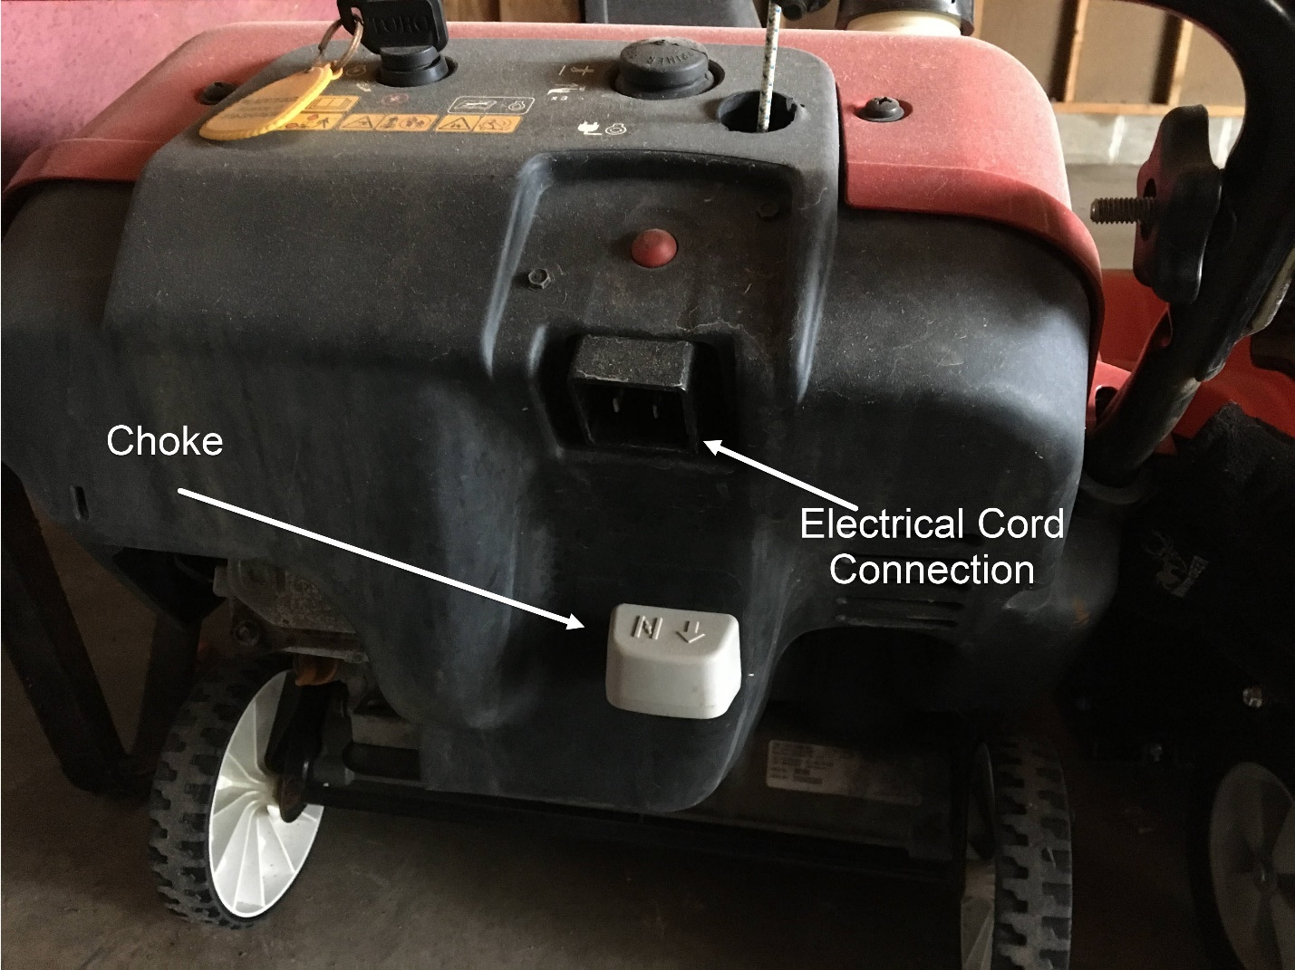To start the Toro, turn the key switch on and pull out the choke, which is a big gray lever that sticks out towards you on the bottom back of the unit. Pull it out (Towards You) press the primer a couple or three times and pull the rope. This unit is also an electric start so if you have problems plug it in and use the electric start. (It’s a lot easier!)

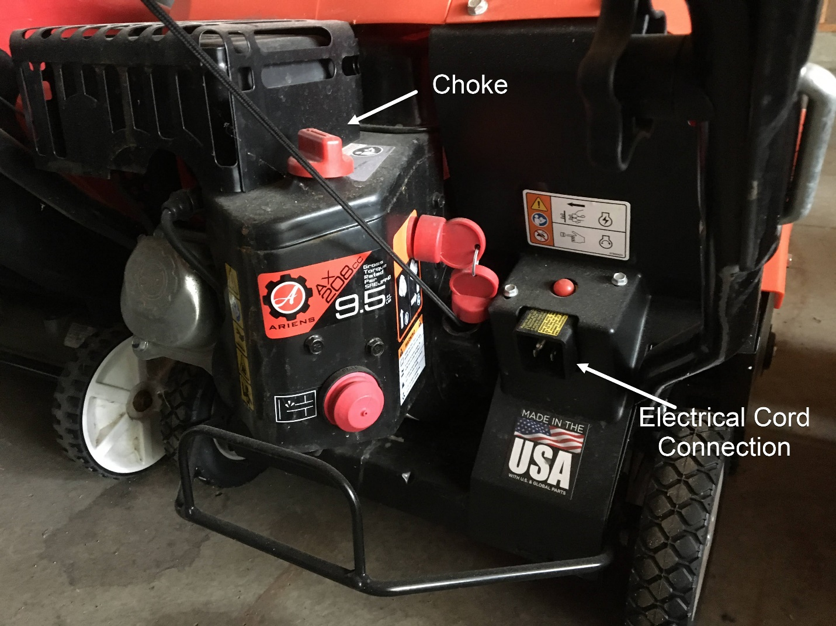The Ariens starts much the same way. The knob on top is the choke. Turn it all the way on, prime it 3 or 4 times, turn the key on and pull or press the electric start (once you have plugged it into electricity!)
Gas (unleaded only, NOT unleaded with ethanol) is in marked containers by the snow blower. IF you need gas either let the church office know and someone will get it for you in the next day or so OR get it yourself and submit the bill to the church office and you will be reimbursed. Do NOT use unleaded with ethanol.
You are responsible to clear just the sidewalks around the church building. We don’t do the walks across Williston or Minnesota. The parking is done by others.
Area Details: We are responsible for...
1.The sidewalks along the alley side of the church. It is also helpful if you can clear about 1 pass IN FRONT of the sidewalks also if the plows have not come through because they cannot get that close.
2.The sidewalks and entry door area on the Minnesota side.
3. The sidewalk that run along Minnesota on the OTHER side of the street once the new parking lot is done and the tire barriers are set. (Just along Minnesota, not across the street along Williston.
3.The sidewalk and both entries areas (Main door and office) on the Williston side in front of the church and parsonage. (We do the parsonage if no one is living there.
4.The path from the parsonage to the church on the west side.
The main concern is to have the walks cleared before any church activities. Normally that would be Wednesday nights and Sunday Morning. If it snows between those times it is not as critical that you get over there and clean up right away. The staff will normally clean the walk from the office door out to Williston and the back door. Others may see that the walks are not done and do it for you so if you are coming in you might want to call the office to make sure someone hasn’t already did it!
If it is slippery sprinkle salt on the walks at the 3 door ways into the church, especially on Sunday mornings. There are shovels and salt inside each door. There are shovels in the garage to clean up the steps and entry if the church is closed.
If you have any problems with gas, the blowers or anything please let the church office know so we can get it taken care of.

