THIS IS NOT OUR HOME

OUR PERMANENT SOJOURN

November 28, 2021 – Advent 1

Given by Craig Minke

Our theme for this Advent week is hope is the final word. In Luke 21, Jesus prophesies about the horrible destruction of the temple in A.D. 70, and how the hope of the Son of Man will triumph even then.

LK 21:25-36 ²⁵ “And there will be signs in sun and moon and stars, and on the earth distress of nations in perplexity because of the roaring of the sea and the waves,
²⁶ people fainting with fear and with foreboding of what is coming on the world. For the powers of the heavens will be shaken.
²⁷ And then they will see the Son of Man coming in a cloud with power and great glory.
²⁸ Now when these things begin to take place, straighten up and raise your heads, because your redemption is drawing near.” (ESV)
²⁹ And he told them a parable: “Look at the fig tree, and all the trees.
³⁰ As soon as they come out in leaf, you see for yourselves and know that the summer is already near.
³¹ So also, when you see these things taking place, you know that the kingdom of God is near.
³² Truly, I say to you, this generation will not pass away until all has taken place.
³³ Heaven and earth will pass away, but my words will not pass away.
³⁴ “But watch yourselves lest your hearts be weighed down with dissipation and drunkenness and cares of this life, and that day come upon you suddenly like a trap.
³⁵ For it will come upon all who dwell on the face of the whole earth.
³⁶ But stay awake at all times, praying that you may have strength to escape all these things that are going to take place, and to stand before the Son of Man.”
- One of the cinematic methods used to show a great war is through flashes of violent scenes shown in quick succession.
- The destruction of Jerusalem in A.D. 70 could be shown by such flashes from a writer of the time:
- For example: (Quotes from Josephus a historian of the time)
  - “and made the whole city run down with blood, to such a degree indeed that the fire of many of the houses was quenched with these men’s blood.”
  - “Round the Altar the heaps of corpses grew higher and higher.”
  - “Crowded together around the entrances many were trampled by their friends, many fell among the still hot and smoking ruins.”
  - They slew those whom they overtook, without mercy.”
- These brutal images – and these are some of the less brutal ones – paint a picture of a merciless scene.
- Rome, the biggest superpower in the world, brings their full force to bear on one religious minority.
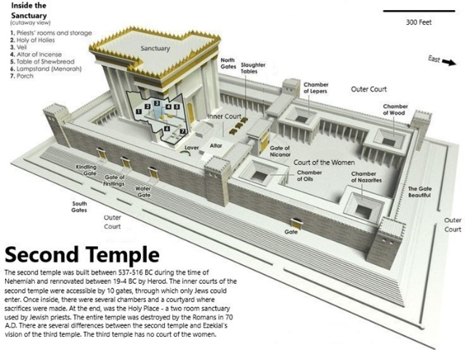
- The temple that Herod renovated, often called the Second Temple, was a wonder of the ancient world.
- It was over 470,000 square feet and over a hundred feet high.
- It was the central nerve of Jewish religious life and contained the Holy of Holies – God’s connection point with earth.
- It was built around 520 BC and by the time of the temples destruction, it had stood for about 500 years, and for most people it was considered as solid and eternal as the sun itself.
Jesus’ words, spoken a few decades before all this happen, describe this day of devastation:
LK 21:25-28 ²⁵ “And there will be signs in sun and moon and stars, and on the earth distress of nations in perplexity because of the roaring of the sea and the waves,
²⁶ people fainting with fear and with foreboding of what is coming on the world. For the powers of the heavens will be shaken.
²⁷ And then they will see the Son of Man coming in a cloud with power and great glory.
²⁸ Now when these things begin to take place, straighten up and raise your heads, because your redemption is drawing near.” (ESV)
- These words are often mistaken as referring to the Second Coming itself, but more likely they are referring to the destruction of the temple – this brutal battle that followed the death and resurrection of Jesus by less than a generation.
THE DESTRUCTION OF HE TEMPLE AND JUDAH IN 70 AD.
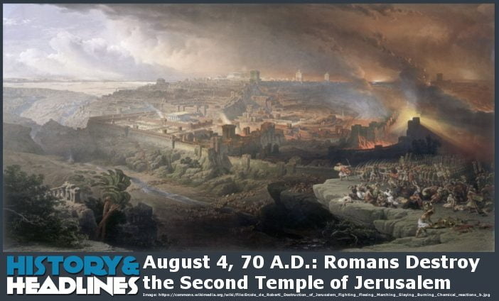
- There is scarcely another period in history so full of vice, corruption, and disaster as the six years between the Neronian persecution and the destruction of Jerusalem.
- Vespasian had left his son Titus to lay siege to Jerusalem
- On the ninth day of the fifth month (August 5), the anniversary of the destruction of the first temple by the Babylonians, the sanctuary was set on fire by the invaders
- A month later the whole city was in Titus’s hands
- Some strongholds held out longer. The last to fall was Masada (possibly as late as 74), where the defenders chose suicide to surrender (Josephus, War 7.8.1–7 [252–388]).
- In April, a.d. 70, immediately after the Passover, when Jerusalem was filled with strangers, the siege began.
- Even the famine which began to rage and sweep away thousands daily, and forced a woman to roast her own child, the cries of mothers and babes, the most pitiable scenes of misery around them, could not move the crazy fanatics
- Josephus, said people were murdered for their wealth. The madness of the rebels grew with the famine, and both terrors blazed forth the more day by day. Food was nowhere visible, but rushing into houses they searched them. Then, if they found any, they tortured the owners for having denied that they had it, and if they did not find any they tormented them on the ground that they had concealed it too carefully.
- Historians reckon that over 1 million 1,100,000 perished by famine and the sword, and that the other rioters and robbers after the capture of the city were pointed out by one another and slain.
- Many over 17 years of age were sent as prisoners to labor in Egypt,³ but more were scattered throughout the provinces to perish in the theatres by the sword and by wild beasts.
- Those under seventeen years were lead away to be sold into slavery, and of these alone the number was reckoned to be about 90,000 men.
- Jerusalem and the temple were destroyed, by the besieging armies
Let’s look at this today and see how we can learn from these ancient – and fulfilled – prophecies.
- But we need to start with the right question, and not reactively pillage this passage for what it might mean to us and leave behind what we don’t understand.
- The first thing we need to ask about this passage should always be our first question:
- 1) What does this tell us about Jesus?
- Then, and only then, can we move on to…
- 2) What does this tell us about the people of God?
- 3) What does this tell us about ourselves?

1st Question to ask as we study this passage is
1) WHAT DOES THIS TELL US ABOUT JESUS?
- This should always be our first question when we approach Scripture – not how this applies to us but how it applies to God.
- What does it teach us about who Jesus is and after that, how do we apply ourselves to that reality?
- This might be a disorienting reading for the beginning of Advent – the incredibly violent destruction of an ancient artifact.
- But let’s hold off judgment for a moment and see how it is entirely appropriate to start our first Advent theme of: HOPE.

LK 21:25 ²⁵ “And there will be signs in sun and moon and stars, and on the earth distress of nations in perplexity because of the roaring of the sea and the waves, (ESV)
- Jesus starts here with a striking image, using a special kind of speech/writing that appears in several places in the Bible and was in wide use at the time – the apocalyptic.
- The sun, the moon, stars and sea – all of these will be shaken out of place.
- These are metaphors for political and religious structures that seemed to be as sure and predictable as the planets themselves falling apart and deconstructing.
- These vivid metaphors were meant to express more about something FELT than describe what exactly happened, and that’s what apocalyptic language is.
  - Think about it this way – have you ever had your heart broken?
  - Maybe it was when we met the love of out life so we thought but things didn’t work out.
  - Our heart may have been broken by the loss of a spouse, a loved one, a child.
  - Our world seemed to shut down or collapse.
  - Did the chambers of your heart shatter and the arteries collapse?
  - Nope, but it felt like it.

Depending on your age, think about when…
- Here you can add in a national event for your area that was widely felt.
- For this writer, an American, it would be something like:
  - the assassination of President Kennedy, or
  - when the Challenger spaceship exploded, or
  - the morning of 911.

The world ended, didn’t it? And yet it didn’t.
- That’s what Jesus describes here, perhaps with a tear in his eye, as the old way of relating to God ended and a new way took its place.
- The language in Revelation describes the literal, physical Second Coming and enthronement of Christ on earth, no question.
- But a lot of the language used is meant to express feeling more than specific events.
- The events themselves will be the end of the world as we know it, but mapping them out in some kind of detailed timeline is to miss the point of this kind of writing.
- Jesus described what was coming shortly, and goes on later in the passage to say that “…this generation will not pass away” until this has happened (verse 31).

LK 21:32 …this generation will not pass away until all has taken place.

There’s a wrong-headed argument against faith that says Jesus predicted that generation wouldn’t pass before the Second Coming.
- Therefore, the logic runs, Jesus was incorrect in his prediction and therefore fallible and not who he said he was.
- There are some belabored Christian answers to this critique.
- But Jesus WAS NOT talking about the Second Coming—he was talking about the completion of the coronation of Jesus as King.
- The temple was destroyed, and Jesus then took over as the connection between God and humanity.

LK 21:27 ²⁷ And then they will see the Son of Man coming in a cloud with power and great glory. (ESV)
- The old has passed away, the new has come.
- Here Jesus makes a reference to where one of the names for God came from, Daniel 7:

DAN 7:13 ¹³ “I saw in the night visions, and behold, with the clouds of heaven there came one like a son of man, and he came to the Ancient of Days and was presented before him.(ESV)
- Daniel uses that same apocalyptic language to describe the ascension of this strange character, the Son of Man, to sit at the right hand of God.
- This describes Jesus coming into the kingly place as the temple, the symbol, falls away, and the Reality the symbol was pointing to steps into place.
- TODAY we live in a time when everyone claims their “OWN TRUTH” and many don’t believe that there’s one coherent truth about the universe.
- How do we in this time life up Jesus as KING over all in a way that’s loving and graceful?

So back to the question again, WHAT DOES THEIS PASSAGE TELL US ABOUT JESUS?
- This strange imagery drives home one of the major themes of Jesus’ life: the kingdom of God has come, and he is the king.
- His ascension is not just a theological construct or some religious artifact – he is king of Jews, of the Christians, of the world.

The second question we are asking about this passage is

2) WHAT DOES THIS PASSAGE TELL US ABOUT THE PEOPLE OF GOD?
- Jesus was talking about his coming to take over as king of God’s kingdom.
- But the lingering question stands out: What does the destruction of the temple have to do with us today, right now?
- Again, we have to step back to look at the whole story of the people of God.

As modern Protestants, we misunderstand our history as God’s people regularly.
- We have a tendency to think that God gave the Law, the Israelites couldn’t keep it, and then Jesus had to clean up the mess.
- From before Eve reached out for the fruit on the tree, God had written the plan for humanity.
- He chose from among fallen humanity one person, then one family, then one nation.
- Then from that nation, one lineage, and from that one family, the womb of a faithful teenage girl.
- All the practice of Judaism through all those centuries was part of the process of God coming to us in Jesus.
- It’s one long continuous story that culminates in Jesus. Nothing was wasted.
  - The symbol of the temple,
  - like the wedding plans a girl might keep before she gets married, or
  - the bike a boy rides before he drives a car,
  - gives way when the Reality comes.
- But this doesn’t mean for a moment that the symbols weren’t important, just that they are, as Jesus said, “fulfilled” in him (Matthew 5:17).

LK 21:21 ²¹ Then let those who are in Judea flee to the mountains, and let those who are inside the city depart, and let not those who are out in the country enter it, (ESV)
- In making what looks like a passing comment here, Jesus expresses the new reality of how the people of God will relate to him.
- He tells God’s people – God’s chosen people – to run away from Jerusalem.
- He’s pointing to the fact that now the people of God will worship him in spirit and in truth, not in a building.
- The presence of God now dwells with the people of God in fellowship with each other, not in a room shrouded by a curtain, as it was in the Holy of Holies.D
- The destruction was so great in 70 AD that many fled for their lives.

LK 21:25 ²⁵ “And there will be signs in sun and moon and stars…(ESV)
- This is not an uncommon image in apocalyptic language.
- The sun and the moon – the predictable dividers of day and night, the mainstays of the universe – will be disrupted.
- The very gravity of the universe shifted and our coordinates will never be the same – our points of reference are all gone.
- Jesus tells them that something new is happening, and the Lord of Jerusalem is restored as the Lord of the Universe.
- The story of the people of God goes from shadows and promises into full relationship.

The 3rd question we ask as we study these scriptures is:
3. WHAT DOES THIS TELL US ABOUT OURSELVES?
- Only after we’ve applied this passage to God and to the greater story of the redemption can we bring it home to our own lives.
- The “living and active” word of God speaks to us continually, as we’ve seen in the story of redemption from Eden to Israel to today.
- What does this apocalypse (which comes from the Greek word for “uncover” and “reveal”) uncover about us?

One of the most important points, as we’ve already discussed, is our connection to the people of God.
- We are brothers and sisters with all those before, even before Jesus, and are part of God’s plan for the universe.
- Another theme in this short passage is to keep watch:

LK 21:34 ³⁴ “But watch yourselves lest your hearts be weighed down with dissipation and drunkenness and cares of this life, and that day come upon you suddenly like a trap. (ESV)
Jesus tells us about being aware, and to be ready, and to realize the fragility of what we think is forever.
- Jesus was prompted to this discussion by someone pointing out how beautiful the temple is.
- As we said, it was a wonder of the ancient world (not one of the Seven Wonders, but still famous).
- The temple was as sure as the sun and the moon, and then it was gone.
- We can feel very comfortable and secure living in Vancouver Canada
  - But the heat dome in June 2021 showed how fragile the area is
  - The fires of 2020, and 2021 show us that also
  - Just 2 weeks ago we saw the fragility of our world through the dumping of rain by the atmospheric river.
  - Our world is not that stable

- If you’ve ever seen something you thought was for sure suddenly fall apart, you know it’s a special kind of trauma.
  - Many of us watched the World Trade Center – an icon of financial triumph – fall to the ground in a cloud of dust and fire.
  - We’ve watched relationships and marriages crumble
  - We’ve seen stable organizations fall apart
  - We’ve seen the whole world grind to a halt when the Covid-19 virus came in 2020.
  - We seen countries that were solid financially then watch as debt cause their economies spiral out of control
  - These institutions aren’t wrong within themselves – they are the way the world runs – but a problem arises when we take them for granted, to trust them more than we trust God.

We are admonished to KEEP WATCH, know that nothing is forever in the world because this world, as it is, is not our permanent home.
- This gives us a certain freedom – we don’t have to be beholden to trends and fads because we know where our identity lies.
- We don’t have to be fixated with the next promotion or the measly bit of spotlight we can catch, because we know that our worth comes from far beyond these things.
- We are all but seconds, minutes, hours or days of being no more, we live in a world of illnesses, cancer, strokes, diabetes, COVID, heart attacks etc.
- The end of he world could come for us today, if e get in a car accident
- This sense of fragility gives us freedom as well as responsibility.

Jesus calls us to keep watch, to not be inebriated by the pleasures and entertainment of the world, but to hold the world with an open hand, knowing it’s not permanent.
- DON’T GET DISTRACTED BY THE FOCUS AND PRIDE OF THIS WORLD.
- AVOID NUMBING ourselves with shopping and diversion, THE PURSUIT OF MATERIAL PLEASURES.
- Don’t be ENTRAILED BY THE BRIGHT LIGHTS AND TEMPORARY PLEASURES OF THE WORLD AND WHAT IT OFFERS
- we keep watch to know that God is on the move and we want to be where he is.
- In Europe, USA and Canada Christianity is on the decline, many have fallen asleep and become intoxicated by the fleeting pleasures the world has to offer.
- This world and all the bright lights will soon come a grinding halt, which side of the fence are we going to be on.
- The HEAT DOME, THE ATMOSPHERIC RIVERSAND THE FIRES OF 2021 SHOW the fragility of our world.
- It is easy to BLAME GLOBAL WARMING FOR WHAT IS HAPPENING, or could it be GOD IS ON THE MOVE AND CHANGES ARE COMING, THAT MANKIND HAS NO CONTROL OVER.
- Will we be FAITHFUL, WATCHING, WAITING HOPING for the soon return of Jesus Christ.
- Or will we be UNFAITHFUL, SLEEPING, AND SWALLOWED UP BY THE CARES OF THIS WORLD.
- It all comes down to a CHOICE – WE ARE ENCOURAGED TO CHOOSE LIFE.

So what do these passages tell us about Jesus?
- Jesus is the king who came to power after old ways fell away. The symbol was obsolete when the Reality it signified arrived.

What does this passage tell us about the people of God?
- This first coming of Jesus started a new era of God relating to humanity.
- Rather than in a temple, we worship in spirit and truth.
  - I guess the question to ask ourselves are we worshipping drawing closer to God in Spirit and truth?
  - Is the Holy Spirit changing the person were before God called us
- Rather than being confined to a particular people group, the body of Christ stretches across the world.

What does this passage tell us about ourselves?
- This cataclysmic event tells us that all our institutions—even the religious ones—aren’t permanent.
- The world around us may look solid but this is not our home, we are travellers, sojourners on our way to a new hope COMING SOON.
- The fragility of this world is absolute, and we look forward to an eternal kingdom.

TODAY we live in a time when theologians say:
- God’s kingdom is “already, but not yet.”
- Jesus brought in the kingdom, but it’s not here all the way, and won’t be until the second coming.
- What does it mean to live in this kind of tension?
- How do we live in the kingdom and wait for it at the same time?
- THAT IS OUR HOPE AS BELIEVERS AND FOLLOWERS OF CHRIST.
- As my title said we are all sojourners here on the earth,
- This is NOT OUR HOME, our FINAL RESTING PLACE.
- We WAIT, and HOPE for Christ’s return when all things our hope will be fully here and Christ’s kingdom will be fully ESTABLISHED.

QUOTE: Alexandre Dumas summed it up on this quote

“All human wisdom is summed up in two words:
wait and hope.”

CLOSING PRAYER

Eusebius of Caesarea. (1953). Ecclesiastical History, Books 1–5. (R. J. Deferrari, Ed. & Trans.) (Vol. 19, pp. 152–153). Washington, DC: The Catholic University of America Press.

