CHAPEL HAPPENINGS
December 3, 2021

The Season of Advent is here…
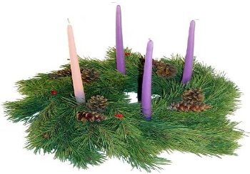

Special Piano Concert
Joseph Kingma Performing

Thursday, December 9th
7 pm at the Chapel - no charge

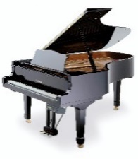

Mr. Kingma enjoys a prolific national and international career as a soloist, chamber musician, and teacher. Learn more about him at www.josephkingma.com His You Tube channel is www.youtube.com/c/josephkingma. He will perform works by J.S. Bach, Johannes Brahms and Frederic Chopin.

Hobe Sound Bible College Choir
At the Chapel

Sunday, December 12th 9:30 am

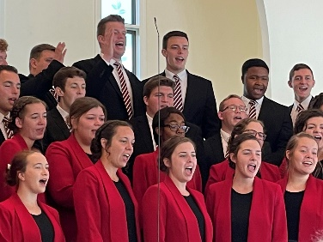
Christmas Eve Service
5 pm

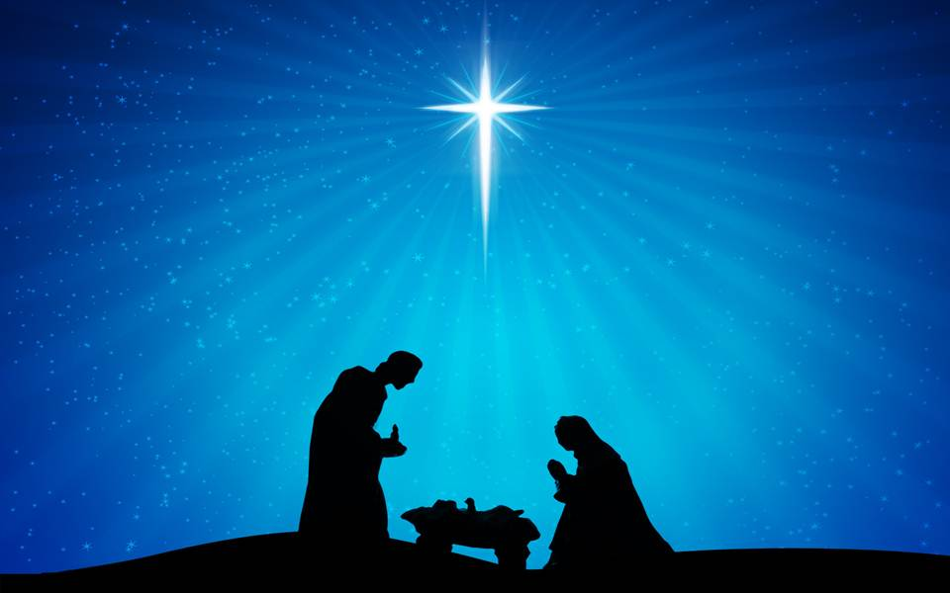

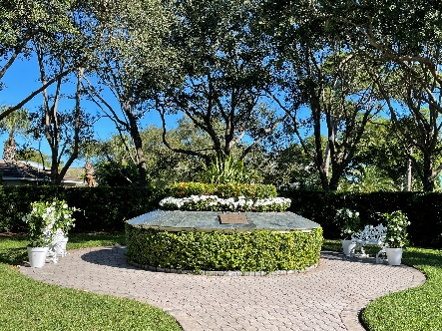

Memorial Services

Before making arrangements with any funeral home, we recommend you call the Chapel office for details on burial in the Memorial Garden. Martin Funeral and Crematorium of Stuart, FL has our contract for all internments in the garden.

