CHAPEL HAPPENINGS
November 26, 2021

Special Piano Concert
Thursday, December 9th
7 pm at the Chapel

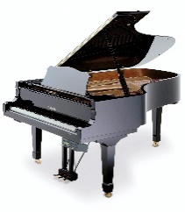
Joseph Kingma Performing

Mr. Kingman enjoys a prolific national and international career as a soloist, chamber musician, and teacher. Learn more about him at www.josephkingma.com His You Tube channel is www.youtube.com/c/josephkingma. He will perform works by J.S. Bach, Johannes Brahms and Frederic Chopin.

Hobe Sound Bible College Living Christmas Tree Concert
Friday, December 3rd, 7pm.

HSBC is sending a coach to pick up those who would like a ride. There are 54 seats available and it will leave promptly at 5:45. Please sign up for coach transportation in the Library.

KinDoo Christmas Craft Fair
December 3 & 4, 10 am-3pm

All handmade gifts!
(Flyer on bulletin board opposite library entrance.)

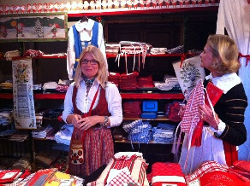

Kin Doo Family Center, 14557 SW 174th Ct., Indiantown, FL

A message from our Chapel President…

(Insert Sandy’s letter here)

