CHAPEL HAPPENINGS
December 10, 2021
3rd Sunday in Advent

Hobe Sound Bible College Choir

At the Chapel

Sunday, December 12th 9:30 am

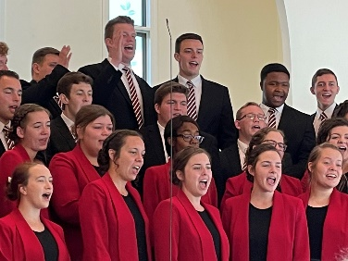

Community Christmas Eve Candlelight Service
5 pm at the Chapel

Join us December 24th for an ecumenical service of traditional lessons and songs of the season, featuring special music with guest soloists and instrumentalists.

A message from our Chaplain…

A member of our congregation shared a brief note with me this week about the importance of coming together for worship. He included in his note an excerpt from a devotional booklet, "Our Daily Bread" (December 1, 20201). The scripture reading was from Hebrews 10:25.

" Let us not give up meeting together as some are in the habit of doing, but encourage one another."
Writer John Blase grew up as the first born son of a Baptist preacher. He says, "Every Sunday, the expectation was clear: I was to be in church. Possible exceptions? Maybe if I had a significant fever. But the truth is, I absolutely loved going, and I even went a few times feverish. But the world has changed, and the significant numbers for regular church attendance are not what they used to be." Here I would add that in my own denomination the face-to-face Sunday attendance dropped 41percent in the past year. Online attendance went up significantly, and that may be due to the COVID virus. But I think it is more than that. Let's consider this question, "why do people go to church?"

Author Kathleen Norris posed this question to a pastor who responded, "We go to church for other people. Because someone may need you there." My own response would include to worship God as a group of those called out to live for Jesus. But here is the point. Going to church for other people is a practical insight to what the biblical writer meant. Hebrews tells us to persevere in the faith and not give up meeting together. Something significant is missed when we are not there. So to apply what Hebrews says, let's encourage one another to do it. Your presence at our worship services means a lot to God, it means so much for others to see you there, and it means a lot to you. In the same way, being there with others to worship God underlines an important truth; you may need them as well."

If you would like the current issue of the daily devotional mentioned here, please stop by the chapel and pick up a copy in our lobby.

Sincerely,
Gary

