CHAPEL HAPPENINGS
January 14, 2022

Sunday Worship Services
Due to rising Covid cases, all sliding doors will remain open during all services, the sanctuary will be reconfigured to allow for two aisles for easy uncongested entry and exit and masks are encouraged. We ask if you are not feeling well (even slight symptoms), you remain home and join us via our live-streaming.

Annual Meeting this Sunday

Sunday, January 16th, 9:30 am
You will receive a packet of reports by email prior to the meeting.

Benevolence Sunday,
January 23rd, 9:30 am

We hope you will join us Sunday, January 23rd for Benevolence Sunday. Out front at the Chapel that morning, there will be a basket tied with yellow ribbon to collect donations for our 2022 community outreach. If you wish to write a check, it should be issued to “Mariner Sands Chapel” with a notation of Chapel Benevolence made on the lower left. Our benevolence giving is concentrated in Martin County, so please consider helping your neighbors. We rely on and thank you for your support!

Special Music Performance
Thursday, January 27th, 7 pm

The Contrast Duo is a renowned and critically-acclaimed ensemble based in the United States with a growing international concert career spanning four continents. They recently won 1st prizes at Liszt-Garrison International Music Competition, the Lyric Chamber Music Competition, John Oliveira String Competition, became finalist at the Carnegie Hall Fellowship, and have received grants from private donors in South Florida and the National Society of Arts and Letters. Their growing artistic pursuits have yielded to performance art collaborations with various artists and musicians.

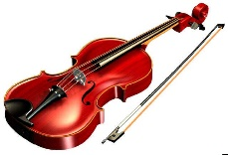
Yasa Poletaeva described by “Manhattan International Artists” as a violinist who’s “performances reflect a great musicality, depth of interpretation, and technical expertise needed to distinguish oneself in the world of professional performance.” She is also a published author and is one of the most sought-after poets in Russia. Ms. Poletaeva also happens to be the grand prize winner of the Miss Saint Petersburg beauty pageant.

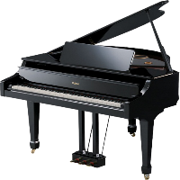

Darren Matias' Charlotte Symphony debut was described to be the “most thrilling and breathtaking concert of the season.” His artistic range has yielded to orchestral engagements and solo recitals throughout the world. He appeared in a Mr. Liberace project at the Kravis Center, and was the Grand Prize Winner of the controversial Ultimate Pianist Competition.
The Contrast Duo is about exploring the depth of humanity and spirituality through music. Their ongoing projects have been supported by individuals with the intent to innovate recital experiences and music education.

Art classes to resume…

Acrylic art classes have been rescheduled to start on March 3. This 4 week session will be on Thursdays from 9:30-12:30 in the upper room of the Chapel. The cost is $100 and participants are responsible for their own supplies. Please contact Sandy Slowik at Secretsandy1@gmail.com to reserve your spot.

Bell Ringers Needed

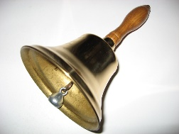

Join this fun group which provides music to enhance our worship. They practice 3:30 pm every Thursday. If you have a basic understanding of reading music notes, we will teach you the rest. We want you!

MARINER SANDS COMMUNITY LIBRARY
OPEN HOUSE SUNDAY, JANUARY 23rd
10:30 am – 12:30 pm

Come and see our new look and hear about the Mariner Sands Community Library

Our shelves are stocked with a wide range of subjects including current best-sellers,
past favorites, mysteries and thrillers, biographies and autobiographies, sports, history, and more

We are located in the Chapel Building to the left of the main entrance

SPEAKER SERIES EVENT
Tuesday, February 1st, 7PM

At the chapel, Hosted by Chaplain Gary Carr

JUDY ALVEREZ
Former ladies golf pro at MSCC

PGA/PGA MASTER GOLF PROFESSIONAL
PGA HOPE – National Lead Trainer
PGA National Patriot Award Recipient 2019
Author and recipient of over 20 awards
Mariner Sands Assistant Golf Professional ’12 – ‘17

PGA HOPE is a Military engagement program which introduces Veterans with disabilities to golf to enhance their lives. PGA National Patriot Award honors the true heroes of America who have proven to exemplify tremendous pride for their country

There will be indoor, outdoor and golf cart seating available.

