CHAPEL HAPPENINGS
January 28, 2022

Mariner Sands Community Library
Featured Resident Author for February!

DEBRA SWIRE

Monday, February 7th at 1:30p.m.
Outside in front of the Chapel, weather permitting

In-person talk on…

Her Books:

Caroline in Rhyme
Grandma’s Cookies: Sweets for My Sweeties

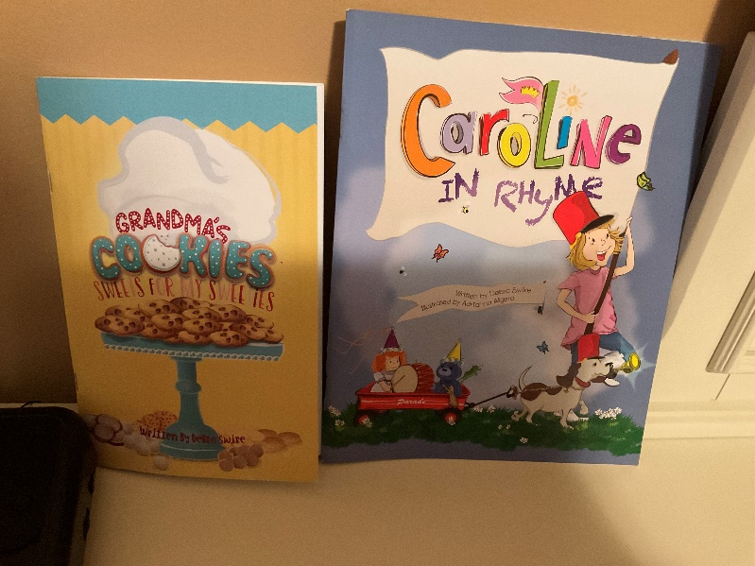

Space Is Limited - Sign Up on clipboard in library, or with Suzanne Mason at suzannehmason@gmail.com

- Chapel grounds cleanup has been RESCHEDULED TO:
Feb 5th 9:00-10:30 at 9-1030 am

- Speaker Series with Judy Alvarez Tuesday, 2/01, 7 pm

- Acrylic art classes to restart Thursday, 3/03, 9:30 am

Link to the Recording of the Chapel Annual Meeting

If you missed the in-person annual meeting, following is the YouTube link to connect you to the recording of that meeting. https://youtu.be/CyCcVZAR9sw It may not work on your phone so use your computer to access it. The link is on YouTube and it is unlisted, therefore not searchable, yet anyone can view it and forward to another viewer.

