CHAPEL HAPPENINGS
February 4, 2022

Sunday, February 6th, 9:30 am

Mariner Sands Community Library
Featured Resident Author for February!

Come support our own
DEBRA SWIRE

Monday, February 7th at 1:30p.m.
Outside in front of the Chapel, weather permitting

In-person talk on…
Her Books:

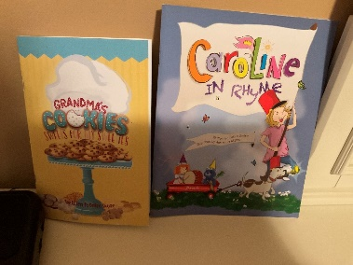

Caroline in Rhyme
Grandma’s Cookies: Sweets for My Sweeties

Sign Up on clipboard in library, or with Suzanne Mason at suzannehmason@gmail.com
SPECIAL CONCERT!

February 17, 700 pm
At the Chapel

From Spirituals to Jazz Fusion: A Journey through Black American Music

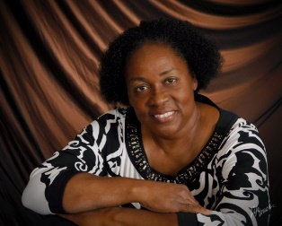

Join Hazel Thorpe Graham and Ignatius Perry, Jr for a Black History Month musical experience that follows the evolution of Negro Spirituals to Blues, Gospel, RnB and Jazz. Our evening together will culminate with Ignatius Perry and the iPerry Project giving an exciting glimpse into the future of Black Improvisational Music--Jazz Fusion.
Hazel Graham began her Music Studies in her native country of Trinidad and Tobago. Her extensive career in Vocal Performance, Instruction and Choral Directing has played itself out in the Caribbean, Ghana, Canada, and in the United States of America.
Mrs. Graham currently serves as Minister of Music at the Episcopal Church of the Nativity, and Faith Congregational Church in Port St Lucie, Florida. She is the founder and director of VOICES Community Chorus located in Port St Lucie, Florida.
An educator at heart, Mrs. Graham also enjoys providing instructional and clinician services for school music programs and students here in South Florida.

Ignatius Perry, Jr is an internationally acclaimed keyboardist, award-winning composer, and music theory clinician. Along with his dynamic band, the iPerry Project, he composes and performs a unique style of music they dub, “World Fusion”. On top of electrifying music, you can expect creative storytelling, active audience participatory moments, and visible enthusiasm for music in any presentation from Ignatius. He consistently sends audiences home engaged and inspired to find and work on their respective passions.

- Chapel grounds cleanup this Saturday, 2/05 at 9-1030 am

- Acrylic art classes to restart Thursday, 3/03, 9:30 am
To sign up contact Sandy Slowik at secretsandy1@gmail.com

