CHAPEL HAPPENINGS
February 11, 2022

Special Themed Dinner and Concerts!

Some very wonderful musical presentations are coming up. Reserve a table at the club for a 5:30 buffet dinner, invite some friends to join you, and then afterwards head to the concert at the Chapel. Please put these dates on your calendar now so you don’t miss out!

Thursday, February 17th, 7pm - Celebration of Black American Music from Spirituals to Blues, Gospel, R&B and Jazz Fusion with Hazel Thorpe and Ignatius Perry Jr. (Cajun buffet dinner theme at club.) Should be a foot-stompin’, hand-clappin’, soul searchin’ good time!

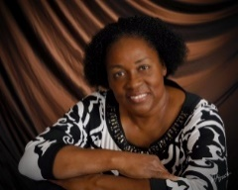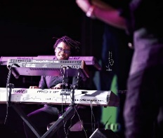

+++++++++++++++++++++++++++

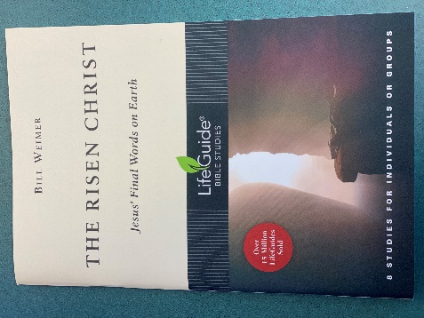

The Ladies ZOOM Bible class has begun a new study, The Risen Christ, by Rev. Bill Weimer, our former minister. This class meets every Monday at 9:00AM via Zoom. No prior Bible class experience or expertise needed. This is a time to study, share and pray together.
If interested, please contact: Tanya Condello. tvjjuk@yahoo.co.uk. 772-919-5638

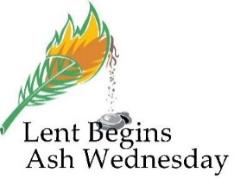

Join us at the Chapel for a noon soup lunch followed by an Ecumenical Ash Wednesday service March 2nd at 1:30 pm.

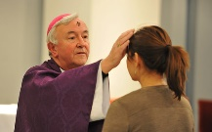

Soup will be served at noon every Wednesday during Lent followed by a short devotional. Empty your bowl and fill your soul…

Thursday, March 10th, 7:30 pm (note time change)
Smiling Strings Ensemble
of the Czech Republic.

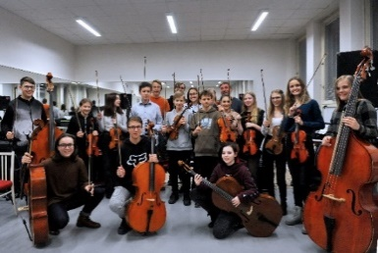

Hear a sample performance of their elegant sounds on YouTube by going to:
https://www.youtube.com/watch?v=Sb4--WQhbJo and
https://www.youtube.com/watch?v=2-owM6EB4eA

++++++++++++++++++++++++++++++

Coffee Hour Resumes March 6th
Bring some goodies, host the coffee table and meet some new friends.

Sunday Flower Donation

Honor your loved ones with a floral tribute.

Please find the sign-up sheets for the above opposite the restrooms in the hallway. Thanks for your participation.

