CHAPEL HAPPENINGS
February 25, 2022

Highlighting
This week’s Chapel Ministry

Tuesday Men’s Bible Fellowship
Every Tuesday at 8am the Chapel Board Room fills up with men who are interested in studying God's word, sharing life and faith based experiences, comparing today's culture with those in biblical times and collectively growing in spirit and understanding.
We select the texts we use, which vary from Old and New Testament books; to C.S. Lewis' "Mere Christianity"; to topical subjects like The Holy Spirit. Sessions are liberally spiced with biblical information and theological explanation from Dr. Carr who is an active and regular member. Many participants arrive with little Bible knowledge and people of all faiths (or none) are welcomed!

Ash Wednesday Ecumenical Service and soup 3/02 – soup @ noon, service at 1:30 pm

Acrylic Art Classes resume – 3/3, 9:30 am to 12:30 – contact Sandy Slowik at:
secretsandy1@gmail.com

Special Charity Week Concert – March 5th

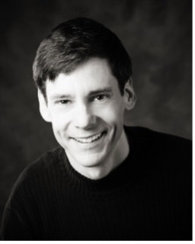

The Chapel and Charity Week have joined forces to present

Mark Sullivan

Bass/baritone for a dinner/concert evening
In the club dining room.

Cash Bar from 5:30, Dinner at 6:15 pm, Concert at 7:30 pm
$75 per person, $25 goes to benevolence. Reserve through the club at 283-0202

Looking Ahead

String Ensemble 3/10, 7:30 pm – “Smiling Strings” – a Free Will offering to help defray their travel expenses from the Czech Republic is appreciated

