CHAPEL HAPPENINGS
March 4, 2022

Last chance to sign up for

Charity Week Dinner Concert
Saturday, March 5th

Mark Sullivan, bass-baritone

Cocktails – 5:30pm, Dinner – 6:15pm, Concert - 7:30pm
$75/person includes dinner, concert and a
$25 Chapel Ecumenical Benevolence Donation

Come enjoy this talented singer, a member of Chanticleer and the Metropolitan Opera chorus from 2010-2021. Mark will perform classical and Broadway/Pops music in our own Mariner Sands Clubhouse. Reserve by calling the clubhouse at 283-0202.

Don’t miss this very special evening, sponsored by Mariner Sands Chapel partnering with Charity Week.

++++++++++++++

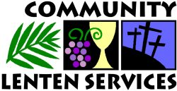

Every Wednesday

Soup at Noon
(Sign up in Chapel Office)

++++++++++++++

Sunday, March 6th, 9:30 am

++++++++++++++

Coming Up!

Theme Dinner/Concert

String Ensemble

Thursday, March 10th, 7:30 pm

At the Chapel
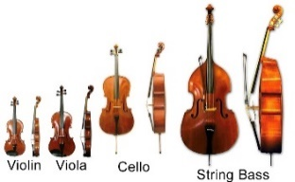
“Smiling Strings”

A young people’s string orchestra from the Czech Republic will grace our Chapel with a concert this coming Thursday evening. A Free Will offering will be collected to help defray their travel expenses

Reserve for 5:30 buffet dinner at the club – call 283-0202
(Ask to join a Friendship Table if you’d like to sit with others.)

++++++++++++++++++++

Highlighting Our Ministries

Each week we will feature a different Chapel ministry in our newsletter. See what activity appeals to you and join in our outreach and service to the Chapel, our MS community and Martin County charities.

Fun Fridays

This group meets every Friday in the Chapel Conference Room from 10 am -noon to offer companionship and fun for those who may have issues with vision, movement, and mild cognitive issues.

Share a cup of coffee, a treat or 2, discuss your week, and find friendship and genuine caring. Currently the ladies are enjoying playing Hand and Foot while the gentlemen play Gin Rummy.

Hosted by Chapel representative Carlene Nehra, led by Irene Merritt, CNA.
For more information contact the Chapel Office at msandschapel@gmail.com

