CHAPEL HAPPENINGS
April 1, 2022

April Showers of Events!

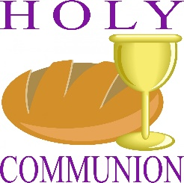

Sunday, April 3rd. 9:30 am
++++++++++

Final Chapel Grounds Cleanup
Saturday, April 9th, 9-10:30 am

The Green team invites you to join us for the final Chapel grounds clean-up of the season. We will provide garbage bags and bottled water. Please bring garden gloves, clippers, rake, and/or shovel. Thanks for your help in beautifying our property.

++++++++++

Associates Day
Monday, April 11th, 8 am – 2 pm

Arrange for pickup of large items by Friday, April 8th 2pm by calling Kim at HOA – 772-283-1114. Drop off donations of clothing, small appliances, tools, etc. to the chapel Palm Sunday 11am – 4pm (after service) or 8 -10 am Monday the 11th. Thanks for your support.

Annual Food Drive

Sponsored by the MS Chapel
Ecumenical Council

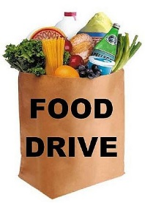
Tuesday, April 12th – Easter Sunday, April 17th

Donations to go to -
Holy Cross Catholic Church Food Pantry in Indiantown.

Go to your local supermarket and check out the canned goods sales. Non-perishable, nonexpired food donations are being collected starting Tuesday, April 12th. Please drop off your donations to the Chapel Office Tues 4/12 – Fri 4/15 9a-12noon, or on Easter Sunday at service. Thank you for your support of this worthy community-wide project.

++++++++++
A New Home for Your Orchids

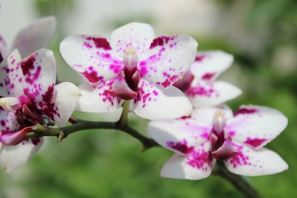

As you leave for the season to head north, please consider donating your orchids to the Green Team to beautify the Chapel trees. Thanks

Mark your Calendars

Lubben Brothers concert – Thursday, April 21st, 7:30 pm, at the Chapel
Hobe Sound Bible College Choir April 24th, at 9:30 worship

