CHAPEL HAPPENINGS
April 8, 2022

Holy Week Services

Palm Sunday Service

April 10th, 9:30 am with Communion

Bags will be passed out at Sunday’s service for food donations to go to Holy Cross Catholic Church in Indiantown, Please drop off your donations to the Chapel from Tuesday, April 12th to Easter Sunday. Thank you.

Holy Thursday, April 14th, 1:30 pm
Ecumenical Communion Service (No Priest)

Good Friday Ecumenical Service
(No Priest)

April 15th, 1:30 pm

(No Catholic Mass Saturday, April 16^{th)}

Easter Sunday Services

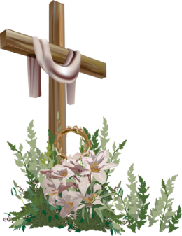

Sunrise Service – 7 am
Protestant Worship – 9 am (note time change)
Last Catholic Mass of the Season – 11 am

++++++++++

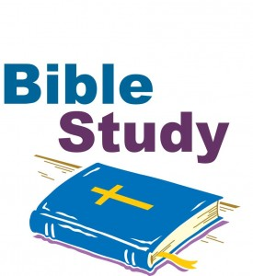

The Ladies “In Chapel” Bible Study meets Mondays at noon,
In the rear of the South Chapel.

(The study is canceled 4/11 because of Associates Day)

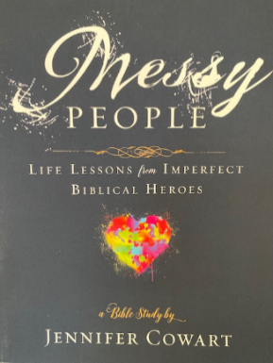

On April 18th a study will begin on Jennifer Cowart’s, Messy People: Life Lessons from Imperfect Biblical Heroes. Purchase the book on Amazon for about $12. In this six week study, Jennifer will help us dig into the lives of Biblical heroes who were “messy” people just like us, but who were used by God in POWERFUL ways! Each chapter is a separate story so you can join any week you choose.

Class will continue until Monday, May 23rd, when the group will take a break for the summer months

The Ladies Zoom Bible Study

On Monday, May 2, the Bible Bunch Zoom class will begin the study of Mitch Albom’s new best-selling novel, “THE STRANGER IN THE LIFEBOAT”. This will be a comprehensive BIBLICAL study of his book discovering how God speaks to us in everything we do, read and experience daily.
In June and July, our study will be “THE JORDAN RIVER RULES” by Robert J. Morgan. We will enhance our study with videos by Debbie Stuart, Woman’s minister of Green Acres Church.
August will see our return to studying with Rev. Bill Weimer in his second study, “Images of Christians.”
All are welcome to join our ZOOM class every Monday at 9:00AM EST. We continue to study throughout the year.
Please contact Tanya Condello at 772-919-5638, tvjjuk@yahoo.co.uk.
++++++++++

Lubben Brothers Concert at the Chapel
Thursday, April 21st, 7:30 pm - FREE

This talented group of triplets playing a variety of string instruments will perform their folk music for our listening pleasure. Along with performing, they also compose original tunes with meaningful messages.

To register for the concert, email the chapel to get on their email list (if you are not already) to receive an invitation, or go to the following link online:
http://events.constantcontact.com/register/event?llr+uz9try6ab&oeidk=a07ej4vaok428d5d71

Chef Isaac will have An All-American Farm Fresh to Table Buffet starting at 5:30 pm that evening at the clubhouse, so reserve a table and gather your friends for a fun night or ask to sit at a friendship table. Click on the following link to sign up for the concert
++++++++++

Scripture Readers, Ushers and Coffee Hour Hosts

We are looking for those who are willing to serve the Chapel in those capacities. A sign- up sheet is posted in the main hallway of the Chapel to indicate the dates you would be available.

