CHAPEL HAPPENINGS
May 6, 2022

I am the resurrection and the Life…

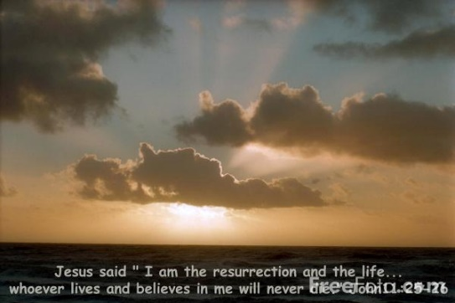

Worship Service
Sunday, May 8, 9:30 am
++++++++++

Hobe Sound Bible College Quartet

Thursday, May 12th, 7:30 pm
At the Chapel

Come join us to hear the fabulous and inspirational harmonies of this talented quartet.
No cost, sponsored by the Chapel.

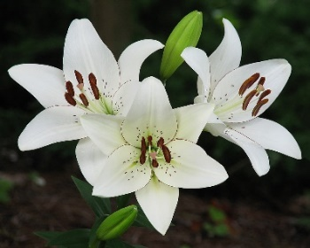

Reminder –

Flo Theile’s Memorial Service

Saturday, May 14th, 11 am

Monthly Message from Your President – May 2022
There is only one topic that follows “blessings” (February’s letter) and that is GRATITUDE. It was not until I sat down to write this letter that I realized I had taken a childhood blessing for granted. Growing up in a Christian home, every time we sat down for a meal, we asked Jesus to come and “be our guest” and before anyone could be excused, we thanked the Lord for His goodness and mercies. Did the repetitive routine of reciting these prayers dilute the significance? Probably so.
Fast forward to adulthood. Are our prayers still a series of repetitive words or are we really thanking God for all the blessings He has bestowed on us? Do we still take some things for granted with them never rising to the “thanksgiving prayer priority list?” Let’s build a “give thanks” prayer list together.
Starting at the top.
- God’s love and forgiveness - “For God so loved the world that He gave His one and only Son, that whoever believes in Him shall not perish but have eternal life.” John 3:16 It’s a free gift! All we have to do is believe that Christ is our Lord and Savior.
- Family and friends – What a blessing they are, until there’s a disagreement. How many relationships (a gift from God) have been tossed to the curb? Over what? Here’s what Paul wrote to the Colossians: “Let the peace of Christ rule in your hearts, since as members of one body you were called to peace. And be thankful. Let the message of Christ dwell among you richly as you teach and admonish one another with all wisdom through psalms, hymns and songs from the Spirit, singing to God with gratitude in your hearts. And whatever you do whether in word or deed, do it all in the name of the Lord Jesus, giving thanks to God the Father through Him.” Colossians 3:15-17
- Creation – We live in paradise! From the floral beauty to the wildlife to the sunrises and sunsets, God’s glory shines all around us. Whether it’s a walk on the beach or a walk around the neighborhood, His greatness is everywhere. “God saw all that he had made, and it was very good.” Genesis 1:31. It is VERY good.
- Food, clothing & shelter – This one, I definitely take for granted. I don’t remember ever going to bed hungry or not having “a thing to wear,” or a roof over my head. I will even take it one step further. I may have grumbled (once or twice) when the restaurant overcooked my steak or the department store didn’t have the dress I needed in my size. Forgive me, Lord for my selfish ways. “But if we have food and clothing, we will be content with that.” 1 Timothy 6:8
- Talents – God has created each one of us uniquely with the talents that He has chosen for us! So, we are not all musicians, athletes, artists, intellectuals, successful business people, etc. The devil loves to creep into our minds with self judgement and comparison. Rather, let us thank God and love ourselves as He has so wonderfully created us. “Thanks be to God for His indescribable gift.” 2 Corinthians 9:15
- Health – I think we can agree that some days are better than others. There are some days that our only prayer of thanksgiving is waking up. Illness and disease don’t make sense until we remind ourselves that we live in a broken and sinful world. As Christians, we find peace and comfort knowing that our hope is in the Lord. Psalm 103: “Praise the Lord, O my soul; all my inmost being, praise His holy name. Praise the Lord, O my soul, and forget not all His benefits – who forgives all your sins and heals all your diseases, who redeems your life from the pit and crowns you with love and compassion.”
Take a look around. What are you thankful for? A grateful heart will change the moment, change the month, change the year and change your life.
Praising God from whom all our blessings flow,
Sandy
“Oh give thanks to the Lord, for He is good; for His steadfast love endures forever!” 1 Chronicles 16:34
“This is the day the Lord has made; let us rejoice and be glad in it.” Psalm 118:24

