CHAPEL HAPPENINGS
May 13, 2022

God’s love endures!

Sunday, May 15, 9:30 am
Holy Communion

Last scheduled service, May 29th

++++++++++

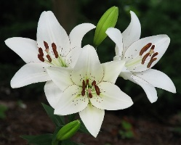

Reminder –

Flo Thiele’s Memorial Service

Saturday, May14th, 11 am

++++++++++

Continuing All Summer –

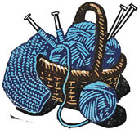

Shawl Ministry

++++++++++

Fun Friday

++++++++++

Ladies Zoom Bible Study
Mondays, 9 am

++++++++++

Mariner Sands Library
Open Daily

