A CANDID SNAPSHOT OF JESUS

May 15, 2022 – Fifth Sunday in Easter

Differences often become excuses for us to exclude and separate.
- Let’s face it sometime people say your really different, and that can be taken in may different way (for the good, the bad and the ugly)
- We even do this unconsciously, based on someone’s appearance, language, or outfit.
- This Easter season, let us be reminded that Jesus invites us into his kingdom, no matter our differences.
- He came to restore all of humanity with his love and peace!

Our sermon today comes from John 13, where King Jesus shares with us the secret to living like his royal family: Love.
Lets read this account.

JN 13:31-35 ³¹ When he had gone out, Jesus said, “Now is the Son of Man glorified, and God is glorified in him.
³² If God is glorified in him, God will also glorify him in himself, and glorify him at once.
³³ Little children, yet a little while I am with you. You will seek me, and just as I said to the Jews, so now I also say to you, ‘Where I am going you cannot come.’
³⁴ A new commandment I give to you, that you love one another: just as I have loved you, you also are to love one another.
³⁵ By this all people will know that you are my disciples, if you have love for one another.”

Throughout history picture have been take that have captured the moment, candid shots that speak volumes.
- Albert Einstein sticking his tongue out for the camera.
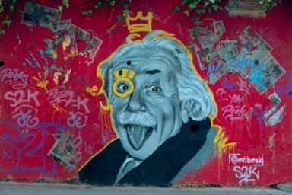
- Apple introducing the Iphone
- Iron workers having lunch sitting on an ibeam, no safely lines.
- Young Afghan girl
- These are some famous pictures in recent history
- They don’t just portray a person; they encapsulate a moment.
- These candid shots capture the personality, the ethos of the person by getting the context just right for just the right moment.

There are many moments like this in the life of Jesus, but one of the most moving takes place in John 13.
- The opening of the chapter sets the scene: poignant

JN 13:1-4 Now before the Feast of the Passover, when Jesus knew that his hour had come to depart out of this world to the Father, having loved his own who were in the world, he loved them to the end.
² During supper, when the devil had already put it into the heart of Judas Iscariot, Simon's son, to betray him,
³ Jesus, knowing that the Father had given all things into his hands, and that he had come from God and was going back to God,
⁴ rose from supper. He laid aside his outer garments, and taking a towel, tied it around his waist. (ESV)

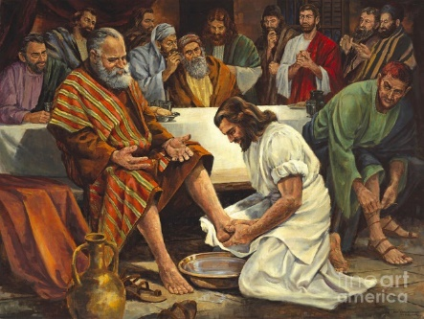

In this verbal crescendo so many things come together:
- Jesus’ death,
- Judas’s betrayal, and
- the enthronement of Christ.
- And the Lord’s reaction in this quantum moment is to wash feet.
- This act was the work of a slave, considered one of the lowliest duties.

In that culture, slaves were a common sight.
- They were part of daily life.
- They weren’t particularly loved or hated—they were just necessary.
- They were treated, for the most part, with consistent disregard.
- Slaves were essentially appliances.

And this is what Jesus chooses to do.
- This is the picture—like Einstien, Steve Jobs, the Afghan girl -- that encapsulates who he is.

Let’s look at this famous moment and see what we can learn:
- The example
- The command
- The indicator

THE EXAMPLE
On a spring day in 1981, a mentally disturbed young man attempted to assassinate then Pope John Paul II. He shot the Pope four times, with each bullet making contact, and the pontiff was critically wounded. The Pope made a slow but full recovery. Two years later, he visited the young man in prison to forgive him in a private conversation. One of the most famous pictures of his ministry was taken of him gently talking with his would-be killer. That’s the heart of someone who understands forgiveness, who learned from Jesus’ example here in John’s gospel and elsewhere.
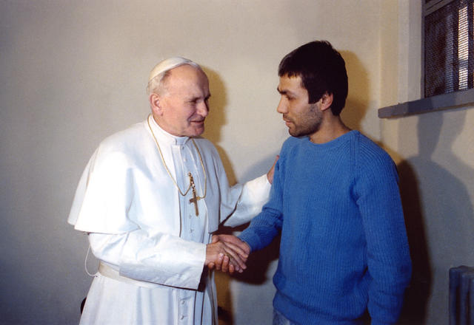
To really explore the depths of John 13, we need to pay attention to the sequence of events.
- The disciples come together for the Passover meal.
- They eat together.
- Jesus gets up to wash feet and has the famous conversation with Peter, addressing the fisherman’s trademark enthusiasm.
- Jesus then finishes the slave’s work of washing feet and reclines back at the table.
- It’s shortly after this that he dismisses Judas to do his dark work, and the narrative goes on.

Let’s pause right there – it’s easy to ignore that detail. Jesus washed Judas’s feet!
- Knowing what he was just about to do, knowing that Satan would enter Judas momentarily.
- Jesus knew this and didn’t hesitate for a moment to wash Judas’s feet.
- Those feet might have still been damp when Judas left to betray him.

Pull even further back, and you see how people sat at the table.
- Famously, John sat next to Jesus and rested his head on Jesus’ chest at the end of the meal.
- This would have been a common placement for a guest of honor at a meal.
- But look how Jesus signifies that Judas will be the one to betray him:

JN 13:26 ²⁶ Jesus answered, “It is he to whom I will give this morsel of bread when I have dipped it.” So when he had dipped the morsel, he gave it to Judas, the son of Simon Iscariot. (ESV)

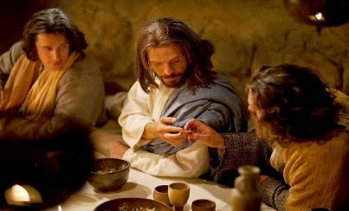

Why was Judas right there to receive the morsel of bread?
- Because Judas was seated right next to Jesus!
- Whether he was placed there by someone else or took the place himself, we don’t know.
- But Jesus shared the table—right next to him—with the man he knew would betray him.

This is the example.
- This is that candid shot of who Jesus really is: sharing a dish with his betrayer, washing the traitor’s feet.
- Jesus shares that example before he starts commenting on it at all.
- He speaks to the disoriented, uncomfortable disciples to say: “This.
- This right here. What I just did, this is what the kingdom is like.”

JN 13:30 So, after receiving the morsel of bread, he immediately went out. And it was night. (ESV)

THE COMMAND
JN 13:34 ³⁴ A new commandment I give to you, that you love one another: just as I have loved you, you also are to love one another. (ESV)

And with these words, Jesus unlocks all of human history and human potential.
- This is the hinge it all hangs upon: love, even before you are loved.
- Love, even when you don’t receive payment or reward, even when your love is unrequited.
- Love because loving is its own reward.
- Love for its own sake, just like Jesus did in washing feet, even those of Judas.

In the culture of the time, there was a steady exchange of honor.
- I honor you by getting you a gift, you honor me by getting me a gift.
- I honor you by showing you hospitality, and my honor profile is raised in the community, which means status and better connections and networking.
- There was a strong cultural exchange or agreement.

And we see the same in our society as well.
- Giving gifts with the expectation of getting something back.
- Networking to make connections that will pay off in the future.
- I scratch your back, you scratch mine.
Yet in ancient times and in our own, we all know there is something more.
- There is something better about giving freely, something that brings us joy and meaning and lightness of heart.
- Even when there’s no one there to applaud the action, we know that selfless giving brings us some of our greatest joy.

Jesus articulated what that “something more” is all about.
- He made sense of the human journey and the very human urge to give and told us:
- That’s the key.
- Giving before we are given to, participating in generosity:
- these urges to give are the only reason that humanity has survived, and they are the key to humanity thriving.

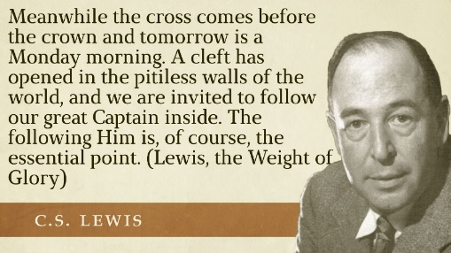

CS Lewis articulates it vividly:
Meanwhile the cross comes before the crown and tomorrow is a Monday morning. A cleft has opened in the pitiless walls of the world, and we are invited to follow our great Captain inside. The following Him is, of course, the essential point. (Lewis, the Weight of Glory)

To know Jesus, to follow the servant’s way of Jesus, is to walk through that cleft in the “pitiless walls of the world.”
- Instead of dog-eat-dog,
- instead of the brutal cycle of seeking and losing status,
- we’re invited to follow the Lord who scrubbed toes,
- Jesus who took the posture of dishonor because he knew it was his greatest glory.
- We’re called to be truly free to love.

The great irony of Jesus’ enthronement begins.
- The language and detail of Jesus’ crucifixion the next day portray his passion as his enthronement.
- He is given a purple robe (Mark 15);
- he is given a reed in his hand in a cruel imitation of a scepter (Matthew 27); and
- he is coronated with a crown of thorns.
- When this king is exalted, he is “lifted up” (John 12) onto the rough wood of a cross.

Jesus calls us along this royal path.
- He calls us not simply to love our neighbors as ourselves,
- but He calls us to love as he loves––without expectation, without caveat, without condition.

THE INDICATOR

Think about who is in the room when Jesus speaks these words:
- Peter – a leather-neck hot-head
- Simon the Zealot – a terrorist who fought Rome with violence
- Matthew – a tax collector who made his money by selling out to Rome
- Thomas – a self-protective skeptic
- John–A young follower of John the Baptist who was likely half revolutionary and half confused mystic.
And several others who were all over the map in terms of loyalties, backgrounds, and character.
- These are the people to whom Jesus gives his great commandment and
- He gives a workshop on how the commandment is to be lived out in daily life.
- He then gives the PRIMARY INDICATOR of the people who follow Jesus:

JN 13:35 ⁵ By this all people will know that you are my disciples, if you have love for one another.” (ESV)
Jesus started with an intensely divided group to show what Christian unity would eventually look like.
- We have biblical records of infighting and one-upmanship in the ranks of the apostles,
- but Jesus knew this, and still chose them.
- He then gave them this dubious indicator of his presence:
- If you love each other, THE WORLD know you belong to me.

Two great theologians, John Wesley and George Whitefield, were huge influences in England’s Evangelical Revival in the 1700s.
- In a time without internet, television, or much media to speak of at all, these renowned orators would have been some of the biggest pop stars around.
- And these two were famous theological rivals.
- They wrote against each other and spoke against each other, holding differing views within the same faith.
- Their disagreement was as famous as their reputations.
- At one point, one of Whitefield’s followers ventured the question,
- “We won’t see Wesley in heaven, will we?”
Whitefield replied, “No.”
- The man then conjectured, “So you don’t think Wesley knows Jesus?”
- Whitefield declared, “No! He will be so close to the throne of God and we so far away that we won’t be able to see him from where we sit!”

Years later, when Whitefield died, he requested that Wesley himself would speak at the funeral.
- So, great disagreement between these two men,
- They had great differences in the theological details of their understanding of faith,
- but also HAD GREAT LOVE.

That’s the indicator.
- That’s our first and last witness to the hope that is within us: love.
- For Jesus to bring together his group of twelve, and for us still to hold fellowship as the 2.5 billion Christ-followers in the world today, LOVE is the primary indicator that we are his disciples.
- LOVE is the deciding factor of who the Christ followers are!
- LOVE is everything
- Think of the love that works in a complicated relationship like that of Wesley and Whitefield,
  - or those of differing political opinions,
  - social classes,
  - racial backgrounds,
  - economic levels—
  - this is the other-worldly love that Jesus is talking about, and it transforms everything it touches.

So, let’s look at what happened in that moment, in the upper room, over a clay basin of water, centuries ago:

The example –
- Judas’s feet were washed clean when he left to betray Jesus.
- Our Lord took the posture of a servant, even to his betrayer as an example of what his kingdom looks like.
- Where can we take the posture of a servant in our daily lives?
- Where can we take it as a church in our community?

The commandment –
- Jesus unlocks the key to the surviving and thriving of humanity:
- Loving, while expecting nothing in return.
- The only way our race will survive is if we learn to give and love without expecting to have our back scratched in return.
- To do this is the way of Jesus, and the secret to true freedom.
- Do we love first? (It’s not always the easiest)
- Do we take the INICIATIVE IN FIRST loving others?

The indicator –
- “They’ll know we are Christians by our love,” the old song goes.
- Wesley and Whitefield show us that even before we can have our theology hammered out to the last detail, we can still share love.
- The apostles – very different men from radically diverse backgrounds
  - Yet they served each other, and some even died alongside each other because they had Christ’s world-stopping, self-sacrificial love for each other.
  - How can we experience this harmony?
  - How can we be an agent of healing in our church family?

Think about yourself, for a moment, if someone was to take a candid shot that would reflect the best of you, what would you be doing?
I will ask that again.
Think about yourself, for a moment, if someone was to take a candid shot that would reflect the best of you, what would you be doing?
The great theologian Francis Shaeffer called love and unity the “final apologetic.”
- We can argue the logic of the Christian story with eloquence and undeniable force, but the “final apologetic” that brings people to faith is not clever presentation.
- No, as Paul said, and it still rings true, “If we have not love, we are nothing.”

Quote to ponder: from Francis Schaefer – and American Theologian
“Our love will not be perfect, but it must be substantial enough for the world to be able to observe or it does not fit into the structure or the verses in John 13 and John 17. And if the world does not observe this among true Christians, the world has a right to make two awful judgments which these verses indicate: that we are not Christians and that Christ was not sent by the Father.”
CLOSING PRAYER

