Dear Investors in the Great Commission in Japan,

My wife and I are truly thankful for your part in what God allows us to do here in Japan. As we have done since we have first begun deputation, we are sending you a semi-annual update video exclusive to our supporting churches. The link below should give you access to view and download this video.

https://drive.google.com/file/d/1tvoZJ4aCXCHz3es-h-aG-DmRY1CWgoYM/view?usp=sharing
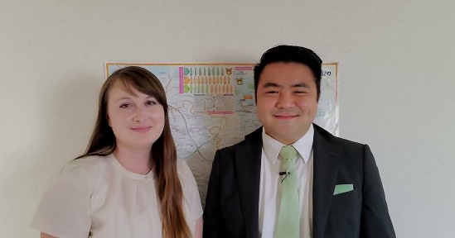 | 10. 2022 Church Plant Location Announcement Video.mp4  drive.google.com
The highlights of this video include our two evangelistic meetings in June, resulting in our most fruitful month on the field yet, as well as our big announcement of deciding on our church plant location as early as next year. Thank you for your part in all that God allows us to do.

For His Honor and Glory,
Go and Danielle Oishi
II Corinthians 8:9-11
Attachments area

