SPIRITUAL RISK ASSESSMENTS

Sept 4, 2022

In our sermon passage, we are told that Jesus expects us to be willing to give up everything, including family, for his sake.

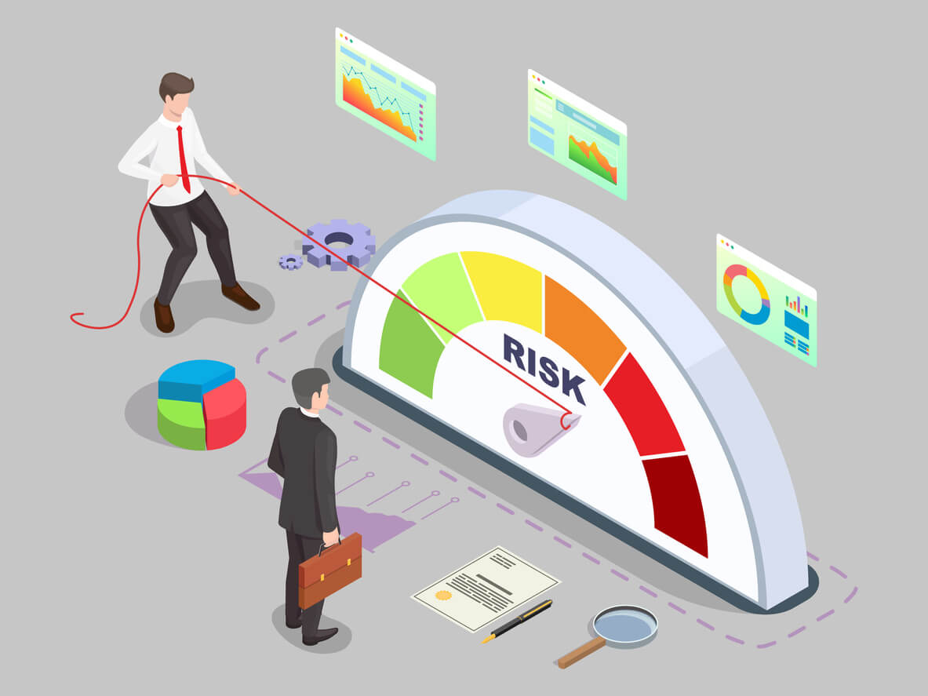

“A flawed or faulty risk.” This is the term used to define the point at which a given course of action should no longer be pursued, or perhaps actively worked against.
- Companies performing risk assessments are expected to define flawed risks to their operations.
- For a powerplant, those risks might define the point of balance between operating safely and operating efficiently.
- For an investor, it’s when the risk of failure for a given project is too high to justify the cost of investing.
- For an individual, it could be when an exciting job opportunity is eclipsed by the upheaval the move would cause.
These risk assessments are examples of why it’s important to consider the implications of your ACTIONS and your CHOICES.
- They are perceived in Western culture as examples of WISDOM and responsibility.
- And they are reflections of a challenge that Jesus gave to his disciples 2000 years ago.

Speaking to his disciples, Jesus warns that complacently following Jesus is not enough—
- we need to think through the implications of that course of action.
- Let’s read what Jesus said to his followers.
- This reading is summarized as “The Cost of Discipleship”

LK 14:25-33 ²⁵ Now great crowds accompanied him, and he turned and said to them,
²⁶ “If anyone comes to me and does not hate his own father and mother and wife and children and brothers and sisters, yes, and even his own life, he cannot be my disciple.
²⁷ Whoever does not bear his own cross and come after me cannot be my disciple.
²⁸ For which of you, desiring to build a tower, does not first sit down and count the cost, whether he has enough to complete it?
²⁹ Otherwise, when he has laid a foundation and is not able to finish, all who see it begin to mock him,
³⁰ saying, ‘This man began to build and was not able to finish.’
³¹ Or what king, going out to encounter another king in war, will not sit down first and deliberate whether he is able with ten thousand to meet him who comes against him with twenty thousand?
³² And if not, while the other is yet a great way off, he sends a delegation and asks for terms of peace.
³³ So therefore, any one of you who does not renounce all that he has cannot be my disciple. (ESV)

It is hard to read this passage of Scripture and not think of your siblings, parents, or spouse.
- It references those we love and asks a heart-piercing question, are you ready to place Jesus above all of them?
- In the risk assessment of our spiritual lives, is the cost of following Jesus more than we could bear?
- If you feel yourself thinking that it might be, it might reassure you to realize you’re not alone.

Even after decades of Christian living, this question will continue to lead passionate followers of Christ to a place of doubt.
- The cost seems too great, yet the reward is immense.
- The scale of our spiritual risk assessment teeters back and forth wildly.
- We know it will land on the side of our eternal relationship with God (Jesus has shown us that), but this doesn’t reduce the anguish caused at the thought of the sacrifices he is calling for.

So, let’s take a moment to break the text down a little further. What is it that Jesus is asking of his disciples in this passage?

SETTING THE BAR HIGH

LK 14:25-27 ²⁵ Now great crowds accompanied him, and he turned and said to them,
²⁶ “If anyone comes to me and does not hate his own father and mother and wife and children and brothers and sisters, yes, and even his own life, he cannot be my disciple.
²⁷ Whoever does not bear his own cross and come after me cannot be my disciple. (ESV)

Jesus does not mince words when he presents the disciples with his expectations.
- Jesus wants everything from us.
- He is presenting us with a core biblical teaching, the supremacy of God.
The Ten Commandments declared that we were to have no other God before him, and Jesus teaches us the heart of that law – there should be nothing in our lives set before God.
- When Jesus tells us to hate our family, he does not mean literally.
  - We know this from looking elsewhere in Scripture. For example, he shows love for his mother and provides for her on the cross by charging John with her care.
  - Furthermore, 1 John 4:20 tells us that the person who hates his brother cannot love God! So where does this leave us?

Jesus has shown us he desires love not hate, so we can say with confidence that here he is using exaggeration to stress the importance of a teaching.
- The extreme reaction we feel at the idea of hating our family is the intent behind Jesus’ teaching here, that aversion to hating them, should be reflected by an even greater love for God.
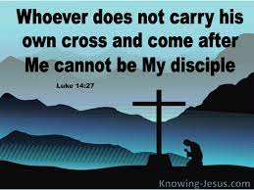

By setting his bar so high as to be unattainable, Jesus is setting out for us a lifelong goal of loving God more and more.
- The Christian walk is a constant struggle to put God in the proper place at the center of our lives.
- As long as he’s not there yet, we haven’t achieved the goal of loving him so much as to hate everything else.
- It is only with the help of God that we truly can carry our cross.
- Our Triune God has called us to a hard job, but He promises to help us along every step of the way.

Jesus does set within his example an achievable goal.
- Contrasted with the call to reject our family is a call to reject ourselves, take up our own cross and follow Jesus.
  - This involves the putting off of the old man and living as Jesus asks us to.
- Jesus has demonstrated we can follow through on this call.
- And that call to a sacrificial love that endures much is core to what it means to be a disciple of Jesus.
- Jesus has called us to an often- painful path to perfection and he wants us to be aware of all that could come with it.

Have you ever found Jesus’ call for COMPLETE AND UTTER DEVOTION intimidating?
- What might you fear losing in your commitment to him?
- Is there something we find hard to let go in this life.
- What little thing in this life is holding us back FROM ETERNAL LIFE.

DOING THE ASSESSMENT

LK 14:28-30 ²⁸ For which of you, desiring to build a tower, does not first sit down and count the cost, whether he has enough to complete it?
²⁹ Otherwise, when he has laid a foundation and is not able to finish, all who see it begin to mock him,
³⁰ saying, ‘This man began to build and was not able to finish.’ (ESV)

COUNTING THE COST
- Napoleon never truly counted the cost when he marched into Russia
- Hitler never learned from history, he repeated the mistake of Napoleon by not counting the cost before he committed his army to march into Russia.
- I am not sure if Russia truly counted the cost before the marched into the Ukraine and the forces are now bogged down in a never ending war with many losses on both side

- The building of largest cruise ship the GLOBAL DREAM II. The largest ship ever built is in trouble.
- The ship can carry 9000 people
- The ship has 20 decks
- Total cost to build 1.2 billion dollars is set to be scrapped, due to company going bankrupt. They are short 200 million dollars with no buyer in sight.
- The ship is structurally sound, equipment and passenger facilities need finishing.
- THE DID NOT COUNT THE COST
- It didn’t help that the Cruise industry is in trouble since COVID HIt

For anyone who has done some RENOVATIONS or overseen construction, the fear of unknown costs and setbacks is an ever-present reality.
- Common advice is to take the quote given to you and add at least twenty percent to determine your budget for the project.
- Falling short of the financial needs of such a project can have far-reaching consequences.
- A botched renovation can put the whole home at risk, and a half-finished building is a danger to those who enter it.

And it’s not a process that ends once the project begins.
- Progress reports, inflation costs, and fluctuation in markets are all things that seem irrelevant until they affect the things one must purchase.
- A change in the cost of lumber can have dire consequences when you’re building a wooden house!

It is an equally agonizing process for our SPIRITUAL LIVES.
- And it is appropriate to point out that while many of the would-be disciples Jesus was speaking to in this passage were new, some had been with him throughout his ministry.
- But that doesn’t reduce the need for these moments of introspective spiritual self-assessment.

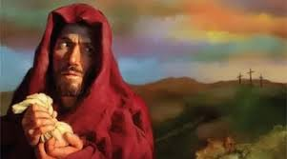

- No doubt Judas did not always intend to betray Jesus, but at some point, he began to value something more than God.
- Perhaps it was money, or as portrayed in Andrew Lloyd Webber’s Jesus Christ Superstar, perhaps it was the ideal of a Jewish nation that did not jive with who Jesus was revealing himself to be.
- Regardless, something led him to conclude that the cost of discipleship was too great.
Then there is the example of Peter who said he would follow Jesus but he denied him three times.

This call from Jesus to carefully assess the cost of following him is not completed the moment we declare him to be Lord.
- Rather, it should become a regular practice to think about the depth of the call God has made to us.

Do you take the time to “count the cost” of your faith as part of your spiritual disciplines?
- Daily prayer
- Daily Bible Study
- Fasting
- Serving
- Fellowship
- Communion etc

A FORECAST LESS DIRE THAN IT MIGHT SEEM

LK 14:31-33 ³¹ Or what king, going out to encounter another king in war, will not sit down first and deliberate whether he is able with ten thousand to meet him who comes against him with twenty thousand?
³² And if not, while the other is yet a great way off, he sends a delegation and asks for terms of peace.
³³ So therefore, any one of you who does not renounce all that he has cannot be my disciple. (ESV)

Everything that we’ve discussed so far could lead us to the conclusion that the Christian life is one of joyless introspection and confessions of inadequacy.
- Indeed, taken alone, this passage could lead us to the conclusion that since we fall short of perfection, perhaps we should just give up.
- Thankfully this passage does not sit alone. Luke takes pains to emphasise to us that the calling of Christ is one that requires complete and utter devotion, a devotion we are unable to provide.

Our passage today comes before the parables of the lost sheep, coin, and prodigal son.
- All these parables speak of the incredible love of God that is present amid the failures of his children.
- Where there is a gap in our ability to relate to God, Jesus steps in and fills that gap.
- An allusion to this can be seen in the final example Jesus gives in this passage: the king who is not capable of fighting the enemy coming toward him.
- In this example, a cost is going to be paid regardless – the other king is coming to wage war on him.
- While the man thinking about building his tower can simply decide not to build it, the king cannot simply decide to ignore the army that is approaching his lands.

Counting his cost, he realizes he comes up short. But that is not the end of his narrative; the parable does not conclude with his defeat and death.
- Instead, the king realizes his need to seek the mercy of his opponent.
- Like this king, we found ourselves in conflict with a foe impossibly beyond us.
- But this foe is not Satan, or sin, but rather God himself.
- In our past rebellion, we found ourselves aligned against the Creator of all things.
- Jesus refers to this when he tells the apostle Paul in a vision “It is hard for you to kick against the goads” (Acts 26:14b).
- Opposition to God is an exercise in futility, much the same as this king’s war.

If the king had insisted on his own rule and way, he would have found himself not just without crown or country but also without his life.
- Instead, he must sue for peace, he must give up the crown and country, he must “renounce all he has.”

On the path to salvation, destruction is found in every direction except the narrow path that leads to Jesus.
- The cost of discipleship is not just about counting what we must give up to follow Jesus, it is also about recognizing how much greater is the loss of not following him.
- This is the point of Jesus’ lesson.
- Without him there is no life, no resurrection, no hope, and no future.
- Without him you would have no mother, father, brother, or sister.
- Without him there is no narrow path to keep to.

When we count the cost of discipleship, we will consistently find we are incapable of providing what is required.
- We too need to realize our need for mercy and grace.
- Counting the cost does not lead us to the conclusion that we will pay and sacrifice what is needed—it leads us to the conclusion that we cannot pay or sacrifice enough.
- But we do not despair.
- Our inability is contrasted by the Holy Spirit’s ability and desire to take hold of us and lead us back to the foot of the cross.
- It recalls the costly price that has been paid for us by Jesus, and the horrific cost we would endure if it had not been paid.
- And it is in light of his loving sacrifice that we once more commit to acknowledging him as the center of our lives.

Let’s conclude with the powerful words of Dietrich Bonhoeffer in The Cost of Discipleship:
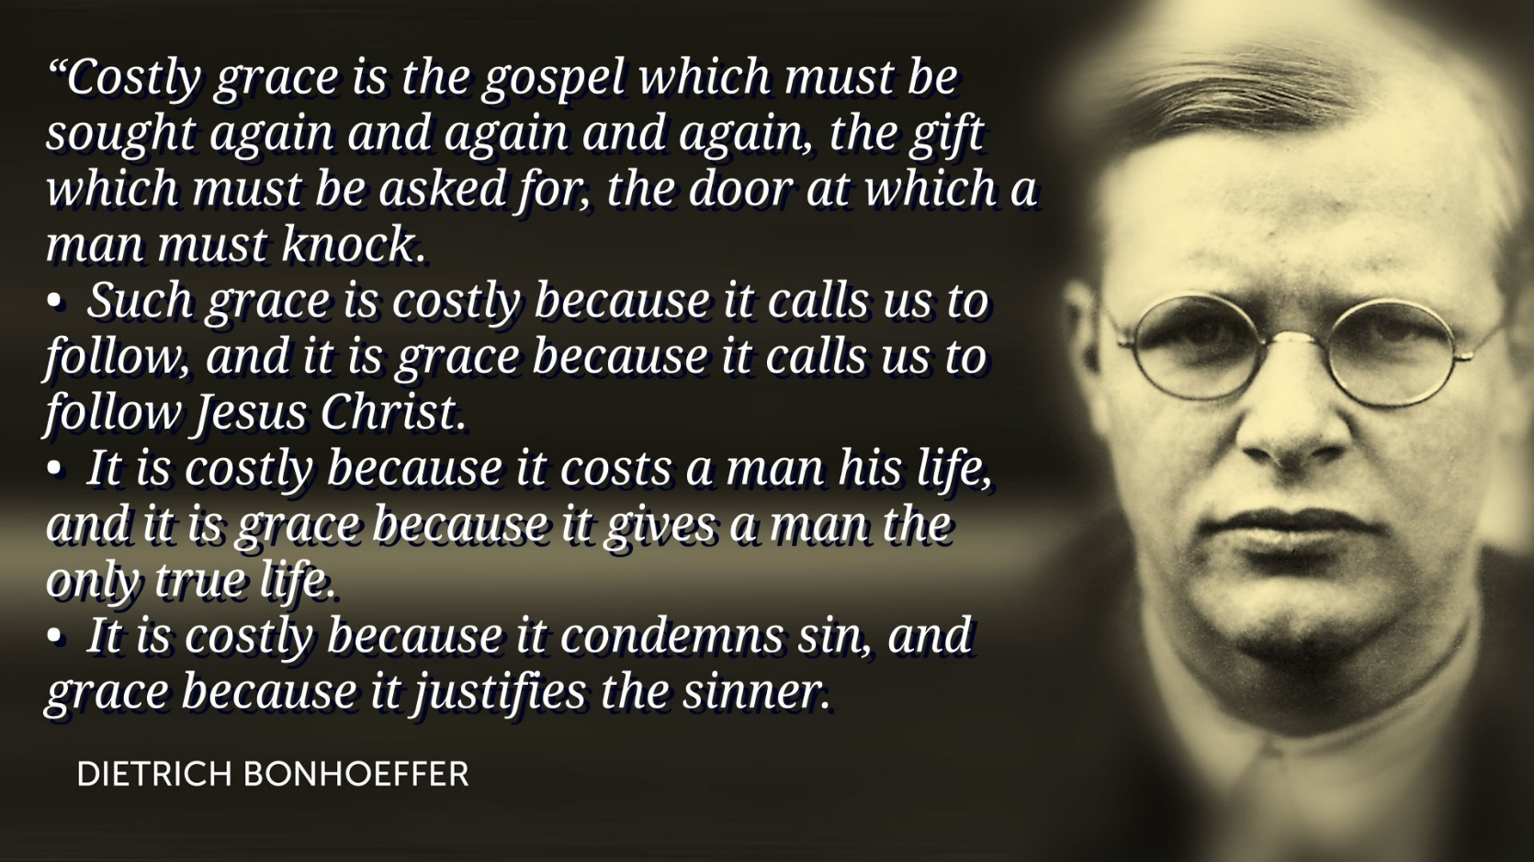

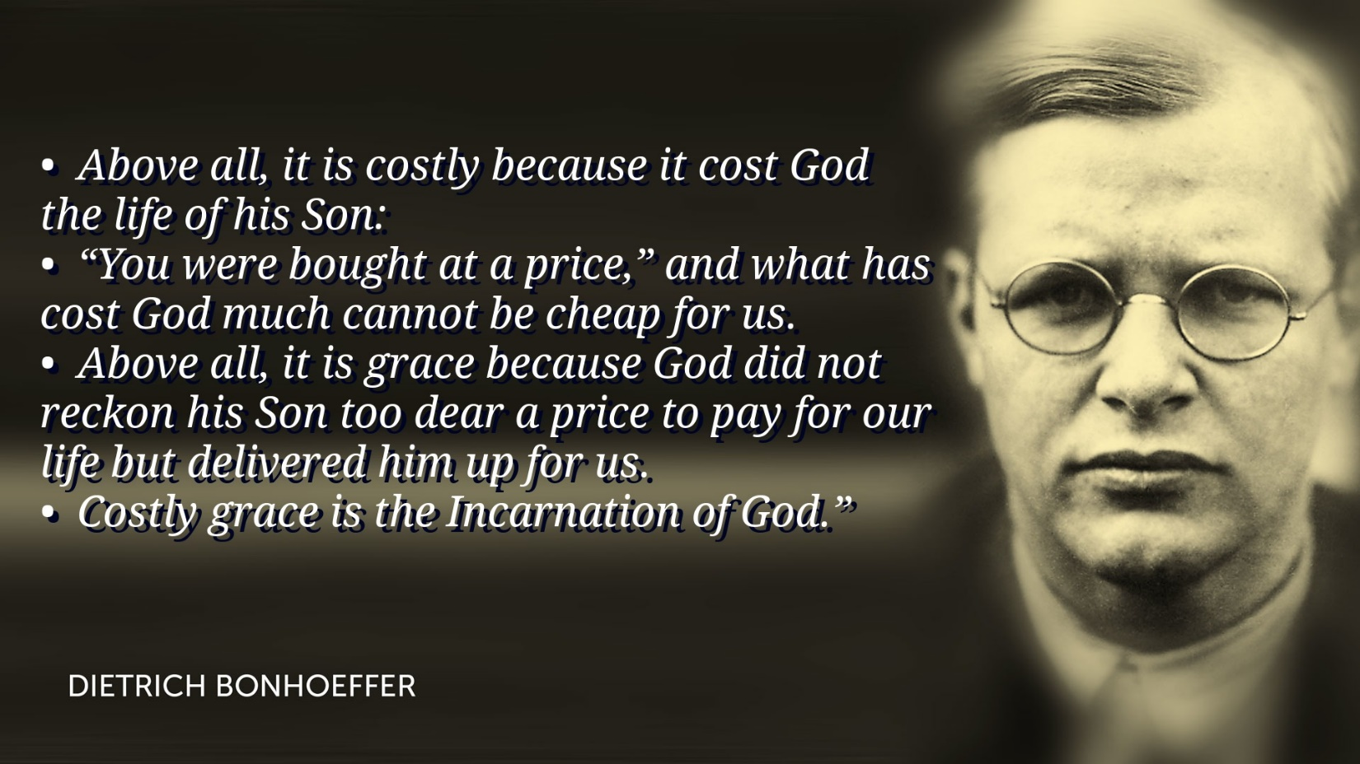
“Costly grace is the gospel which must be sought again and again and again, the gift which must be asked for, the door at which a man must knock.
- Such grace is costly because it calls us to follow, and it is grace because it calls us to follow Jesus Christ.
- It is costly because it costs a man his life, and it is grace because it gives a man the only true life.
- It is costly because it condemns sin, and grace because it justifies the sinner.
- Above all, it is costly because it cost God the life of his Son:
- “You were bought at a price,” and what has cost God much cannot be cheap for us.
- Above all, it is grace because God did not reckon his Son too dear a price to pay for our life but delivered him up for us.
- Costly grace is the Incarnation of God.”
Bonhoeffer pointed out that the cost of discipleship is ultimately paid by Jesus,
- and that it is for this reason that we should be faithful in our following of his calling.
- How does the costly grace freely given by Jesus encourage us in how we live your lives today?

