WHAT PRAYER TELLS US ABOUT LOVE

Given in Vancouver on Oct 16

By Craig Minke

Our sermon text today is Luke 18:1-8, where Jesus shares the parable of the Unjust Judge (also called the parable of the Persistent Widow) to help us understand more about the purpose of prayer.
You might remember hearing some years ago about the humanitarian Mother Teresa.
- She was a nun who won the Nobel Peace Prize in 1979 for her efforts in founding the Missionaries of Charity, which managed and supported homes for people dying of leprosy, HIV/AIDS, and tuberculosis.
- She lived in India for most of her life, and worked to organize soup kitchens, schools, and orphanages.
- There’s a story told about Mother Teresa.
In her efforts to raise money, Mother Teresa was meeting in New York City with the president and vice-president of a large company. They had already agreed ahead of time that they were not going to donate to her organizations, but they said they would meet with her.
Mother Theresa sat across from them and shared about her work and the need of the people she served. After she finished, the executives told her, “We appreciate what you’re doing, but we can’t donate at this time.”

Mother Teresa responded to them by saying, “Let us pray,” and then proceeded to beseech God to soften their hard hearts toward the poor and the sick. After she said, “Amen,” she asked again for their support, and they again refused to help.

“Let us pray,” Mother Teresa said, and at this, the president relented and wrote a check.
We might laugh at Mother Teresa’s version of persistent prayer, but we find a similar example in the Parable of the Persistent Widow in Luke 18:1-8. Let’s take a look.
LK 18:1-8 Then Jesus told them a parable about their need to pray always and not to lose heart.
² He said, “In a certain city there was a judge who neither feared God nor had respect for people.
³ In that city there was a widow who kept coming to him and saying, ‘Grant me justice against my accuser.’
⁴ For a while he refused, but later he said to himself, ‘Though I have no fear of God and no respect for anyone,
⁵ yet because this widow keeps bothering me, I will grant her justice, so that she may not wear me out by continually coming.’ ”
⁶ And the Lord said, “Listen to what the unjust judge says.
⁷ And will not God grant justice to his chosen ones who cry to him day and night? Will he delay long in helping them?
⁸ I tell you, he will quickly grant justice to them. And yet, when the Son of Man comes, will he find faith on earth?” (NRSV)

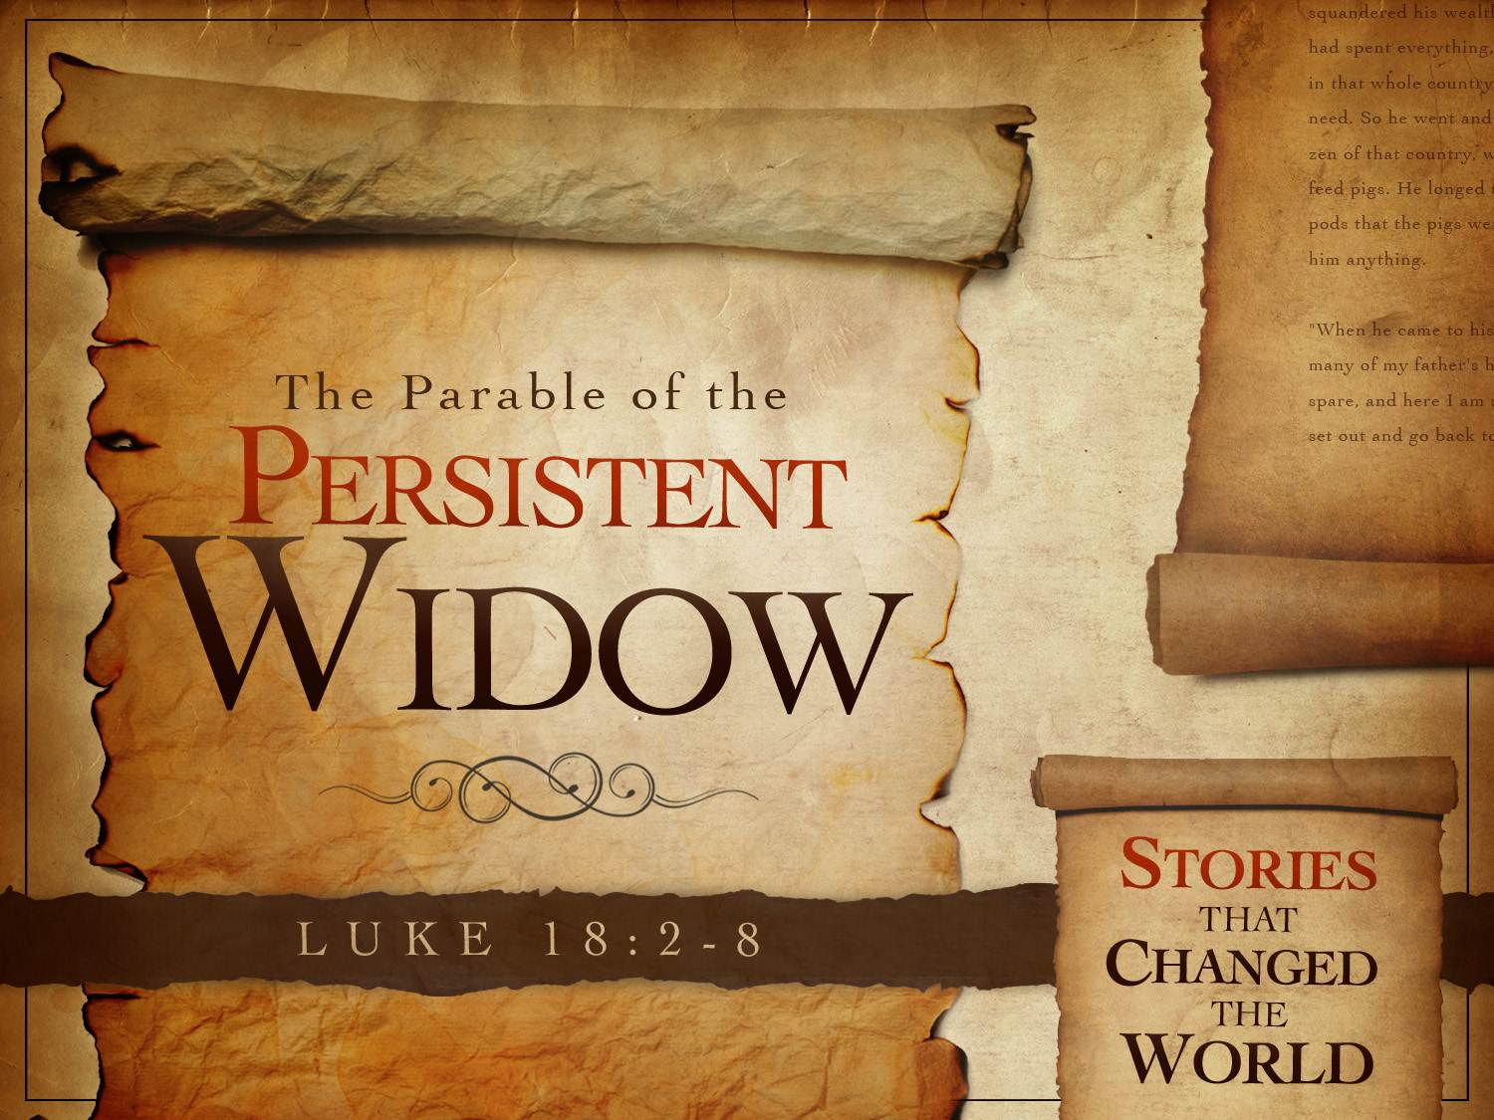

What can we notice about this passage?
- Depending on the translation you choose, the parable in Luke 18 could be titled
  - “The Parable of the Persistent Widow” or
  - “The Parable of the Unjust Judge.”
- This difference in perspective highlights the many layers of the parable that offer insight into social justice issues, God’s loving character, and our faithful prayer.
- Let’s consider a few things:
  - Widows are symbols of vulnerability in both Testaments.
  - With no means of support, they were dependent their grown children–or on charity
  - Because of their vulnerability, the scriptures demand protection for widows:
  - God has a special affection for widows, orphans and aliens (Deuteronomy 10:18-19).
  - Just as God provided relief for the Israelites from their Egyptian captivity, God requires Israel to provide relief for other vulnerable people in society as defined in DEUT 24:17-21

DEUT 24:14,17-18
14 “You shall not oppress a hired servant who is poor and needy, whether he is one of your brethren or one of the sojourners who are in your land within your towns;
17 You shall not deprive a resident alien or an orphan of justice; you shall not take a widow’s garment in pledge.

  - Notice what God also says in

EXOD 22:21-24 21 You shall not wrong or oppress a resident alien, for you were aliens in the land of Egypt.
22 You shall not abuse any widow or orphan.
23 If you do abuse them, when they cry out to me, I will surely heed their cry;
24 my wrath will burn, and I will kill you with the sword, and your wives shall become widows and your children orphans.

  - Jesus in the NT condemns those “who devour widow’s houses” (20:47).
  - The early church provides food for widows (Acts 6:1-6).
  - Widows are honored, because of their dependence on God (1 Timothy 5:3-5).

This widow, like the man who demanded bread from his neighbor in the middle of the night (11:5-8), persists in asking.
- Her feisty character is unusual for a woman in that patriarchal society, but she has the weight of scripture and justice on her side.
- She dwells on high moral ground, and everyone knows it.
- This judge would not tolerate this nagging behavior by a man, but even a judge who knows no shame must exercise forbearance in the presence of a woman who enjoys the protection of scripture and the sympathy of the community.

- The Need for Justice:

- Jesus begins the parable by describing the character of a judge
LK 18:2 ² He said, “In a certain city there was a judge who neither feared God nor had respect for people.
- In this story a widow in need of justice kept coming to see him, yet he refused to help her.
- In the cultural context, Jesus’ Jewish listeners would understand that this judge was ungodly because of how he lived and the decisions he made
- As we read scripture does specify protections for widows, along with others who are considered among the most vulnerable.
This judge “neither feared God nor respected man (better: human beings).”
- So if the great commandments are to love God above all else and to love neighbor as self … the judge does neither.
- And apparently he doesn’t care—his attitude is of cynical disregard—he doesn’t “fear” God or “respect” neighbor.

LK 18:5 ⁵ yet because this widow keeps bothering me, I will grant her justice, so that she may not wear me out by continually coming.’ ”

However, this widow’s actions showed her determination not to submit to exploitation, or to not allow herself to be used or abused by the system.
- In v. 5, the original Greek can be translated like this: “because this widow causes trouble for me, I will give her justice so that she may not give me a black eye by her coming Greek word used is (hypōpiazō).
- Paul uses the same word in

I COR 9:26-27 26 So I do not run aimlessly, nor do I box as though beating (hypōpiazō) the air; 27 but I punish my body and enslave it, so that after proclaiming to others I myself should not be disqualified.
- Notice the word is used in the context of boxing where something was taking a beating.
- There was an intensity in the widow’s refusal to accept injustice despite her situation.
- She knew she deserved justice, and she refused to take less. (OR NO FOR AN ANSWER)

We can consider our response to social justice issues, where human beings are oppressed and marginalized by human institutions.
- What if we are struggling from injustice?
- God is big enough to give us peace – even in the midst of struggling?
- He doesn’t need our help to fix things, but we can we seek to join in what he is doing?

Do we intentionally seek God for wisdom, insight, and intervention?
- This parable highlights our need to pray and not lose heart.
- When we see others struggling because of injustice, will we seek God’s direction?
- Sometimes we fall on the side of being overly critical for someone’s desire for justice.
- Can we hurt when others hurt?
- Can we go to God on their behalf?
- The parable suggests that praying for justice on behalf of vulnerable people is part of our responsibility as God’s children.

- God’s Goodness and Love

A second point to consider from this parable is that of “God’s Goodness and Love”
- Jesus contrasts God’s loving character with the unjust judge in vv. 16-18a:

LK 18:6-8a ⁶ And the Lord said, “Listen to what the unjust judge says.
⁷ And will not God grant justice to his chosen ones who cry to him day and night? Will he delay long in helping them?
⁸ I tell you, he will quickly grant justice to them…” (NRSV)

Here we see the Contrast of God’s care with that of the uncaring, unjust judge and it helps us to remember to whom we are praying.

- We are not approaching the throne of an abusive father, one who would delight in our demise, but instead, we are running into the arms of our Creator, the one who made us and delights in us.
- Notice the words of Zephaniah about the God we worship:

ZEPH 3:17 17 The Lord, your God, is in your midst, a warrior who gives victory; he will rejoice over you with gladness, he will renew you in his love; he will exult over you with loud singing (NRSV)

We are loved by a God who renews us and who sings over us.
- If an unjust judge finally gave a persistent widow the justice she deserved, how much more likely it is that God will intervene on our behalf.
- We now come to a third takeaway what we can learn from this parable.

- Persistence in Faith and Prayer
Jesus ends the passage with an important question:
LK 18:8b ⁸… And yet, when the Son of Man comes, will he find faith on earth?” (NRSV)
We often think of faith as belief: belief in a set of theological doctrines or belief that there is a triune God who created everything there is, including us.
- However, we can expand our idea of faith to encompass the belief that God truly is who he says he is, that nothing surprises him, and that he is in control.
- Our faith in and through Christ motivates us to participate with him, joining him in doing good in the world by pointing to the one who can fix all things.
- In other words, our faith trusts in God’s ultimate power and authority despite the presence of evil and injustice that surrounds us in this world.
This brings us back to the first verse in the passage:
LK 18:1 Then Jesus told them a parable about their need to pray always and not to lose heart. (NRSV)

We remember Paul’s admonition in I THES 5:17 to “pray without ceasing”
- But sometimes we view this as a requirement to having our prayers answered rather than seeing it as a means of developing a deeper connection with the lover of our souls.
- When an answer to prayer is delayed, we sometimes think to ourselves, “I must not be praying enough or praying the right words.”
- This type of thinking is based on the wrong idea that we control God by our prayers – or actions.
- In reality, we must redefine faith as a willingness to persist in seeking to connect with God, believing in God’s goodness and love even when faced with difficult circumstances.
- This type of faith is a way of living that refuses to turn away from the connection with the Father, Son, and Holy Spirit, even when life doesn’t make sense.
- This type of faith persists in the face of sorrow, and it’s the faith the prophet Habakkuk spoke of:

HAB 2-3-4 3 For there is still a vision for the appointed time; it speaks of the end, and does not lie. If it seems to tarry, wait for it; it will surely come, it will not delay. 4 … but the righteous live by their faith. (NRSV)
- Our faith enables us to persist in hope and love, living out our Christian value of loving others as ourselves.
- Our faith makes us take our troubles to the One who provides what is best for us.
- Consider these New Testament examples who were commended for their faith:
- The centurion who asked Jesus to heal his slave (Matthew 8:5-13)
- The paralyzed man and the friends who lowered him through the roof to be healed (Luke 5:17-39)
- The bleeding woman who touched Jesus’s robe and was healed (Luke 8:43-48)
- The grateful Samaritan leper (Luke 17:11-19)
- The blind beggar on the road to Jericho who was healed (Luke 18:35-43)

Notice these people who received healing had suffered, some of them for years and others for their entire lives.
- Their healing was a long time coming.
- Even Jesus was not resurrected for three days.
- But God’s justice and healing will prevail, and when we think about the certainty of this, we can see how God might be more like the determined widow in the parable who refuses to give up in her pursuit of justice.

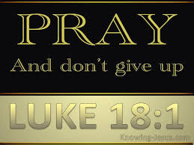

Think of prayer as our way of saying “Yes” to letting God love us.
- This can help us be persistent in prayer without turning it into a transaction, expecting God’s response in direct proportion to our effort.
- Ruth Burrows offers these thoughts about our role in persistent prayer:
Almost always when we talk about prayer we are thinking of something we do and, from that standpoint, questions, problems, confusion, discouragement, [and] illusions multiply…. Our Christian knowledge assures us that prayer is essentially what God does, how God addresses us, looks at us. It is not primarily something we are doing to God, something we are giving to God but what God is doing for us. And what God is doing for us is giving the divine Self in love… We are here to receive this indescribable, all-transforming, all beatifying Love. (Essence of Prayer, pp. 1-3, 5)
Here is a quote take from Mere Christianity by C.S. Lewis

An ordinary simple Christian kneels down to say his prayers. He is trying to get into touch with God. But if he is a Christian he knows that what is prompting him to pray is also God: God, so to speak, inside him. But he also knows that all his real knowledge of God comes through Christ, the Man who was God—that Christ is standing beside him, helping him to pray, praying for him. You see what is happening. God is the thing to which he is praying—the goal he is trying to reach. God is also the thing inside him which is pushing him on—the motive power. God is also the road or bridge along which he is being pushed to that goal. So that the whole threefold life of the three-personal Being is actually going on in that ordinary little bedroom where an ordinary man is saying his prayers. The man is being caught up into the higher kinds of life—what I called Zoe or spiritual life: he is being pulled into God, by God, while still remaining himself”
—C.S. Lewis, Mere Christianity

Persistent prayer and “unceasing” prayer stem from cultivating an awareness of God’s love that is ever-present in our day-to-day lives.
- We grow more confident of God’s presence and goodness, and when our prayers seem to go unanswered, our faith is resilient and patient.

IN SUMMARY I HAVE A FEW POINTS ON HOW WE CAN APPLY THIS PARABLE IN OUR LIVES TODAY
- Recognize our role in ensuring justice for those who are marginalized in our culture.
  - Jesus’s parable tells us we are to pray with purpose and seek God’s direction – all while not losing hope.
  - This parable shows that justice for the most vulnerable is important, and we need to consider our response to those who cry for justice.

- Realize that we are loved with an everlasting love.
  - God delights in us and always has our best interests in mind.
  - He is persistent in loving us and providing what is best for us.

- Understand that faith means persistent hope in our loving God, and unceasing prayer is our confident “yes” to rest in God’s presence and care.
  - By living in this confidence, we learn to see God’s presence in everything, even the most difficult of circumstances.
Mother Teresa was persistent in prayer, wearing down the executives who were reluctant to support her work with the poor.
In the “Parable of the Persistent Widow,” we see persistence demonstrated and we see justice for vulnerable people. If an unjust judge eventually heard a poor widow or a couple of New York City execs finally paid attention to a nun from India, how much more will a loving God attentive to our prayers.
Our understanding of prayer moves from a stance of control and transaction to a relationship where we seek to say “yes” to God’s love and allow it to flow to others.
CLOSING PRAYER

