Envision Chicago - General Short Term Trip Information

Introduction: At Envision Chicago (or ChiTown Envision) we are excited to provide a unique and life transforming experience in an environment that intentionally catalyzes the holistic development and strategic deployment of emerging leaders called to greater Kingdom impact.
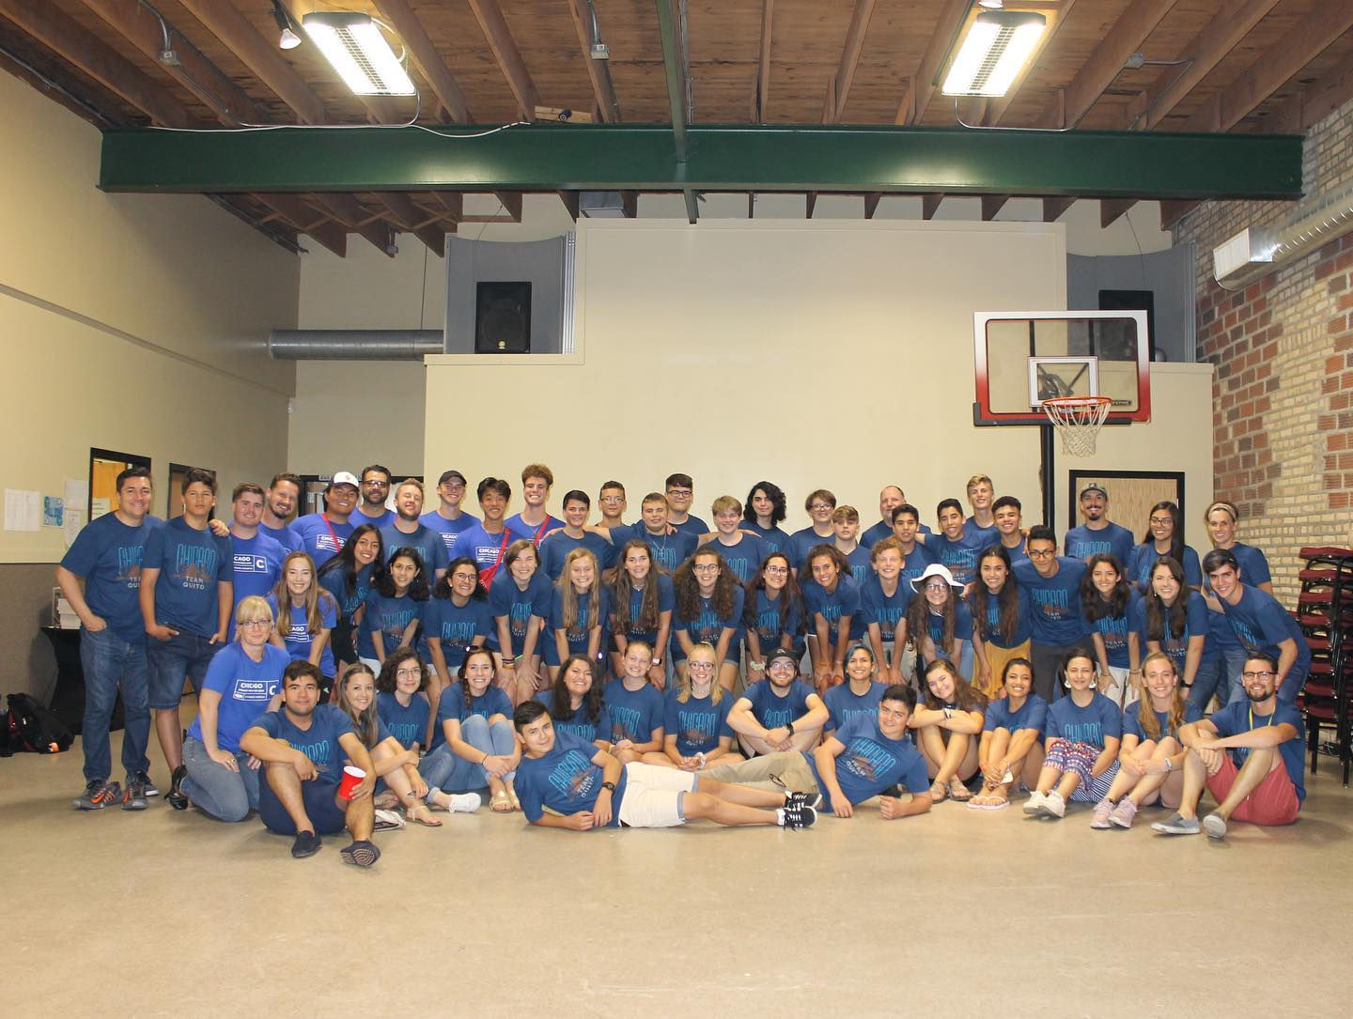
Our philosophy is simple: Make sure that participants are served well, have real ministry opportunity, have tangible kingdom impact on the ground, are exposed to various cultures, have a well rounded experience, and are trained to reproduce what they learn back home.
One recent short-term trip leader had this to share with us, “I keep hearing stories of what God did while we were there! Just amazing. I have had two adult leaders in the past 2 days that shared that they are feeling a call to ministry, that God has been speaking during and since the trip. These two have very successful jobs and are asking what is next and asking how to transition into full time ministry.”
Location: Although we serve and collaborate broadly across the city of Chicago, we have two primary ministry locations.
The Family Empowerment Centers is the anchor location and is on the northside of Chicago in a community called Rogers Park. With roughly 60,000 people calling this area home you will not find a more diverse community in Chicago. With more than 50 primary languages spoken, the economic diversity, diversity in sexual orientation, numerous anti-Christian institutions and the Loyola college campus, opportunities for broad ministry exposure abound. www.familyempower.org
The South Asian Friendship Center is located in the heart of Little India on the northside of Chicago, the ministry here is predominately focused on their Indian and Pakistani neighbors who are of a majority Muslim and Hindu background. www.safcchicago.com
The majority of teams will be exposed to both of these site locations on their trip.
What you will be doing: Now this is a loaded question. In short you will be pouring yourselves out in various ways within our community contexts and then also among one another. We are strong in stressing the importance of “Loving your neighbor” and for us that means anyone you are in close proximity with at any given moment in time becomes your ministry focus.
Teams work with active ministries on the ground and among a diverse people. Many of the people who live in the 10/40 window can be found here as immigrants, students, former refugees, and for business purposes. The nations of the world are on our doorstep and so is the opportunity for teams to reach that world without the high cost of going around the world. We work with pastors, youth pastors and mission coordinators to ensure that we experience God together and that our unique goals are accomplished.
Teams are often empowered to run VBS, soccer camps, day camps, community events, after school programs, help with ESL, clean up in the community, do work projects and a myriad of other things while with us depending on the season.
What will you receive: We highly value pouring into our teams and this is what separates Envision Chicago from other, non-Envision, mission trip experiences. We incorporate trainings that will equip your participants to not only serve well during their trip but be equipped to take the skills they learn back home and implement them locally. We create cultural immersion experiences that will pull them out of a more monocultural understanding into a broader understanding regarding the peoples and religions of the world. There is often exposure and discussions that take into account homelessness as well as a myriad of other societal urban and world complexities.
One leader commented in reference to the wholistic nature of the trip and what they received, “This is no mission trip.” His experience, as is the experience of most, is that a mission trip is all about pouring out. Not in Chicago.
The nuts and bolts:
Cost: The cost for a trip is $475 per person for a weeklong trip. Trips run from Sunday afternoon (we encourage teams to arrive no later than 4:00) until Saturday morning. Trips end as soon as the team cleans up the facility that morning. Teams can linger on Saturday and site see but our staff usually needs the 24-hour period between Saturday and Sunday to recuperate for the next team.
Extended trips can be arranged so long as there is room in the week leading up to or after your trip but an additional fee of $65 per person will be added to the $475 base for each extra day.
Weekend trips are also welcome, and they cost $75 per night or $150 for a Friday afternoon (beginning with dinner) until a Sunday lunchtime.
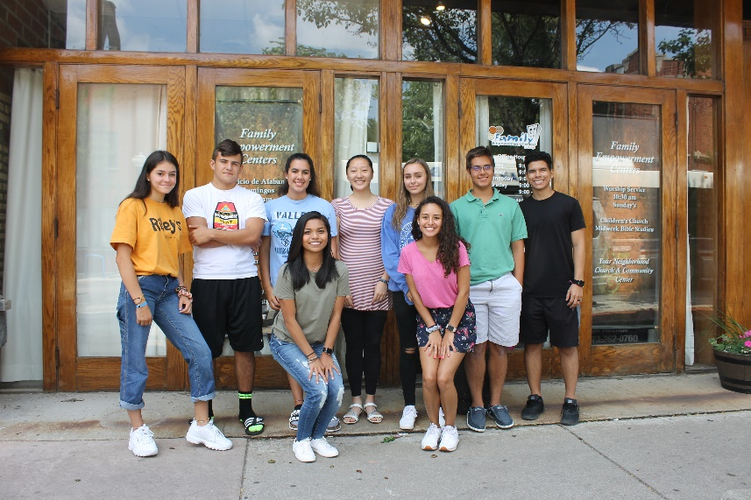
Cost includes everything you need to serve for the week, food and supplies. Teams are responsible for travel to and from the site (but once on site we provide transportation if needed). Teams site seeing expenses are also their responsibilities (travel, food, site seeing fees)
Accommodations: Our facility has held up to 55 people in it at a time and we have spillover opportunities for teams over 55. We also find that having teams from other churches the same week creates a great learning experience as well and so we will add teams to the same week until we hit a firm 40-50 people. We are often asked about showers and sleeping arrangements and so we have 2 working showers; guys and girls are separated for sleeping between the classrooms and our multipurpose room.
There are optional mattress & sleeping Bag rentals available. Teams sleep on the floor in our facility and it is highly encouraged that teams bring air mattresses and sleeping bags. If you would prefer renting these items from us, you can do so for $15 per person for the week. This fee is paid directly to the site upon arrival and must be pre-arranged. This cost is utilized to keep our inventory fresh and clean .
Food: One of the best parts of our site location is that it is within walking distance of the worlds foods and so teams will be fed a myriad of foods from the around the world while here. Some of those options may include Vietnamese, Mexican, South Asian, Middle Eastern, and others. We also serve a mixture of cold and hot breakfast during the stay as well as cold cut sandwiches for lunch (or dinner depending on when we serve the main meal). We have found that teams prefer buying their own snacks in between and we have plenty of places within walking distance for them to do that. Also, if teams decide to have a site seeing day, they can pre-make sandwiches or have a meal at their own expense while site seeing. Dietary restrictions are accommodated for and we have found direct conversation upon arrival with individuals who have concerns allows us to purchase foods that they are used to and comfortable with.
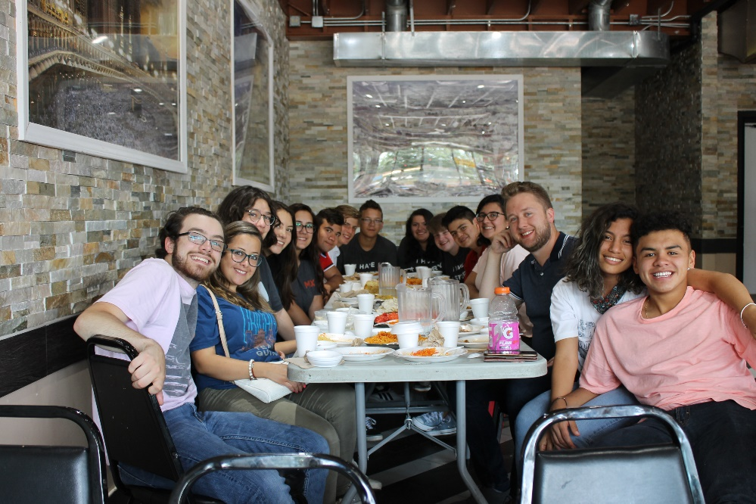
Shirts: We will make sure that everyone who comes gets an Envision Chicago shirt. These shirts may all be the same or different depending on what we have in stock from year to year and the season in which you come.
Schedules: We begin our typical week with a community barbecue (or cookout depending on what part of the country you are from) and then a nuts and bolts discussion of the week ahead. We have trainings 3 to 4 times during the week, often a direct ministry activity (VBS, camp, after school program) daily, often times our direct ministry activities are centered around children but not limited to children, meals , and service projects in the community or at partner sites daily, and in the summer a downtown excursion to see fireworks midweek.
Schedules are tentative until you arrive on site. This is very important to know because sometimes we have to make changes due to unforeseen circumstances. Service projects are also undefined until you arrive because we have a rolling list of projects that as completed are marked as done. Some teams finish a lot of projects and others not as many, so it is hard to schedule them so far in advance. We will provide you a general schedule for the main ideas and flow of the week in advance, but the details are subject to change.
What we ask of you: Come with the expectation to give and serve, in other words be flexible. The more open you are to let the experience be defined by God as you serve the better the experience will be for you and the team. Do not oversell to the parents what their children will experience. The best things to tell parents is “this is what the trip experience will look like, but some things are subject to change on arrival. The best thing you can do is let your child know that they can trust God that if they go with an open heart that they will see and experience God at work.”
If we have specific needs for you leading up to the trip we will let you know in advance. Also if you have specific things you would like to see accomplished on the trip please let us know in advance so we can do our best to adapt for you.
Safety: Oh, the questions of safety often comes up. My response is always the same: the safest place on earth for any person is exactly where God wants them at any given moment in time. In 10 plus years of hosting teams and 15 plus years of ministry in the community we have not had any significant safety issues. We inform teams when they arrive about do’s and don’ts and so long as teams follow our directions, they tend to do just fine. One year a team came with the idea that wearing different colored bandanas was a good idea to differentiate within their team. We promptly asked they not wear them in public – colors displayed on bandanas can represent gang factions .
Publicity: The best way to catch a glimpse of our site is to check out our webpages and Social media pages. Feel free to harvest photos and videos for the purpose of trip promotion.
www.familyempower.org
www.safcchicaago.com
https://www.facebook.com/familyempower/
https://www.facebook.com/EnvisionChicago/

