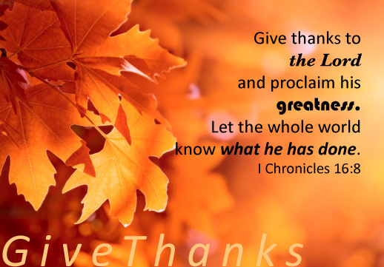
Thorntons in
Argentina

November, 2022

Dear Prayer Partners,

About FURLOUGH: We have been having great meetings in the churches we have visited, and enjoyed the times of fellowship, though I do have to admit that we are getting anxious to get back to Argentina. We appreciate your prayers as we wind up our time here in the US, and head back to Rosario on January 10, 2023.

About MATIAS: You might remember that Matias was saved 4 months ago and was really excited about his new life in Christ. His wife did not share in his excitement and would not accept Jesus as her Saviour. She decided to separate from him and move back with her parents. As you can imagine, Matias became really discouraged and at this time has decided not to come back to church until he can work things out with his wife and children. Please continue to pray for Matias and especially for his wife’s salvation.

About the RIBBA CHURCH PLANTER’S CONFERENCE: We praise God for the churches who have already sent offerings to help pay the transportation expenses for the pastors and their families to attend the conference in Rosario. We are still $2,250.00 short of what is needed to help the 16 families who have already confirmed their desire to attend (about 60 people total). Would you be able to assist and be a blessing to these national pastors and their families? If so, you can send an offering through the mission office, GIBM, marked for RIBBA in Argentina.

We give THANKS for you! THANK YOU so much for being an important part in the ministry of winning souls, training leaders and planting churches in Argentina. Have a wonderful Thanksgiving!

Steve and Pam

“I thank my God upon every remembrance of you ...” Philippians 1.3

