SHOULD WE CELEBRATE JESUS’ SECOND COMING

Nov 27, 2022

Message by Craig Minke

In the book of Matthew, Jesus admonished his followers to be continuously prepared for his arrival by doing the things he instructed them to do.
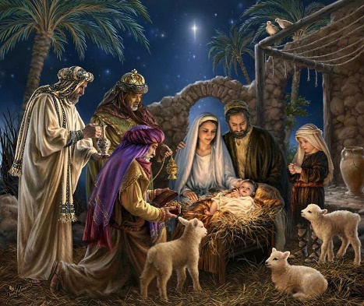
We begin the Advent season this week
- A time when we celebrate the incarnation of Jesus, his arrival into the life of every believer, and his anticipated Second Coming.
- Advent means “coming” or “arrival,” so we remember the various ways Jesus comes to us individually and collectively.
- Most of the imagery surrounding this season focuses on Christ’s first coming, and that makes sense.
- The nativity story is amazing, with memorable visuals like the manger, guiding star, and wise men. It is easy to turn our attention to such a phenomenal event.
- Every believer has some kind of personal history with Jesus; a story about how he arrived in our lives.
- We may not have difficulty rejoicing over Jesus’ first coming and personal advent, but what about Christ’s Second Coming?
- Do we celebrate his eventual return in the same way?
- Of course, the Second Coming brings us joy and hope that one day all things will be made new.
- But, what about the event itself?
- Do we hope to bear witness to the return of Christ and the end of this world?
- For many of us, the answer is no.
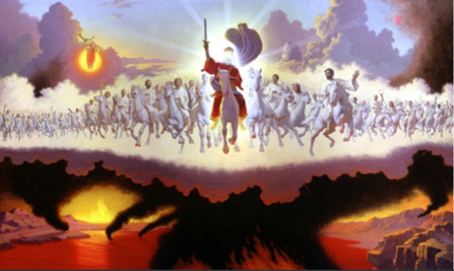
For many of us, Christ’s Second Coming is a little scary.
- At the very least, it can seem a bit strange.
- Let’s be honest, what we think we know about the return of Jesus does not make most people break out in celebratory singing.
- Notice that I said “what we think we know” because it appears as though no one really knows for sure.
- Doesn’t it seem like everyone says something different?
  - Some think a bunch of people disappear in something called the Rapture.
  - Some say that there will not be a Rapture, but a big war when people see Jesus.
  - Maybe both?
  - It could be that believers have to go to a place of safety, but didn’t they already disappear in the Rapture?
  - I think there may be some witnesses or an anti-Christ.
  - There’s definitely a dragon, although no one seems to agree on the identity of any of these folks.
  - Are they even people?

Many seem to believe that Jesus’ return will happen soon, but every prediction of when has been wrong.
- Do we just need to find the right formula or algorithm?
- Maybe the bottom line is that at Jesus Christ’s return there will be lots of death, lots of judgment, the end of the world, and it can happen at any time.
- Right?*

I do not mean to make light of this important topic, but I am trying to show that there is a lot of uncertainty, confusion, and fear associated with our understanding of Christ’s Second Coming.
- This apprehension can negatively affect how we see Jesus and his return.
- In many Christian circles, Jesus’ Second Coming is used almost like a threat of impending doom to keep us in line instead of a source of joy and hope.
- This undercuts two core beliefs of our faith
  - that the gospel of Jesus Christ is, in fact, good news, and
  - that God is love.
- Advent season is a great time to get more clarity on what we need to know about Jesus’ return, so we can internalize the truth that we never need to fear the Savior of humanity.
- For answers, we will start with Jesus and some of what he says about his Second Coming. Let’s look at his words recorded in the Book of Matthew:
MATT 24:36-44 ³⁶ “But about that day or hour no one knows, not even the angels in heaven, nor the Son, but only the Father.
³⁷ As it was in the days of Noah, so it will be at the coming of the Son of Man.
³⁸ For in the days before the flood, people were eating and drinking, marrying and giving in marriage, up to the day Noah entered the ark;
³⁹ and they knew nothing about what would happen until the flood came and took them all away. That is how it will be at the coming of the Son of Man.
⁴⁰ Two men will be in the field; one will be taken and the other left.
⁴¹ Two women will be grinding with a hand mill; one will be taken and the other left.
⁴² “Therefore keep watch, because you do not know on what day your Lord will come.
⁴³ But understand this: If the owner of the house had known at what time of night the thief was coming, he would have kept watch and would not have let his house be broken into.
⁴⁴ So you also must be ready, because the Son of Man will come at an hour when you do not expect him. (NIV)

Before we unpack the passage, we should take note of Jesus’ starting point.
- All that he shares in these verses is from the perspective of someone who does not know when the events he described will happen.
- Jesus never relinquished his divinity.
- He was and is 100% God and 100% human.
- However, in his incarnation, Christ humbled himself and lived like a human being, except for a few occasions when the Father instructed him to reveal some of his divine power such as the transfiguration.
- So, in his humanity, Jesus did not know when he would return.
- Therefore, we have to conclude that the moment of Christ’s return is not important for us to know.

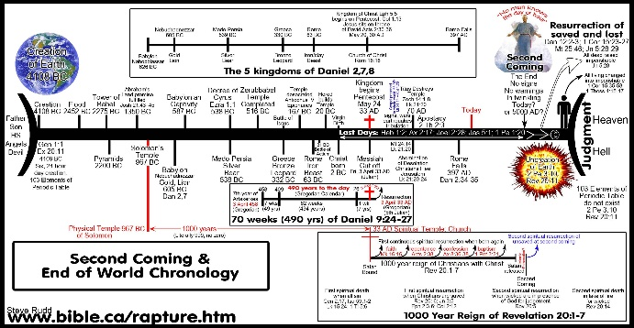

Studying this and other similar passages to devise a detailed timeline and sequence of events of the end of time misses the point.
- While we should seek to understand Scripture as best we can, it is not important to know the “when” of Christ’s return.
- Even the angels in heaven and Jesus himself does not know the date of his return. (Matt 24:36)
- We are not even supposed to know the key events surrounding the Second Coming.
- If we were, the Bible would be far less murky on the subject.
- We do not need to know these things in order for us to do the most important things,
  - follow Christ,
  - worship, and
  - bear witness to him.
- We are naturally curious about the future events hinted to in the Bible, however, we should not use prophecy for our own purposes.
- We need to approach prophecy in the way God intended.

In this passage, Jesus explained what he wants his audience to know.
- First, he assured his followers that he will return at some undetermined time after his ascension.
- Next, the Second Coming could happen at any time, so believers should live holy lives, not self-centered lives.
- Last, Jesus’ return could take time, so we should be prepared to persist in participating in his life and work.
- Put simply, Jesus told his followers, in light of his Second Coming, to live as if Jesus was coming today, but plan like he would not return in his audience’s lifetime.
- Not doing so could have unpleasant and lasting consequences for those who do not remain spiritually prepared.

In his compassion, Jesus taught his disciples how to navigate the “now” and “not yet” of the kingdom of God.
- Jesus ushered in the kingdom (an eternal space where God lovingly rules and people strive to follow him as one), and his followers can experience the benefits of the kingdom now.
- At the same time, we live in the “present evil age,” and the kingdom is hidden and will one day be revealed in full.
- Jesus revealed the kingdom, but our brokenness causes humans to experience the kingdom imperfectly.
- However, he promised to return and make everything new so that we can all experience the kingdom of God in full for all eternity.

Jesus knows us, and he knows the natural tendencies of humans who exist in ambiguous times – like the period of the “now” and “not yet.”
- In this passage, Christ addressed two harmful ways of being.
- First, Jesus had the self-indulgent in view.
  - Some live by the saying, “When the cat’s away, the mice will play.”
  - If these folks knew when Christ would return, they would live self-centered lives and only “act Christian” when the deadline approached.
  - The danger of this way of being is that the self-indulgent acknowledge the coming kingdom but do not truly want to be a part of it.
  - The purpose of our faith is not to produce people who look Christian, it is to help us get to know Christ and be changed by that relationship.
  - The self-indulgent worship their appetites and desires and do not prioritize God.
  - They want to look outwardly holy to avoid eternal unpleasantness, but do not see sin as the enemy it is.
  - They want to embrace sin without experiencing the consequences.
  - The self-indulgent show by their actions that they do not want to be citizens of the kingdom, and God will not force them to be otherwise.

- Second, Jesus spoke to the self-righteous, those at the other extreme.
  - The self-righteous will be tempted to disengage from the world because they believe Christ’s return to be very soon.
  - In their mind, the world will be destroyed soon so why bother dealing with anyone who is not “saved”?
  - They have an “us” and “them” mentality and are comfortable with others being destroyed as long they and those they care about are safe.
  - The self-righteous do not obey Christ’s imperative to love our fellow humans and make sacrifices for their well-being.
  - They misunderstand the nature of love and show they have not been transformed by their proximity to Christ.
  - They also do not understand that just as Jesus was sent by the Father, Christians are sent by Christ into the world.
  - Loving our neighbors and bearing witness to the reality of Jesus are not optional activities for believers, because they were not optional activities for God.
  - Therefore, the self-righteous reject the King of kings by refusing to follow in his ways, and God will not force them to be otherwise.
What do you think would happen if people knew the exact time of Christ’s return? DEC 5, 2029
  - We are in 2022, lots of time we will think about God as time gets closer. Lets go do our own thing now. ( a little sin, a little fun etc)
  - In 2025 life is good, let’s continue to ignore God we have lots of time a little more sin, compromise on out values
  - 2027 more of the same, PICTURE OF THE PRODIGAL SON, STILL ENJOYING THE GOOD LIFE

  - January 1, 2029 this is the year have to prepare for Jesus’ return, but summer is coming and we plan to have a wild revelling summer right after summer
  - I am a bit worried with all the wars and fighting going on, but life is still good here in Canada
  - Oct 1, 2029 – Need to get serious about this but I still have 2 months
  - Dec 1, 2029 – Hi God I am here to be saved, forgive, God can you hear me. Not sure if he hears me, fear worry and anxiety begins.
  - Dec 3, 2029 still not sure if God hears me, I don’t feel warm and fuzzy that things will work in my favor. Maybe I need to fast to get his attention.
  - Dec 4, 2029 Nuclear bomb have exploded around the world. God it would be good for you to listen to me now. Where are you?
  - The scripture in Luke comes to mind

LK 6:46 “Why do you call me, ‘Lord, Lord,’ and do not do what I say?

MATT 7:21-23 ²¹ “Not everyone who says to me, ‘Lord, Lord,’ will enter the kingdom of heaven, but only the one who does the will of my Father who is in heaven.
²² Many will say to me on that day, ‘Lord, Lord, did we not prophesy in your name and in your name drive out demons and in your name perform many miracles?’
²³ Then I will tell them plainly, ‘I never knew you. Away from me, you evildoers!’

So, Jesus explains to believers who exist in this present evil age, that we should live as if Christ was coming today, but plan like his arrival is far in the future.
- Living like Christ was coming today means that we strive to take advantage of every opportunity to increase our intimacy with him.
- It means we desperately pursue him as the source of our life and desire to worship him in all that we think, say, and do.
- We pursue Christ not out of fear of death but because he pursued us to give us life.
- We have tasted and seen that he is good, and nothing else will satisfy.

Planning like Christ’s arrival is far in the future means that we do not ignore the plight of our neighbor.
- We are compelled by love to build authentic relationships with others, especially those who do not yet know Christ.
- We do so not with ulterior motives, but by the Spirit and with the hope that something of Christ will shine though us to spark something in them.
- Believers bear witness to the King by offering our neighbors opportunities to experience the kingdom with us.
- In other words, we participate in the work Jesus is doing to recreate the world.

What Jesus is asking of his followers is nothing new.
- He plainly said in multiple ways that to experience his salvation, we must love God and love our neighbor
LUKE 10:27-28 ²⁷ He answered, “‘Love the Lord your God with all your heart and with all your soul and with all your strength and with all your mind’; and, ‘Love your neighbor as yourself.’” ²⁸ “You have answered correctly,” Jesus replied. “Do this and you will live.”
- That is what believers are to be doing no matter the times.
- We were not told the timing or precise circumstances of Christ’s return because that information does not change anything about what Christians are to be doing.
- What is different about this passage in Matthew is that Christ is warning us that there are consequences to not doing things his way.
- While some of the descriptions of the end of this age are scary, the inclusion of consequences should only bother those who commit to disobedience.
- Those who sincerely strive to love God and love others need feel nothing but excitement at Christ’s Second Coming.

The most important thing about this passage is that Jesus said it in the first place.
- The only reason to warn someone of danger is to keep any harm from happening to them.
- This reminds us that Christ is a Savior not a destroyer.
- He is a Savior, not because he is playing a role; it is who he is.
- It is part of his essential nature.
- We cannot be so distracted by our curiosity that we forget who is speaking to us.
- Think about the love Christ showed for all, the way he stood up for the marginalized and oppressed, and how he did all he could to eliminate suffering.
- This is the one who is coming back.
- Think about the compassion of Jesus, the care he took in teaching his disciples, and the intimate love he showed for the Father.
- This is the one who is coming back.
- Think about how he boldly defeated evil, how he humbly submitted to the leading of the Spirit, and how he bore every indignity for us.
- This is the one who is coming back.

We should celebrate the Second Coming of Jesus for many reasons, but primarily because of Jesus himself.
- He is in every way wonderful, and he is coming back for us!
- He is in every way beautiful, and he is coming back for us!
- He is in every way worthy, and he is coming back for us!
- During Advent, we should continue to make much of the incarnation and personal coming of Christ.
- However, let us equally celebrate that Jesus is coming back.
- We have nothing to fear because it is Jesus who is coming.
- Come, Lord Jesus! Come!

CLOSING PRAYER

