DEC 18, 2022
LOVE CAME DOWN
MESSAGE BY CRAIG MINKE

WELCOME: Welcome to all our guests, visitors who got our invitation. We are GCI (Grace Communion International Canada). We are a Spirit-led evangelical denomination with churches in over 70 countries around the world. In fact, some of our immigrants have come from our churches in Malawi and our churches in the refugee camps of Kenya. We meet here every Sunday afternoon at 1:30 pm for worship.

I would like to begin my message with a video from the beginning.

PLAY VIDEO: In The Beginning (The Creation Story)

In the very beginning God created all things. And mankind was the crown jewel of his creative work.

Humans were created by God for a purpose, we did not evolve. Consider the incredible human body. Did you know that:
- There are anywhere between 60,000 -100,000 miles of blood vessels in your body. If they could be taken out and laid end to end they would travel around the earth more than 3 times.
- Every second, your body produces 25 million new cells. This means in 20 seconds you will have produced more cells then there are people in North America.
- The human heart beats around 100,000 times every day or about 30 million times in a year.

Humans were miraculously designed by God. They are masterpieces of his design and function far beyond the scope of chance or evolution.

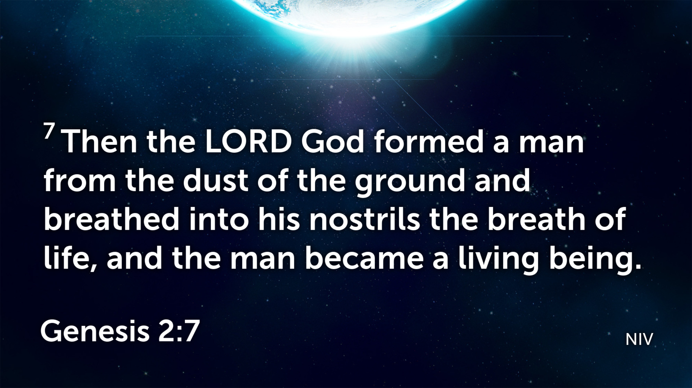

The book of Genesis describes God’s creation of the living world and mankind being created in his image.

God instructed the first man Adam and his wife Eve to CHOOSE LIFE. In choosing life there would be no pain, now wars, no sorrow, no fear, not hurts.

Adam and Eve however, did not make wise choices. They disobeyed God, their own way. They sinned and every person since that time has sinned. This has resulted in the trouble we see in this world today. Mankind chose to pursue his own agenda and do his own thing resulting in conflicts, wars, strife, pain, sorrow, hardship and difficulty. Mankind choose the way of sin, and that path has been followed since the beginning of time. The end result of that choice was death.

But there’s GOOD NEWS. The Bible tells us the gift of God is ETERNAL LIFE. The Bible describes in detail that the gift of God is eternal life. CHOOSING LIFE RESULTS IN ETERNAL LIFE.

ROM 6:23 ²³ For the wages of sin is death, but the free gift of God is eternal life in Christ Jesus our Lord.

From the very beginning of creation described in Genesis God set a plan in motion that would change the future of mankind for all eternity. Even though Adam and Eve sinned and abandoned God, God in his infinite love did not abandon them….AND HE HAS NOT ABANDONED US EITHER.

You see, there was NO hope for mankind, no eternity, no future, no eternal life, no tomorrow, no life after death, no resurrection. We all have sinned and deserve death.

UNTIL JESUS CHANGED EVERTHING

About 2000 years ago JESUS, the same Jesus (God) who is a member of the trinity created the universe, the galaxies, the planets mountains, volcanoes, rivers oceans he empties himself of his power and CAME TO EARTH as a tiny baby.

He did not come in full power and might as people expected but he came to the world as a helpless baby. GOD BECAME FLESH. God moved into our neighborhood. This is what we celebrate at Christmas. God came to earth.

Lets’s consider the following scriptures from the book of Matthew.

MATT 1:18 ¹⁸ Now the birth of Jesus the Messiah took place in this way. When his mother Mary had been engaged to Joseph, but before they lived together, she was found to be pregnant from the Holy Spirit. (NRSV)
- Here we read that Mary likely a teenager is engaged to Joseph and it is found she is pregnant by the Holy Spirit.
- She tells Joseph that God did it!!!
- Think of it today if your engaged spouse got pregnant. Would you believe here if she told you the Holy Spirit got her pregnant.

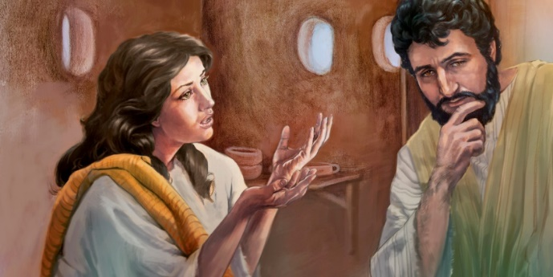
- Well neither did Joseph believer the Holy Spirit was responsible for getting his future spouse pregnant.
- This was a big deal by the Jewish law of the day. Mary should have been killed since the engagement was a binding as the marriage laws.
- Joseph could divorce here and get back the bride price or the dowery he had paid to her family.
- Let’s read on

MATT 1:19 Her husband Joseph, being a righteous man and unwilling to expose her to public disgrace, planned to divorce her quietly. (NRSV)
- Joseph is described as “being a righteous man.”
- He was unwilling to let Mary be disgraced.
- By the Jewish law, Joseph would be expected to divorce Mary for her apparent adultery.
- Instead of going through the courts, he attempts to “divorce her quietly” as a way of minimizing as much public shame as he could.
MATT 1:20-21 ²⁰ But just when he had resolved to do this, an angel of the Lord appeared to him in a dream and said, “Joseph, son of David, do not be afraid to take Mary as your wife, for the child conceived in her is from the Holy Spirit.
²¹ She will bear a son, and you are to name him Jesus, for he will save his people from their sins.” (NRSV)
- Now we find that Joseph is presented with the truth of his and Mary’s situation.
- The child was NOT CONCEIVED by another human but is conceived by the Holy Spirit.
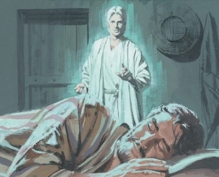
- For Joseph to continue with the marriage will mean he will now share in the shame that would otherwise be limited to Mary.
- It will be assumed that Joseph and Mary conceived the child before their marriage, which will be a stigma they both would have to carry.
- It’s interesting that Joseph and Mary will be branded with sinners in their community as they play their part of bringing into the world the one who “will save his people from their sins.” THE MESSIAH
MATT 1:22-23 ²² All this took place to fulfill what had been spoken by the Lord through the prophet:
²³ “Look, the virgin shall become pregnant and give birth to a son, and they shall name him Emmanuel,” which means, “God is with us.” (NRSV)
- Matthew only gives one reason to why Jesus was born in this way, and that is to fulfill Scripture.
- This tells us the importance God places on his written word. (the Bible)
- He has chosen to speak through his written word and even today we can go to the Scriptures to hear God.
- He is meeting with us even today in the pages of the Bible.
- Let’s read on:
MATT 1:24-25 ²⁴ When Joseph awoke from sleep, he did as the angel of the Lord commanded him; he took her as his wife ²⁵ but had no marital relations with her until she had given birth to a son, and he named him Jesus. (NRSV)
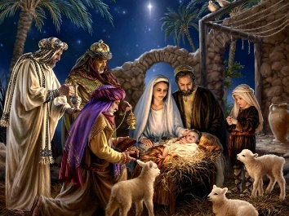

SO WHY DID JESUS COME TO EARTH AS A HUMAN BABY?

Because of the foolish choices and the SINS of man, the Bible talks about a penalty that would have to be paid. Romans 6:23 says the wage of sin is death. The Bible talks about a perfect sacrifice that had to be offered to pay for the penalty of sin. But NO MAN IS WITHOUT SIN. NO MAN IS PERFECT.
- Read what Romans says:

ROM 3:23 ²³ since all have sinned and fall short of the glory of God;

The perfect sacrifice had to be a perfect human and only God himself could be that perfect sacrifice. Jesus the Son of God came to the earth as a helpless human baby. We call this the INCARNATION. He spend approximately 30 years growing up on earth and during his entire life HE DID NOT SIN.

During the last 3 years of his life he mentored 12 disciples He walked with them , talked with them, and cried with them and would use these men to begin his church on earth.

As a human Jesus experience pain, sorrow, grief and loss. His life as a human enabled him to fully feel and understand the things you and I experience in this life. He is truly an empathic, caring and compassionate KING who now sits at the heavenly Father’s right hand in heaven interceding for us.
- How are you feeling today?
  - Disappointed? Jesus understands
  - Depressed? Jesus understands
  - Lonely? Jesus understands
  - Are you troubled, worried, overwhelmed? Jesus understands because he has been where you are.
  - He knows exactly how you feel!!!!
  - He experienced the same pain, sorrow, hurt and endured the same trials that you and I endure today. His life on earth qualified him to fully feel and understand that things we go though in this life which make him a truly empathetic caring and compassionate God.
And the good news is THAT HE IS THE GIFT.

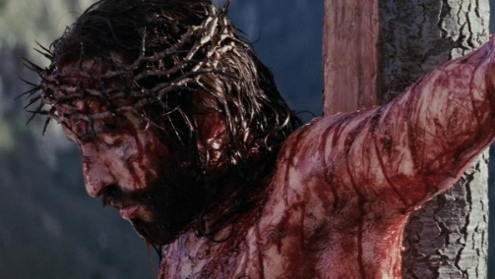

After living 30 some perfect years on earth as a human he was wrongly accused and arrested, and condemned to death on the cross. He LAID DOWN his life to become the perfect sacrifice to pay the penalty of the sins of all mankind. He was as is the gift because the Father raised him from the grave to ETERNAL LIFE.

And we can have that ETERNAL LIFE TOO! We have to receive the gift of Jesus. We have to choose LIFE.

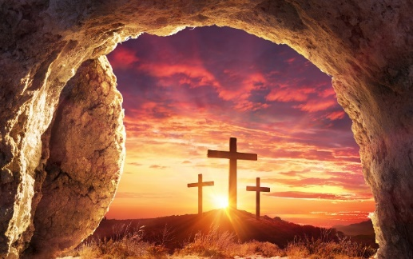

CHOOSING LIFE involves REPENTANCE (turning from our sins)
CHOOSING LIFE involves being BAPTIZED
CHOOSING LIFE involves the receiving of the HOLY SPIRIT which will give us the POWER, and the WISDOM, and the ABILITY to live in a new way.

- The Birth of Jesus, His Death on the Cross and His Resurrection changed the course of humanity forever. The doors of LIFE, ETERNAL LIFE SWUNG WIDE OPEN. The gift of SAVATION, the gift of GRACE, the gift of UNDESERVED PARDON is available to everyone.

There is one verse that sums everything up. I am sure many of you have heard of this scripture.
- John writes

JN 3:15-17 ¹⁵ that whoever believes in him may have eternal life.
¹⁶ “For God so loved the world that he gave his only Son, so that everyone who believes in him may not perish but may have eternal life.
¹⁷ “Indeed, God did not send the Son into the world to condemn the world but in order that the world might be saved through him.

These 3 verses sum everything up very well.

SO WHY DO WE CELEBRATE CHRISTMAS?
- Jesus is the reason for the season.
- Christmas is about Christ.
- God became flesh and saved mankind.

In Bible translation of the Message we read in John 1:14

JN 1:14 The Word (God Himself) became flesh and blood, and moved into the neighborhood. We saw the glory with our own eyes, the one-of-a-kind glory, like Father, like Son, Generous inside and out, true from start to finish.

In closing I would like to play a video which is a summary of my message today.

PLAY VIDEO: For God So Loved the World

If our greatest need had been information, God would have sent us an educator;
If our greatest need had been technology, God would have sent us a scientist;
If our greatest need had been money, God would have sent us an economist;
If our greatest need had been pleasure, God would have sent us an entertainer;
But our greatest need was forgiveness, so God sent us a Savior.

This is what we celebrate today.

CLOSING PRAYER

