CHRIST CHURCH
of Exeter

__________________________________________

Live
joyfully in faith

Connect
with God and one another

Serve
the local and global community ____________________________________

January 8, 2023
First Sunday after Epiphany
8:00 and 10:00 am
www.christchurchexeter.org

Reflections on Today’s Readings

Today is one of four occasions in the year designated by the Prayer Book as a baptismal day. (The other three are Easter, Pentecost, and All Saints’ Day.) Each of the four days has its particular theme, which enhances our understanding of one aspect of the primary Christian sacrament, Holy Baptism.

On this First Sunday after the Epiphany, we celebrate the Baptism of Our Lord. Jesus’ baptism was for all the Gospel writers and in the apostolic preaching of the Gospel, the event that initiated the redemptive ministry of the Messiah. It was in that event that Jesus was revealed as Messiah (Christ). God designated him as the beloved son and he was anointed by the Holy Spirit. We administer Holy Baptism today in the context
of this theme.

In Holy Baptism, each Christian is adopted as the child of God. Each Christian becomes a
“messianic” person, anointed by the Holy Spirit. We do not simply become passive recipients of the benefits of Christ; we are “christed” or christened. We become sharers in his life and in his redemptive ministry.

Those baptized today and anointed with Chrism are received “into the household of God.” They join with that household in confessing “the faith of Christ crucified,” proclaiming his resurrection and sharing in his eternal priesthood -- the priesthood that is enacted sacramentally in Eucharist and daily in lives of self-giving love toward one another and toward the world.

From The Rite Light: Reflections on the Sunday Readings and Seasons of the Church Year. Copyright © 2009 by Michael W. Merriman. Church Publishing Incorporated, New York.

Welcome to Christ Church: If you are visiting for the first time, please fill out the welcome cards in the pews and hand it to a member of the clergy after the service. Welcome bags are available in the narthex entrance hall. Books and resources for children are located on the table near the side left door. Although there are customary postures (such as standing and kneeling) in Episcopal worship, you are invited to be seated at any point, according to your needs and comfort.

Coffee Hour Fellowship: Please join us in the Parish Hall after each service.

Sunday school for children ages 5-12 will gather at 9:30 A.M. downstairs in the corner classrooms. Children will return to worship by the time of the Peace. Child Care is also available beginning at 9:30 a.m.

Healing team is available to offer healing prayers during the Eucharist, at the side of the church. Please tell your healing minister if you have a specific prayer need and if you would like a laying on of hands, just prayers or both.

Communion: Both the bread and wine are offered at Communion. You may drink from the cup, or place your hand on the base as a sign of devotion. Intinction (dipping the bread/wafer) is not permitted at this time. Please know that Communion in one kind (bread/wafer only) is sufficient to experience the Real Presence of our Risen Lord.

The Holy Eucharist

[10:00 service]
Prelude I’ve Been in the Storm so Long arr. by Calvin Taylor
Deep River

✠ All stand, as they are able, as the bell tolls.

[10:00 service]
Processional Hymn 135 Songs of thankfulness and praise Salzburg

Presider Blessed be God: Father, Son and Holy Spirit.
People And blessed be God’s kingdom, now and forever. Amen.

In Unison: Almighty God, to you all hearts are open, all desires known, and from you no secrets are hid: Cleanse the thoughts of our hearts by the inspiration of your Holy Spirit, that we may perfectly love you, and worthily magnify your holy Name; through Christ our Lord. Amen.

[10:00 service] Gloria S-280

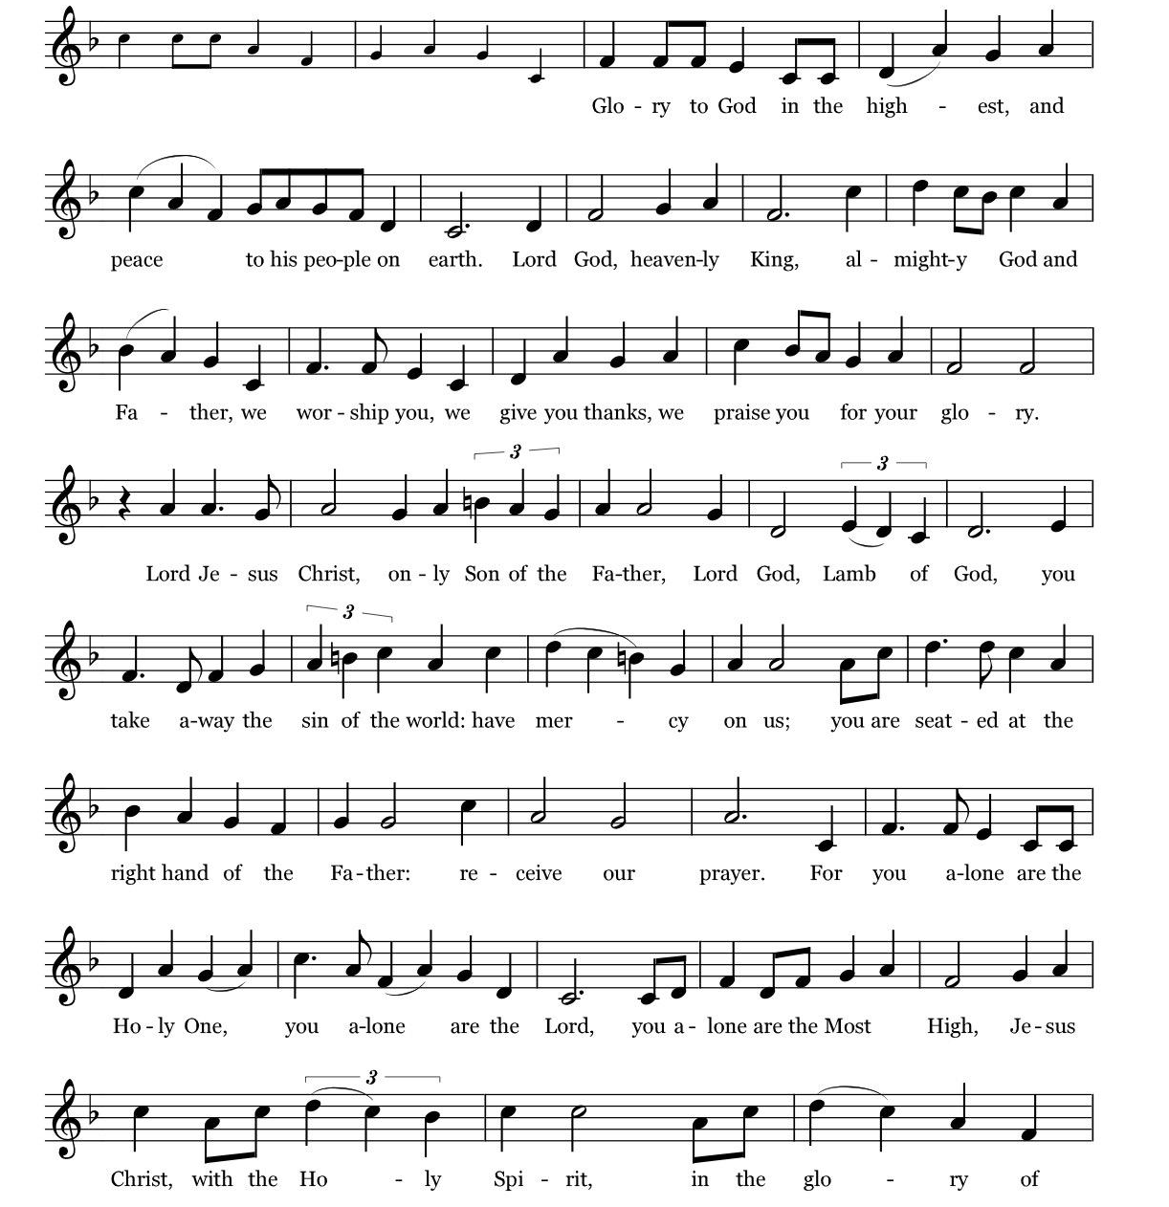
Music: Robert J. Powell © 1985 - Church Publishing, Inc. All rights reserved. Reprinted under OneLicense.net A700244
The Collect of the Day

Presider The Lord be with you.
People And also with you.
Presider Let us pray.

Father in heaven, who at the baptism of Jesus in the River Jordan proclaimed him your beloved Son and anointed him with the Holy Spirit: Grant that all who are baptized into his Name may keep the covenant they have made, and boldly confess him as Lord and Savior; who with you and the Holy Spirit lives and reigns, one God, in glory everlasting. Amen.

The First Reading Isaiah 42:1-9
Reader A Reading from the Book of Isaiah
Here is my servant, whom I uphold, my chosen, in whom my soul delights; I have put my spirit upon him; he will bring forth justice to the nations. He will not cry or lift up his voice, or make it heard in the street; a bruised reed he will not break, and a dimly burning wick he will not quench; he will faithfully bring forth justice. He will not grow faint or be crushed until he has established justice in the earth; and the coastlands wait for his teaching. Thus says God, the Lord, who created the heavens and stretched them out,
who spread out the earth and what comes from it, who gives breath to the people upon it and spirit to those who walk in it: I am the Lord, I have called you in righteousness, I have taken you by the hand and kept you;
I have given you as a covenant to the people,
a light to the nations, to open the eyes that are blind, to bring out the prisoners from the dungeon, from the prison those who sit in darkness. I am the Lord, that is my name;
my glory I give to no other, nor my praise to idols. See, the former things have come to pass, and new things I now declare; before they spring forth, I tell you of them.”

Reader The word of the Lord.
People Thanks be to God.

Psalm 29 pg 620 in BCP

1 Ascribe to the Lord, you gods, *
ascribe to the Lord glory and strength.

2 Ascribe to the Lord the glory due his Name; *
worship the Lord in the beauty of holiness.

3 The voice of the Lord is upon the waters; the God of glory thunders; *
the Lord is upon the mighty waters.

4 The voice of the Lord is a powerful voice; *
the voice of the Lord is a voice of splendor.

5 The voice of the Lord breaks the cedar trees; *
the Lord breaks the cedars of Lebanon;

6 He makes Lebanon skip like a calf, *
and Mount Hermon like a young wild ox.

7 The voice of the Lord splits the flames of fire; the voice of the Lord shakes the wilderness; *
the Lord shakes the wilderness of Kadesh.
8 The voice of the Lord makes the oak trees writhe *
and strips the forests bare.

9 And in the temple of the Lord *
all are crying, "Glory!"

10 The Lord sits enthroned above the flood; *
the Lord sits enthroned as King for evermore.

11 The Lord shall give strength to his people; *
the Lord shall give his people the blessing of peace.

The Second Reading Acts 10:34-43
Reader A Reading from the Acts of the Apostles
Peter began to speak to them: “I truly understand that God shows no partiality, but in every nation anyone who fears him and does what is right is acceptable to him. You know the message he sent to the people of Israel, preaching peace by Jesus Christ--he is Lord of all. That message spread throughout Judea, beginning in Galilee after the baptism that John announced: how God anointed Jesus of Nazareth with the Holy Spirit and with power; how he went about doing good and healing all who were oppressed by the devil, for God was with him. We are witnesses to all that he did both in Judea and in Jerusalem. They put him to death by hanging him on a tree; but God raised him on the third day and allowed him to appear, not to all the people but to us who were chosen by God as witnesses, and who ate and drank with him after he rose from the dead. He commanded us to preach to the people and to testify that he is the one ordained by God as judge of the living and the dead. All the prophets testify about him that everyone who believes in him receives forgiveness of sins through his name.”

Reader The word of the Lord.
People Thanks be to God.

Sequence Hymn 121, vv. 1-3 Christ, when for us you were baptized Caithness

The Gospel Matthew 3:13-17
Gospeler The Holy Gospel of our Lord Jesus Christ according to Matthew
People Glory to you, Lord Christ.
Jesus came from Galilee to John at the Jordan, to be baptized by him. John would have prevented him, saying, “I need to be baptized by you, and do you come to me?” But Jesus answered him, “Let it be so now; for it is proper for us in this way to fulfill all righteousness.” Then he consented. And when Jesus had been baptized, just as he came up from the water, suddenly the heavens were opened to him and he saw the Spirit of God descending like a dove and alighting on him. And a voice from heaven said, “This is my Son, the Beloved, with whom I am well pleased.”

Gospeler The Gospel of the Lord.
People Praise to you, Lord Christ

Sermon The Rev. Mark Pendleton

✠ A brief period of silence follows the sermon.

The Nicene Creed (said together) Page 358 in the Book of Common Prayer

We believe in one God,
the Father, the Almighty,
maker of heaven and earth,
of all that is, seen and unseen.

We believe in one Lord, Jesus Christ,
the only Son of God,
eternally begotten of the Father,
God from God, Light from Light,
true God from true God,
begotten, not made,
of one Being with the Father.
Through him all things were made.
For us and for our salvation
he came down from heaven:
by the power of the Holy Spirit
he became incarnate from the Virgin Mary,
and was made man.
For our sake he was crucified under Pontius Pilate;
he suffered death and was buried.
On the third day he rose again
in accordance with the Scriptures;
he ascended into heaven
and is seated at the right hand of the Father.
He will come again in glory to judge the living and the dead,
and his kingdom will have no end.

We believe in the Holy Spirit, the Lord, the giver of life,
who proceeds from the Father and the Son.
With the Father and the Son he is worshiped and glorified.
He has spoken through the Prophets.
We believe in one holy catholic and apostolic Church.
We acknowledge one baptism for the forgiveness of sins.
We look for the resurrection of the dead,
and the life of the world to come. Amen.

Prayers of the People (adapted from the New Zealand prayer book)

Holy God, you have promised to hear when we pray in the name of your Son. Therefore in confidence and trust we pray for the Church:

Silence

Enliven the Church for its mission that we may be salt of the earth and light to the world. Breathe fresh life into your people. Give us power to reveal Christ in word and action.

We pray for Michael our Presiding Bishop, Rob our Bishop and all the people of God.

Silence
We pray for the world:

Creator of all, lead us and every people into ways of justice and peace.
That we may respect one another in freedom and truth.

Awaken in us a sense of wonder for the earth and all that is in it.
Teach us to care creatively for its resources.

We pray for the end of the war in Ukraine and the suffering of the innocent through
the cold winter months.

Silence
We pray for our community:
God of truth, inspire with your wisdom those whose decisions affect the lives of others
that all may act with integrity and courage.

Give grace to all whose lives are linked with ours.
May we serve Christ in one another, and love as he loves us.

Silence

We pray for those in need:

Chuck, Marlene & Steve, Martha, Bobbi, Phil, Pat, Frank and for others we name now:

Silence

God of hope, comfort and restore
all who suffer in body, mind or spirit.
May they know the power of your healing love.

Make us willing agents of your compassion.
Strengthen us as we share in making people whole.

Silence

We remember those who have died and those who mourn:

We remember with thanksgiving those who have died in the faith
of Christ, and those whose faith is known to you alone.

Holy God, into your hands we commend them.
Give comfort to those who mourn.

Bring them peace in their time of loss.
We praise you for all your saints
who have entered your eternal glory.

May their example inspire and encourage us.
We pray for ourselves, families and friends.

Presider prays:

Lord, you have called us to serve you.
Grant that we may walk in your presence:
your love in our hearts,
your truth in our minds,
your strength in our will;
until, at the end of our journey,
we know the joy of our homecoming
and the welcome of your embrace,
through Jesus Christ our Lord. Amen.

Confession of Sin

Let us confess our sins against God and our neighbor.

Please stand or kneel.

Most merciful God,
we confess that we have sinned against you
in thought, word, and deed,
by what we have done,
and by what we have left undone.
We have not loved you with our whole heart;
we have not loved our neighbors as ourselves.
We are truly sorry and we humbly repent.
For the sake of your Son Jesus Christ,
have mercy on us and forgive us;
that we may delight in your will,
and walk in your ways,
to the glory of your Name. Amen.

Presider:
Almighty God have mercy on you, forgive you all your sins through our Lord Jesus Christ, strengthen you in all goodness, and by the power of the Holy Spirit keep you in eternal life. Amen.

The Peace

✠ The people greet one another in the name of the Lord. The Peace may be expressed by shaking hands, bowing, “fist or elbow bumps”, namaste greeting, putting hand over heart, waving, making the peace sign, and by offering a smile.

Presider The peace of the Lord be always with you.
People And also with you.

The Holy Communion

[8:00 service]
Presider All things come of thee, O Lord.
People And of thine own have we given thee. Amen.

[10:00 service] Offertory Anthem Crashing Waters of Creation arr. by Drelich
Christ Church Choir

Crashing waters at creation, ordered by the Spirit’s breath,
first to witness day’s beginning from the brightness of night’s death.
Parting water stood and trembled as the captives passed on through,
washing off the chains of bondage, channel to a life made new.
Cleansing water once at Jordan closed around the one foretold,
opened to reveal the glory ever new and ever old.
Living water, never ending, quench the thirst and flood the soul.
Wellspring, source of life eternal, drench our dryness, make us whole.

[10:00 service]
Offertory Hymn 400 All creatures of our God and King Lasst uns erfreuen

The Great Thanksgiving Eucharistic Prayer B Pg. 367

Presider The Lord be with you.
People And also with you.
Presider Lift up your hearts.
People We lift them to the Lord.
Presider Let us give thanks to the Lord our God.
People It is right to give him thanks and praise.

It is right, and a good and joyful thing, always and everywhere to give thanks to you, Father Almighty, Creator of heaven and earth. Because in the mystery of the Word made flesh, you have caused a new light to shine in our hearts, to give the knowledge of your glory in the face of your Son Jesus Christ our Lord.

Therefore, we praise you, joining our voices with Angels and Archangels and with all the company of heaven, who for ever sing this hymn to proclaim the glory of your name:

[8:00 service] Presider and People
Holy, holy, holy Lord, God of power and might,
heaven and earth are full of your glory.
Hosanna in the highest.
Blessed is he who comes in the name of the Lord.
Hosanna in the highest.

[10:00 service] Sanctus WLP 858
Music: Land of Rest, adapt. Marcia Pruner © 1985, Church Publishing, Inc. All rights reserved. Reprinted under OneLicense.net A700244

The Presider continues
We give thanks to you, O God, for the goodness and love which you have made known to us in creation; in the calling of Israel to be your people; in your Word spoken through the prophets; and above all in the Word made flesh, Jesus, your Son. For in these last days you sent him to be incarnate from the Virgin Mary, to be the Savior and Redeemer of the world. In him, you have delivered us from evil, and made us worthy to stand before you. In him, you have brought us out of error into truth, out of sin into righteousness, out of death into life.

On the night before he died for us, our Lord Jesus Christ took bread; and when he had given thanks to you, he broke it, and gave it to his disciples, and said, “Take, eat: This is my Body which is given for you. Do this for the remembrance of me.”

After supper he took the cup of wine; and when he had given thanks, he gave it to them, and said, “Drink this, all of you: This is my Blood of the new Covenant, which is shed for you and for many for the forgiveness of sins. Whenever you drink it, do this for the remembrance of me.”

Therefore, according to his command, O Father,

Presider and People
We remember his death,
We proclaim his resurrection,
We await his coming in glory;

The Presider continues
And we offer our sacrifice of praise and thanksgiving to you, O Lord of all; presenting to you, from your creation, this bread and this wine.

We pray you, gracious God, to send your Holy Spirit upon these gifts that they may be the Sacrament of the Body of Christ and his Blood of the new Covenant. Unite us to your Son in his sacrifice, that we may be acceptable through him, put all things in subjection under your Christ, and bring us to that heavenly country where, with all your saints, we may enter the everlasting heritage of your sons and daughters; through Jesus Christ our Lord, the firstborn of all creation, the head of the church, and the author of our salvation.
By him, and with him, and in him, in the unity of the Holy Spirit all honor and glory is yours, Almighty Father, now and forever. AMEN.

The Presider then continues
And now, as our Savior Christ has taught us, we are bold to say,

People and Presider
Our Father, who art in heaven, hallowed be thy Name, thy kingdom come, thy will be done, on earth as it is in heaven. Give us this day our daily bread. And forgive us our trespasses, as we forgive those who trespass against us. And lead us not into temptation, but deliver us from evil. For thine is the kingdom, and the power, and the glory,
for ever and ever. Amen.

The Breaking of the Bread

✠ The Presider breaks the consecrated Bread. A period of silence is kept.

[8:00 service]
Presider Alleluia. Christ our Passover is sacrificed for us;
People Therefore let us keep the feast. Alleluia

[10:00 service] Fraction Anthem WLP 878 Whoever Comes to Me

Music: Carl Haywood, from Fraction Anthems, Canticles, and Chants. © 1987, Church Publishing, Inc . All rights reserved. Reprinted under OneLicense.net A700244

Invitation to Communion

The gifts of God for the people of God. Take them in remembrance that Christ died for you, and feed on him in your hearts by faith, with thanksgiving.

Instructions Concerning Communion and Healing

You are invited to receive Holy Communion. Following the usher’s instructions, we begin with those seated in the side sections, starting with the front pews. Please go to the back of the church and proceed down the center aisle to the communion rail. Return to your seat using the outside aisles of those sections. Those seated in the center sections, please come forward beginning with the back pews using the center aisle and return using the diagonal aisles.

Communion may be received kneeling or standing at the altar rails.. The bread is received in the open palm. (Gluten-free wafers are available). You may drink from the cup, or place your hand on the base as a sign of devotion. Intinction (dipping the bread/wafer) is not permitted at this time.

Those who do not wish to receive Communion are invited to come forward for a blessing, indicated by crossing your arms over your chest.

Communion can also be brought to you in the pews. Please communicate this request to an usher or the clergy.

The Healing team is available to offer healing prayers at the side of the church. Please tell your healing minister if you have a specific prayer need and if you would like a laying on of hands, just prayers or both.

[10:00 service]
Communion Hymn 116 “I come,” the great Redeemer cries This Endris Nyght
120 The sinless one to Jordan came Solemnis haec festivitas

The Post Communion Prayer (Page 365) in the Book of Common Prayer

Presider and People
Eternal God, heavenly Father,
you have graciously accepted us as living members
of your Son our Savior Jesus Christ,
and you have fed us with spiritual food
in the Sacrament of his Body and Blood.
Send us now into the world in peace,
and grant us strength and courage
to love and serve you
with gladness and singleness of heart;
through Christ our Lord. Amen.

The Blessing

[10:00 service]Recessional Hymn 448, vv. 1-3 O Love, how deep Deus tuorum militum

The Dismissal

Priest Let us go forth in the name of Christ.
People Thanks be to God.

[10:00 service] Postlude Toccata in B major Marcel Dupré

The worship is over ✠ The service begins
Participating in Today’s Liturgy:
Preacher: The Rev. Mark Pendleton
Presider: The Rev. Melissa Remington
Lector at 8:00 a.m.: Becky Moore
Lector at 10:00 a.m.: Katie Simon
Eucharistic Minister: at 8:00 a.m.: Sue Ingram
Eucharistic Minister: at 10:00 a.m:
Greeter/Usher: 10:00 a.m.
Live Stream: Leslie Pendleton
Sunday School: Lisa Lowry, William Lowry
Altar Guild: Sue Ingram, Priscilla Santiago
Flower Delivery: Carol Allard
Hospitality:
Altar Flowers

This week at Christ Church
January 8-14

Sunday | Reception for Maggie O’Neill 11:15 a.m.  Confirmation Class 12:00 p.m.  PSP Rehearsal 12:30 p.m.
Tuesday | Bible Study 11:00 a.m.  PSP Rehearsal 5:30 p.m.  Scouts 6:00 p.m.
Wednesday | Oasis Sisters 10:30 a.m.  PSP Rehearsal 3:30 p.m.  Choir Rehearsal 7:00 p.m.

As of January 3 we have received 100 pledges for 2023 totaling $251,048.23
In 2022 we received 134 pledges for $331,512.

Our 2023 goal is 150 pledges for $380,000 to return to pre-Pandemic levels of giving.
Pledge cards have been mailed out and are available in the narthex entrance and online. We invite your continued faithfulness and support.

Inquirers’ Classes/Episcopal 101
The Rector will offer five Zoom sessions for those who want to learn more about the Episcopal Church and for those who might be interested in being confirmed or received by the bishop on May 7, 2023. Zoom links to follow. Email mpendleton@christchurchexeter.org for more information.

January 23 Monday at 7 p.m. Zoom
What does it mean to be an Episcopalian/Anglican?
What do Episcopalians believe?

February 15 Wednesday at 7 p.m. Zoom
Are Episcopalians Protestants or Catholics?
The History of the English and American church.

March 6 Monday at 7 p.m. Zoom
A Tour through the Book of Common Prayer

March 21 Tuesday at 7pm Zoom
The Sacraments and Episcopal Liturgy

March 27 Monday 7 p.m. Zoom
Structure, Decision Making, and all things Episcopal

CHRIST CHURCH
43 Pine St., Exeter, NH 03833
Phone: (603) 772-3332 E-mail: office@christchurchexeter.org

Office Hours: Mon, Tue, Thur 9 a.m. - 12 Noon, Weds 9 a.m. - 4 p.m. OFFICE CLOSED FRIDAYS

Rector Ext. 12 [cell phone 860 490-8544]
The Rev. Mark Pendleton mpendleton@christchurchexeter.org

Priest Assoc. for Pastoral care
The Rev. David Holroyd dholroyd@christchurchexeter.org

Priest Associate Ext. 13
The Rev. Melissa Remington mremington@christchurchexeter.org

Director of Music and Communications
choircccexeter@gmail.com

Organist
Bruce Adami bruce@christchurchexeter.org

Administrative Assistant Ext. 11
Darla Watt office@christchurchexeter.org

Bookkeeper
Jeannie Madley bookkeeper@christchurchexeter.org

Senior Sexton
George Malgeri ssexton@christchurchexeter.org

Artistic Director of Pine Street Players
Lexi Meunier thepinestreetplayers@gmail.com

Events Coordinator
Christina DeMaio events@christchurchexeter.org

Vestry
Senior Warden Patricia Gianotti
Junior Warden John Gilbert Treasurer Richard Ingram
Clerk Deb Fournier

Shannon Hays Lauri Ayers John Hodsdon
Christopher Sera John Cofer Jennifer Murray
Gene Stilwell Gordon Rehnborg Morgan McCay

