CHRIST CHURCH
of Exeter

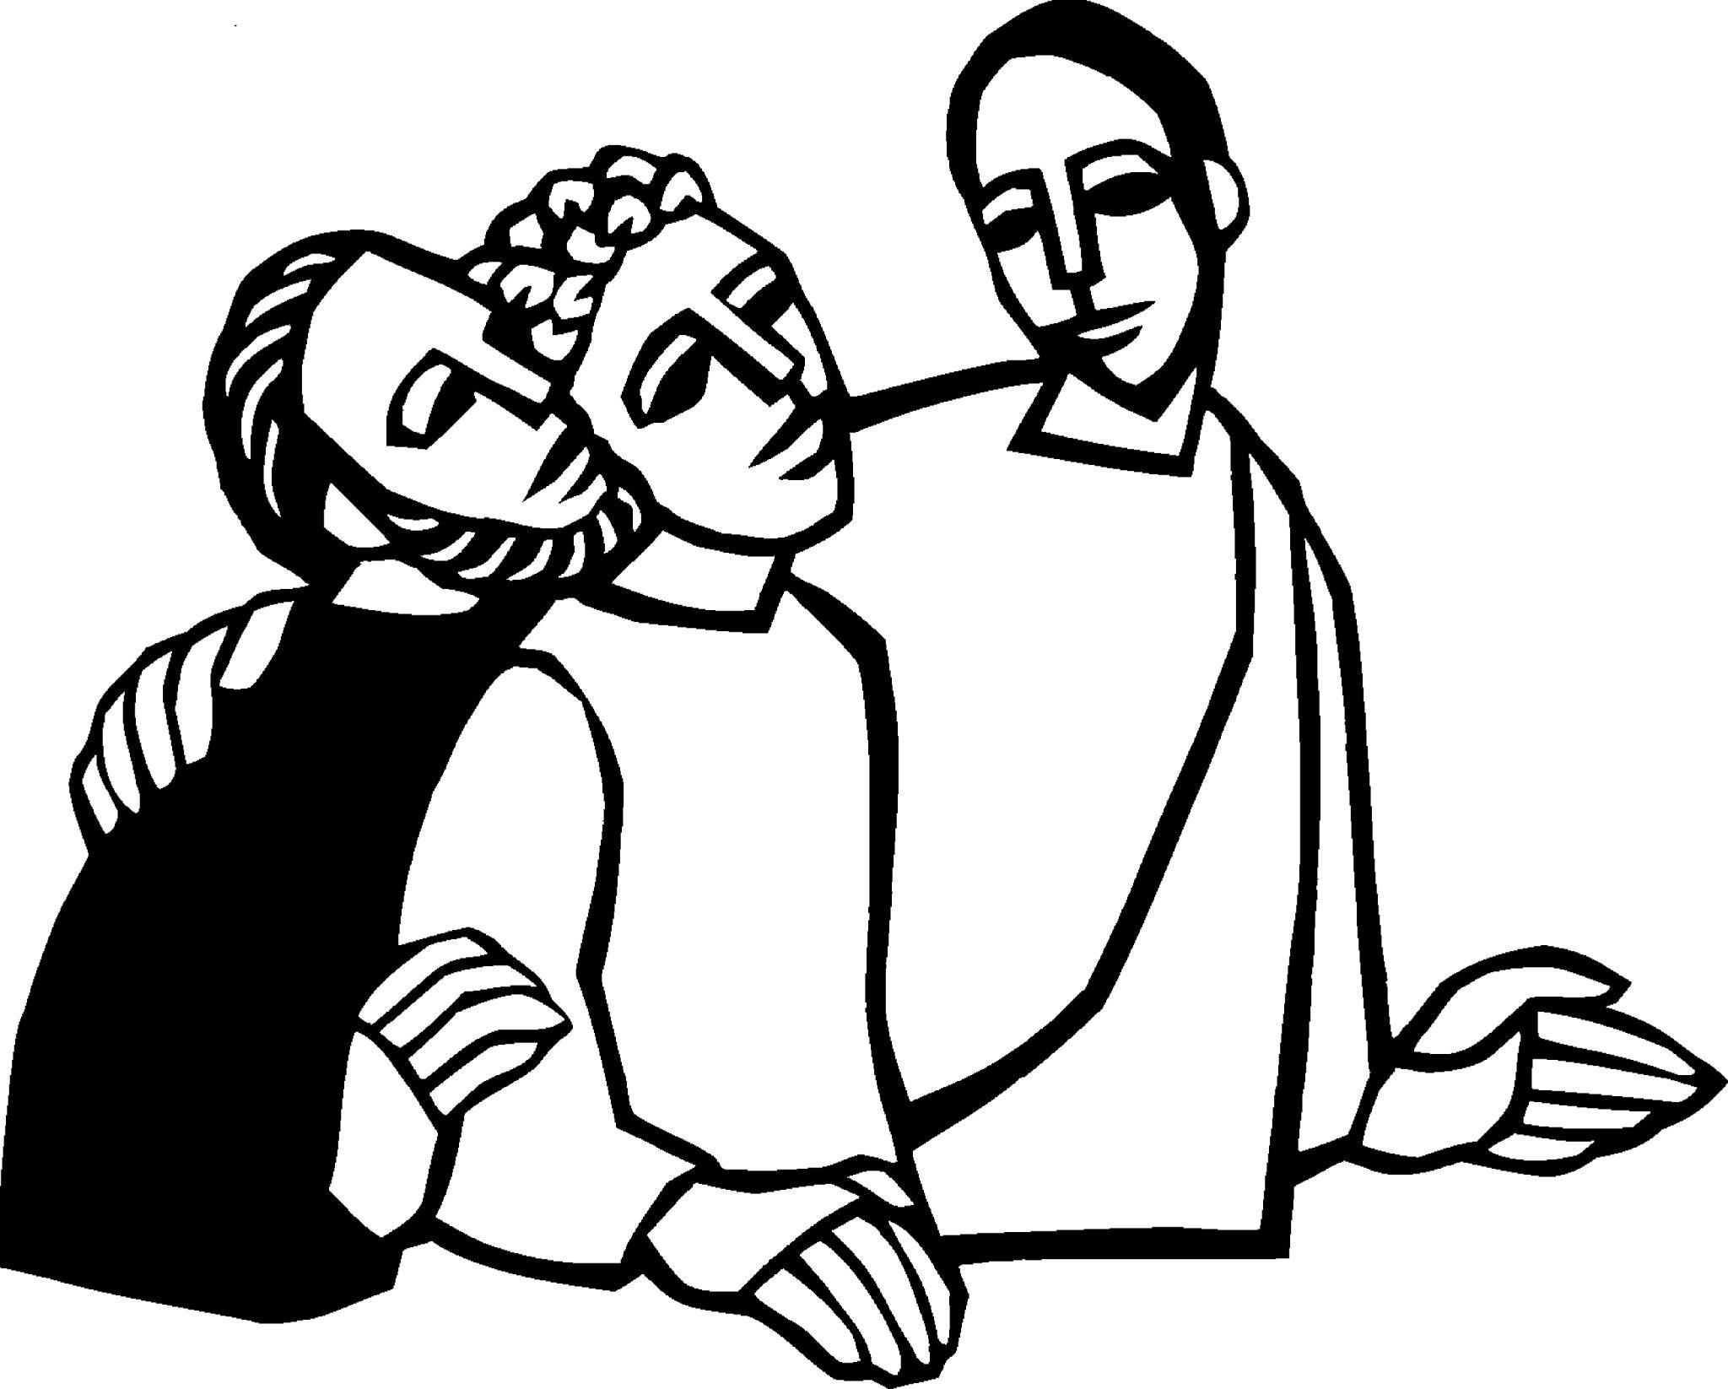
__________________________________________

Live
joyfully in faith

Connect
with God and one another

Serve
the local and global community ____________________________________

January 15, 2023
Second Sunday after Epiphany
8:00 and 10:00 am
www.christchurchexeter.org

Reflections on Today’s Readings

The liturgy today continues the theme of Epiphany, the manifestation of Jesus as the Christ. Therefore, in today’s Gospel reading we hear the testimony of John the Baptist to Jesus. John recounts the Holy Spirit’s descent at Jesus’ baptism and tells his followers that Jesus is the Lamb of God who takes away the sin of the world. Two of John’s disciples then follow Jesus and one of them, Andrew, brings his brother, Simon Peter.

In the first reading, one of the servant songs of Isaiah, God announces that the servant of God will bring not only the people of Israel into God’s household but will be sent to all humankind.

Throughout this Epiphany period, we read from the First Epistle to the Corinthians. This

letter of Paul is particularly concerned with the life of the Church as the Body of Christ, for the church is the ongoing manifestation of Christ in the world. The Spirit of God who rested upon Jesus at his baptism dwells in the church and Paul explores the meaning of our membership in Christ’s Body.

Each time we gather to celebrate Eucharist, we are reconstituted as the church. We proclaim the story of God’s salvation, we pray for the church and the world, and in the Eucharistic feast, God reveals our unity with Jesus in the Bread and Wine of Holy Communion. We are revealed by Word and Sacrament to be the Body of Christ in the world.

From The Rite Light: Reflections on the Sunday Readings and Seasons of the Church Year. Copyright © 2009 by Michael W. Merriman. Church Publishing Incorporated, New York.

Welcome to Christ Church: If you are visiting for the first time, please fill out the welcome cards in the pews and hand it to a member of the clergy after the service. Welcome bags are available in the narthex entrance hall. Books and resources for children are located on the table near the side left door. Although there are customary postures (such as standing and kneeling) in Episcopal worship, you are invited to be seated at any point, according to your needs and comfort.

Coffee Hour Fellowship: Please join us in the Parish Hall after each service.

Sunday school for children ages 5-12 will gather at 9:30 A.M. downstairs in the corner classrooms. Children will return to worship by the time of the Peace. Child Care is also available beginning at 9:30 a.m.

Healing team is available to offer healing prayers during the Eucharist, at the side of the church. Please tell your healing minister if you have a specific prayer need and if you would like a laying on of hands, just prayers or both.

Communion: Both the bread and wine are offered at Communion. You may drink from the cup, or place your hand on the base as a sign of devotion. Intinction (dipping the bread/wafer) is not permitted at this time. Please know that Communion in one kind (bread/wafer only) is sufficient to experience the Real Presence of our Risen Lord.

The Holy Eucharist

[10:00 service] Prelude This Little Light of Mine arr. by Calvin Taylor
I Want Jesus to Walk with Me

✠ All stand, as they are able, as the bell tolls.

[10:00 service]
Processional Hymn 599 Lift every voice and sing Lift Every Voice

Presider Blessed be God: Father, Son and Holy Spirit.
People And blessed be God’s kingdom, now and forever. Amen.

In Unison: Almighty God, to you all hearts are open, all desires known, and from you no secrets are hid: Cleanse the thoughts of our hearts by the inspiration of your Holy Spirit, that we may perfectly love you, and worthily magnify your holy Name; through Christ our Lord. Amen.

[10:00 service] Gloria S-280
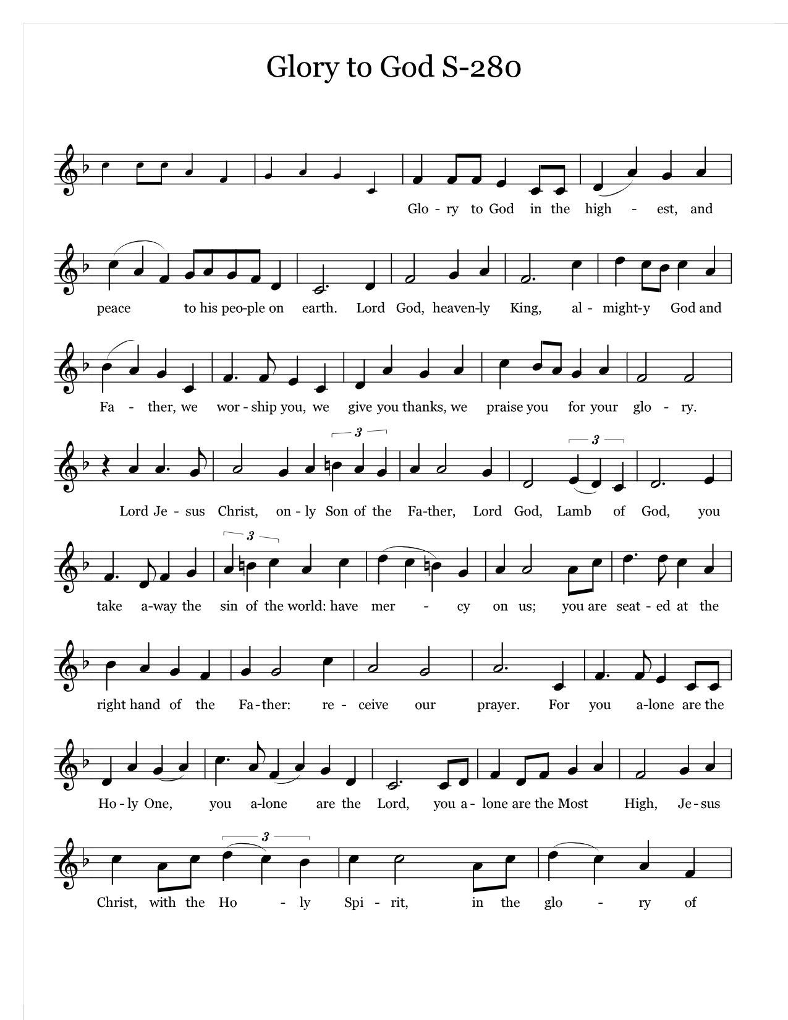
Music: Robert J. Powell © 1985 - Church Publishing, Inc. All rights reserved. Reprinted under OneLicense.net A700244

The Collect of the Day

Presider The Lord be with you.
People And also with you.
Presider Let us pray.

Almighty God, whose Son our Savior Jesus Christ is the light of the world: Grant that your people, illumined by your Word and Sacraments, may shine with the radiance of Christ's glory, that he may be known, worshipped, and obeyed to the ends of the earth; through Jesus Christ our Lord, who with you and the Holy Spirit lives and reigns, one God, now and for ever. Amen.

The First Reading Isaiah 49:1-7
Reader A Reading from the Book of Isaiah
Listen to me, O coastlands, pay attention, you peoples from far away! The Lord called me before I was born, while I was in my mother's womb he named me. He made my mouth like a sharp sword, in the shadow of his hand he hid me; he made me a polished arrow, in his quiver he hid me away. And he said to me, “You are my servant, Israel, in whom I will be glorified.” But I said, “I have labored in vain,
I have spent my strength for nothing and vanity; yet surely my cause is with the Lord,
and my reward with my God.” And now the Lord says, who formed me in the womb to be his servant, to bring Jacob back to him, and that Israel might be gathered to him, for I am honored in the sight of the Lord, and my God has become my strength– he says, “It is too light a thing that you should be my servant
to raise up the tribes of Jacob and to restore the survivors of Israel; I will give you as a light to the nations, that my salvation may reach to the end of the earth.” Thus says the Lord, the Redeemer of Israel and his Holy One, to one deeply despised, abhorred by the nations, the slave of rulers, “Kings shall see and stand up, princes, and they shall prostrate themselves, because of the Lord, who is faithful, the Holy One of Israel, who has chosen you.”

Reader The word of the Lord.
People Thanks be to God.

Psalm 40:1-12 pg 640 in BCP

1 I waited patiently upon the Lord; *
he stooped to me and heard my cry.

2 He lifted me out of the desolate pit, out of the mire and clay; *
he set my feet upon a high cliff and made my footing sure.

3 He put a new song in my mouth, a song of praise to our God; *
many shall see, and stand in awe, and put their trust in the Lord.

4 Happy are they who trust in the Lord! *
they do not resort to evil spirits or turn to false gods.

5 Great things are they that you have done, O Lord my God!
how great your wonders and your plans for us! *
there is none who can be compared with you.

6 Oh, that I could make them known and tell them! *
but they are more than I can count.

7 In sacrifice and offering you take no pleasure *
(you have given me ears to hear you);

8 Burnt-offering and sin-offering you have not required, *
and so I said, "Behold, I come.

9 In the roll of the book it is written concerning me: *
'I love to do your will, O my God; your law is deep in my heart."'

10 I proclaimed righteousness in the great congregation; *
behold, I did not restrain my lips; and that, O Lord, you know.

11 Your righteousness have I not hidden in my heart;
I have spoken of your faithfulness and your deliverance; *
I have not concealed your love and faithfulness from the great congregation.

12 You are the Lord; do not withhold your compassion from me; *
let your love and your faithfulness keep me safe for ever.

The Second Reading 1 Corinthians 1:1-9
Reader A Reading from the First Letter of Paul to the Corinthians
Paul, called to be an apostle of Christ Jesus by the will of God, and our brother Sosthenes, to the church of God that is in Corinth, to those who are sanctified in Christ Jesus, called to be saints, together with all those who in every place call on the name of our Lord Jesus Christ, both their Lord and ours: Grace to you and peace from God our Father and the Lord Jesus Christ. I give thanks to my God always for you because of the grace of God that has been given you in Christ Jesus, for in every way you have been enriched in him, in speech and knowledge of every kind-- just as the testimony of Christ has been strengthened among you-- so that you are not lacking in any spiritual gift as you wait for the revealing of our Lord Jesus Christ. He will also strengthen you to the end, so that you may be blameless on the day of our Lord Jesus Christ. God is faithful; by him you were called into the fellowship of his Son, Jesus Christ our Lord.

Reader The word of the Lord.
People Thanks be to God.

[10:00 service] Sequence Hymn
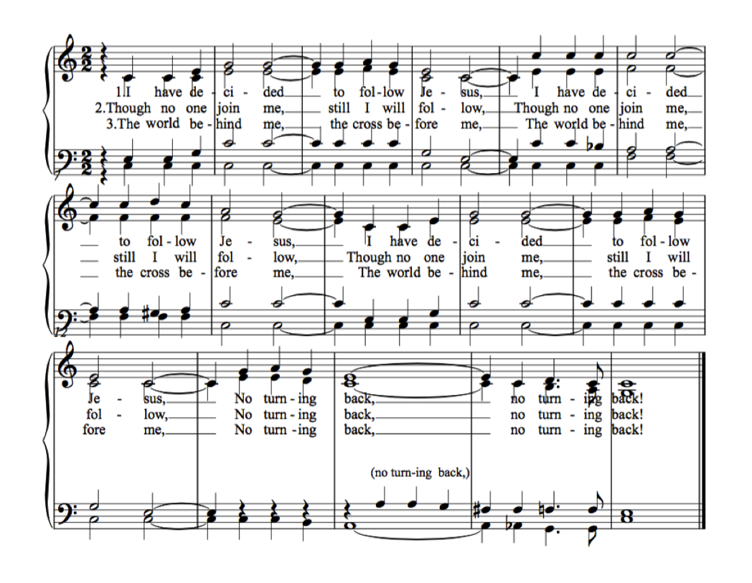

The Gospel John 1:29-42
Gospeler The Holy Gospel of our Lord Jesus Christ according to John
People Glory to you, Lord Christ.
John saw Jesus coming toward him and declared, “Here is the Lamb of God who takes away the sin of the world! This is he of whom I said, ‘After me comes a man who ranks ahead of me because he was before me.’ I myself did not know him; but I came baptizing with water for this reason, that he might be revealed to Israel.” And John testified, “I saw the Spirit descending from heaven like a dove, and it remained on him. I myself did not know him, but the one who sent me to baptize with water said to me, ‘He on whom you see the Spirit descend and remain is the one who baptizes with the Holy Spirit.’ And I myself have seen and have testified that this is the Son of God.”
The next day John again was standing with two of his disciples, and as he watched Jesus walk by, he exclaimed, “Look, here is the Lamb of God!” The two disciples heard him say this, and they followed Jesus. When Jesus turned and saw them following, he said to them, “What are you looking for?” They said to him, “Rabbi” (which translated means Teacher), “where are you staying?” He said to them, “Come and see.” They came and saw where he was staying, and they remained with him that day. It was about four o’clock in the afternoon. One of the two who heard John speak and followed him was Andrew, Simon Peter’s brother. He first found his brother Simon and said to him, “We have found the Messiah” (which is translated Anointed). He brought Simon to Jesus, who looked at him and said, “You are Simon son of John. You are to be called Cephas” (which is translated Peter).

Gospeler The Gospel of the Lord.
People Praise to you, Lord Christ

Sermon The Rev. Mark Pendleton

✠ A brief period of silence follows the sermon.

The Nicene Creed (said together) Page 358 in the Book of Common Prayer

We believe in one God,
the Father, the Almighty,
maker of heaven and earth,
of all that is, seen and unseen.

We believe in one Lord, Jesus Christ,
the only Son of God,
eternally begotten of the Father,
God from God, Light from Light,
true God from true God,
begotten, not made,
of one Being with the Father.
Through him all things were made.
For us and for our salvation
he came down from heaven:
by the power of the Holy Spirit
he became incarnate from the Virgin Mary,
and was made man.
For our sake he was crucified under Pontius Pilate;
he suffered death and was buried.
On the third day he rose again
in accordance with the Scriptures;
he ascended into heaven
and is seated at the right hand of the Father.
He will come again in glory to judge the living and the dead,
and his kingdom will have no end.

We believe in the Holy Spirit, the Lord, the giver of life,
who proceeds from the Father and the Son.
With the Father and the Son he is worshiped and glorified.
He has spoken through the Prophets.
We believe in one holy catholic and apostolic Church.
We acknowledge one baptism for the forgiveness of sins.
We look for the resurrection of the dead,
and the life of the world to come. Amen.

Prayers of the People (adapted from the New Zealand prayer book)

Holy God, you have promised to hear when we pray in the name of your Son. Therefore in confidence and trust we pray for the Church:

Silence

Enliven the Church for its mission that we may be salt of the earth and light to the world. Breathe fresh life into your people. Give us power to reveal Christ in word and action.
We pray for Michael our Presiding Bishop, Rob our Bishop and all the people of God.

Silence
We pray for the world:

Creator of all, lead us and every people into ways of justice and peace.
That we may respect one another in freedom and truth.

Awaken in us a sense of wonder for the earth and all that is in it.
Teach us to care creatively for its resources.

Silence

We pray for our community:
God of truth, inspire with your wisdom those whose decisions affect the lives of others
that all may act with integrity and courage.

Give grace to all whose lives are linked with ours.
May we serve Christ in one another, and love as he loves us.

Silence

We pray for those in need:

Chuck, Marlene & Steve, Martha, Bobbi, Phil, Pat, Frank, Snookie, and for others we name now:

Silence

God of hope, comfort and restore
all who suffer in body, mind or spirit.
May they know the power of your healing love.

Make us willing agents of your compassion.
Strengthen us as we share in making people whole.

Silence

We remember those who have died and those who mourn.

Silence

Presider prays:
Lord, you have called us to serve you.
Grant that we may walk in your presence:
your love in our hearts,
your truth in our minds,
your strength in our will;
until, at the end of our journey,
we know the joy of our homecoming
and the welcome of your embrace,
through Jesus Christ our Lord. Amen.

Confession of Sin

Let us confess our sins against God and our neighbor.

Please stand or kneel. Silence.

Most merciful God,
we confess that we have sinned against you
in thought, word, and deed,
by what we have done,
and by what we have left undone.
We have not loved you with our whole heart;
we have not loved our neighbors as ourselves.
We are truly sorry and we humbly repent.
For the sake of your Son Jesus Christ,
have mercy on us and forgive us;
that we may delight in your will,
and walk in your ways,
to the glory of your Name. Amen.

Presider:
Almighty God have mercy on you, forgive you all your sins through our Lord Jesus Christ, strengthen you in all goodness, and by the power of the Holy Spirit keep you in eternal life. Amen.

The Peace

✠ The people greet one another in the name of the Lord. The Peace may be expressed by shaking hands, bowing, “fist or elbow bumps”, namaste greeting, putting hand over heart, waving, making the peace sign, and by offering a smile.

Presider The peace of the Lord be always with you.
People And also with you.

The Holy Communion

[8:00 service]
Presider All things come of thee, O Lord.
People And of thine own have we given thee. Amen.

[10:00 service]
Offertory Anthem Deep River African-American Spiritual
Christ Church Choir arr. John Barnard

Deep river, my home is over Jordan, deep river, Lord
I want to cross over into campground.
O don’t you want to go home to that gospel feast,
that promised land where all is peace?

[10:00 service] Offertory Hymn 529 In Christ there is no East or West McKee

The Great Thanksgiving Eucharistic Prayer B Pg. 367

Presider The Lord be with you.
People And also with you.
Presider Lift up your hearts.
People We lift them to the Lord.
Presider Let us give thanks to the Lord our God.
People It is right to give him thanks and praise.

It is right, and a good and joyful thing, always and everywhere to give thanks to you, Father Almighty, Creator of heaven and earth. Because in the mystery of the Word made flesh, you have caused a new light to shine in our hearts, to give the knowledge of your glory in the face of your Son Jesus Christ our Lord.

Therefore, we praise you, joining our voices with Angels and Archangels and with all the company of heaven, who for ever sing this hymn to proclaim the glory of your name:

[8:00 service] Presider and People
Holy, holy, holy Lord, God of power and might,
heaven and earth are full of your glory.
Hosanna in the highest.
Blessed is he who comes in the name of the Lord.
Hosanna in the highest.

[10:00 service] Sanctus WLP 858
Music: Land of Rest, adapt. Marcia Pruner © 1985, Church Publishing, Inc. All rights reserved. Reprinted under OneLicense.net A700244

The Presider continues
We give thanks to you, O God, for the goodness and love which you have made known to us in creation; in the calling of Israel to be your people; in your Word spoken through the prophets; and above all in the Word made flesh, Jesus, your Son. For in these last days you sent him to be incarnate from the Virgin Mary, to be the Savior and Redeemer of the world. In him, you have delivered us from evil, and made us worthy to stand before you. In him, you have brought us out of error into truth, out of sin into righteousness, out of death into life.

On the night before he died for us, our Lord Jesus Christ took bread; and when he had given thanks to you, he broke it, and gave it to his disciples, and said, “Take, eat: This is my Body which is given for you. Do this for the remembrance of me.”

After supper he took the cup of wine; and when he had given thanks, he gave it to them, and said, “Drink this, all of you: This is my Blood of the new Covenant, which is shed for you and for many for the forgiveness of sins. Whenever you drink it, do this for the remembrance of me.”

Therefore, according to his command, O Father,

Presider and People
We remember his death,
We proclaim his resurrection,
We await his coming in glory;

The Presider continues
And we offer our sacrifice of praise and thanksgiving to you, O Lord of all; presenting to you, from your creation, this bread and this wine.

We pray you, gracious God, to send your Holy Spirit upon these gifts that they may be the Sacrament of the Body of Christ and his Blood of the new Covenant. Unite us to your Son in his sacrifice, that we may be acceptable through him, put all things in subjection under your Christ, and bring us to that heavenly country where, with all your saints, we may enter the everlasting heritage of your sons and daughters; through Jesus Christ our Lord, the firstborn of all creation, the head of the church, and the author of our salvation.
By him, and with him, and in him, in the unity of the Holy Spirit all honor and glory is yours, Almighty Father, now and forever. AMEN.

The Presider then continues
And now, as our Savior Christ has taught us, we are bold to say,

People and Presider
Our Father, who art in heaven, hallowed be thy Name, thy kingdom come, thy will be done, on earth as it is in heaven. Give us this day our daily bread. And forgive us our trespasses, as we forgive those who trespass against us. And lead us not into temptation, but deliver us from evil. For thine is the kingdom, and the power, and the glory,
for ever and ever. Amen.

The Breaking of the Bread

✠ The Presider breaks the consecrated Bread. A period of silence is kept.

[8:00 service]
Presider Alleluia. Christ our Passover is sacrificed for us;
People Therefore let us keep the feast. Alleluia

[10:00 service] Fraction Anthem WLP 878 Whoever Comes to Me

Music: Carl Haywood, from Fraction Anthems, Canticles, and Chants. © 1987, Church Publishing, Inc . All rights reserved. Reprinted under OneLicense.net A700244

Invitation to Communion

The gifts of God for the people of God. Take them in remembrance that Christ died for you, and feed on him in your hearts by faith, with thanksgiving.

Instructions Concerning Communion and Healing

You are invited to receive Holy Communion. Following the usher’s instructions, we begin with those seated in the side sections, starting with the front pews. Please go to the back of the church and proceed down the center aisle to the communion rail. Return to your seat using the outside aisles of those sections. Those seated in the center sections, please come forward beginning with the back pews using the center aisle and return using the diagonal aisles.

Communion may be received kneeling or standing at the altar rails.. The bread is received in the open palm. (Gluten-free wafers are available). You may drink from the cup, or place your hand on the base as a sign of devotion. Intinction (dipping the bread/wafer) is not permitted at this time.

Those who do not wish to receive Communion are invited to come forward for a blessing, indicated by crossing your arms over your chest.

Communion can also be brought to you in the pews. Please communicate this request to an usher or the clergy.

The Healing team is available to offer healing prayers at the side of the church. Please tell your healing minister if you have a specific prayer need and if you would like a laying on of hands, just prayers or both.

[10:00 service]
Communion Music Swing Low, Sweet Chariot African-AmericanSpiritual arr. Kay Eames

The Post Communion Prayer (Page 365) in the Book of Common Prayer

Presider and People
Eternal God, heavenly Father,
you have graciously accepted us as living members
of your Son our Savior Jesus Christ,
and you have fed us with spiritual food
in the Sacrament of his Body and Blood.
Send us now into the world in peace,
and grant us strength and courage
to love and serve you
with gladness and singleness of heart;
through Christ our Lord. Amen.

The Blessing

[10:00 service]
Recessional Hymn WLP 805 I want Jesus to walk with me Negro Spiritual

The Dismissal

Priest Let us go forth in the name of Christ.
People Thanks be to God.

[10:00 service] Postlude Fugue in B major Marcel Dupré

The worship is over ✠ The service begins

Participating in Today’s Liturgy:
Preacher/Presider: The Rev. Mark Pendleton
Lector at 8:00 a.m.: Lee Woodworth
Lector at 10:00 a.m.: Laurel Patterson
Eucharistic Minister at 8:00 a.m.: Sue Ingram
Eucharistic Minister at 10:00 a.m.: Jeannette McDonald
Greeter/Usher 10:00 a.m.: Donna & Morgan McCay
Live Stream: Joe DiPalermo
Sunday School: Lisa Lowry, William Lowry
Altar Guild: Shannon Tosatti, Melissa Poirier
Flower Delivery: Elaine Wiltamuth
Hospitality: Adrienne Spear, Linzee Coleman-Bagge
Altar Flowers

This week at Christ Church
January 15-21

Sunday | Parish Choir 9:00 a.m.  PSP Rehearsal 12:30 p.m.
Monday | Scouts-Parents Meeting 6:30 p.m.
Tuesday | Bible Study 11:00 a.m.  PSP Rehearsal 5:30 p.m.  Scouts 6:00 p.m.
Wednesday | Oasis Sisters 10:30 a.m.  PSP Rehearsal 3:30 p.m.  Parish Choir Rehearsal 7:00 p.m.
Thursday | Scouts 6:00 p.m.
Saturday | Men’s Group 8:00 a.m.

Suzanne Jalbert Jones has been named Interim Director of Music at Christ Church. As our Director of Music from 2014 - 2018, Suzanne enjoyed the richly musical and spiritual parish of Christ Church and considers it her home. She brings with her a diverse background of musical training from New England Conservatory of Music and University of New Hampshire, although her greatest teachers are her friends and family, with whom she often shares the stage. She honors the power of music to heal and bring people together and has built her musical practice upon that tenant. She hopes to inspire any individual, with a song in their heart, to join the Christ Church Choir! In her words: "she is grateful to once again be making a joyful sound with Christ Church Exeter." Suzanne will join us next Sunday, January 22nd.

Seacoast Family Promise week. There are many ways to help with this ministry. Seacoast Family Promise has provided a current list of household needs:
- Hefty 30-gallon strong trash bags (not contractor bags)
- Laundry detergent (no pods please)
- Ziplock bags, gallon size
- Ziplock bags, sandwich size
- 6-12 pack of Scott or Scott equivalent toilet paper
- 3-6 pack of select-a-size paper towels
- Tissues
- Tinfoil
- Ground coffee
- New, unused sheet sets and comforters, full size

You can drop them off in the Narthex in the bin near the Chapel or in the office during office hours.
Barbara Cutting is our SFP coordinator. We’re always looking for more volunteers! If you’re interested in joining this ongoing ministry, please contact Barbara at sfpcce2@gmail.com

As of January 12, we have received 128 pledges for 2023 totaling $307,058. In 2022 we received 134 pledges for $331,512. There is still time to pledge.

Our 2023 goal is 150 pledges for $380,000 to return to pre-Pandemic levels of giving.
Pledge cards have been mailed out and are available in the narthex entrance and online. We invite your continued faithfulness and support.

Inquirers’ Classes/Episcopal 101
The Rector will offer five Zoom sessions for those who want to learn more about the Episcopal Church and for those who might be interested in being confirmed or received by the bishop on May 7, 2023. Zoom links to follow. Email mpendleton@christchurchexeter.org for more information.

January 23 Monday at 7 p.m. Zoom
What does it mean to be an Episcopalian/Anglican?
What do Episcopalians believe?

February 15 Wednesday at 7 p.m. Zoom
Are Episcopalians Protestants or Catholics?
The History of the English and American church.

March 6 Monday at 7 p.m. Zoom
A Tour through the Book of Common Prayer

March 21 Tuesday at 7pm Zoom
The Sacraments and Episcopal Liturgy

March 27 Monday 7 p.m. Zoom
Structure, Decision Making, and all things Episcopal

CHRIST CHURCH
43 Pine St., Exeter, NH 03833
Phone: (603) 772-3332 E-mail: office@christchurchexeter.org

Office Hours: Mon, Tue, Thur 9 a.m. - 12 Noon, Weds 9 a.m. - 4 p.m. OFFICE CLOSED FRIDAYS

Rector Ext. 12 [cell phone 860 490-8544]
The Rev. Mark Pendleton mpendleton@christchurchexeter.org

Priest Assoc. for Pastoral care
The Rev. David Holroyd dholroyd@christchurchexeter.org

Priest Associate Ext. 13
The Rev. Melissa Remington mremington@christchurchexeter.org

Director of Music and Communications
choircccexeter@gmail.com
Organist
Bruce Adami bruce@christchurchexeter.org

Administrative Assistant Ext. 11
Darla Watt office@christchurchexeter.org

Bookkeeper
Jeannie Madley bookkeeper@christchurchexeter.org

Senior Sexton
George Malgeri ssexton@christchurchexeter.org

Artistic Director of Pine Street Players
Lexi Meunier thepinestreetplayers@gmail.com

Events Coordinator
Christina DeMaio events@christchurchexeter.org

Vestry
Senior Warden Patricia Gianotti
Junior Warden John Gilbert Treasurer Richard Ingram
Clerk Deb Fournier

Shannon Hays Lauri Ayers John Hodsdon
Christopher Sera John Cofer Jennifer Murray
Gene Stilwell Gordon Rehnborg Morgan McCay

