CHRIST CHURCH
of Exeter

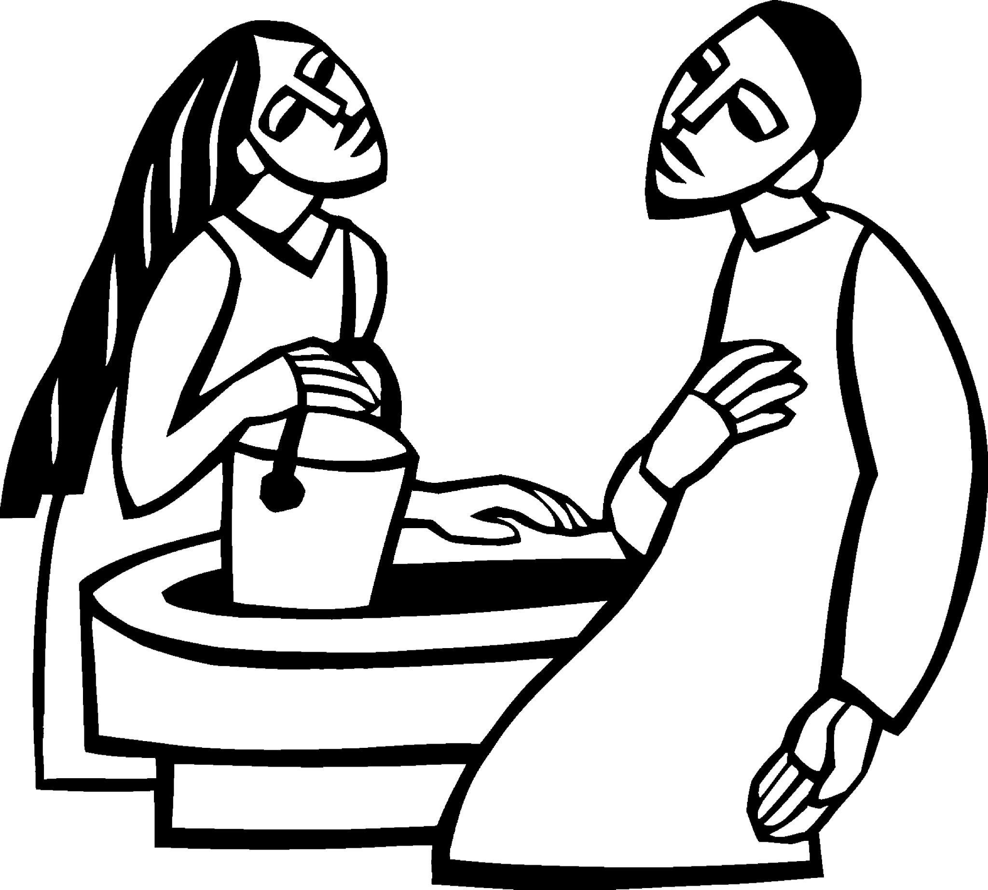

Live
joyfully in faith

Connect
with God and one another

Serve
the local and global community

March 12, 2023
The Third Sunday in Lent
8:00 and 10:00 am
www.christchurchexeter.org

Reflections on Today’s Readings

This story is one of the classic biblical passages for those preparing for baptism at Easter. As the woman was gradually
enlightened about Jesus and about her relationship to God, so the candidates are growing in their relationship with God during Lent. They look forward to receiving in baptism the “living water” of God’s Spirit in their lives. Those already baptized are filled with that living water and continue to be enlightened by God’s Spirit.

In the first reading, we move forward in the history of salvation from the call of Abraham and Sarah to the account of Moses and Israel in the Exodus from Egypt. On the occasion we read about today, God provides water for the people in the desert. This is an image of God’s loving care for all people in the spiritual dryness of this world.

As people in the desert thirst for water, so Christians find in their Lenten living the thirst for life that only God can quench. All of us, both the baptized and those preparing for baptism, are, like the Samaritan woman, being enlightened and filled with the grace of the living water that comes from our Savior.

From The Rite Light: Reflections on the Sunday Readings and Seasons of the Church Year. Copyright © 2009 by Michael W. Merriman. Church Publishing Incorporated, New York.

Welcome to Christ Church: If you are visiting for the first time, please fill out the welcome cards in the pews and hand it to a member of the clergy after the service. Books and resources for children are located on the table near the side left door. Although there are customary postures (such as standing and kneeling) in Episcopal worship, you are invited to be seated at any point, according to your needs and comfort.

Coffee Hour Fellowship: Please join us in the Parish Hall after each service.

Sunday school for children ages 5-12 will gather at 9:30 A.M. downstairs in the corner classrooms. Children will return to worship by the time of the Peace. Child Care is also available beginning at 9:30 a.m.

Healing team is available to offer healing prayers during the Eucharist, at the side of the church. Please tell your healing minister if you have a specific prayer need and if you would like a laying on of hands, just prayers or both.

Communion: Both the bread and wine are offered at Communion. You may drink from the cup, or place your hand on the base as a sign of devotion. Intinction (dipping the bread/wafer) is not permitted at this time. Please know that Communion in one kind (bread/wafer only) is sufficient to experience the Real Presence of our Risen Lord.

The Holy Eucharist

[10:00 service]
Prelude Sicilienne (Suite) Maurice Duruflé

[10:00 Service] Welcome

✠ All stand as they are able as the bell tolls.

Silent Processional
A Penitential Order

The people standing, the Presider says

Bless the Lord who forgives all our sins.
People His mercy endures for ever.

Jesus said, "The first commandment is this: Hear, O Israel: The Lord your God is the only Lord. Love the Lord your God with all your heart, with all your soul, with all your mind, and with all your strength. The second is this: Love your neighbor as yourself. There is no commandment greater than these." Mark 12:29-31
The Presider then says
Let us confess our sins against God and our neighbor.

Silence may be kept. You may kneel or sit.

Minister and People
Most merciful God,
we confess that we have sinned against you
in thought, word, and deed,
by what we have done,
and by what we have left undone.
We have not loved you with our whole heart;
we have not loved our neighbors as ourselves.
We are truly sorry and we humbly repent.
For the sake of your Son Jesus Christ,
have mercy on us and forgive us;
that we may delight in your will,
and walk in your ways,
to the glory of your Name. Amen.

The Presider says
Almighty God have mercy on you, forgive you all your sins through our Lord Jesus Christ, strengthen you in all goodness, and by the power of the Holy Spirit keep you in eternal life. Amen.

Kyrie (said at 8:00, sung at 10:00)

Presider Lord, have mercy.
People Christ, have mercy
Presider Lord, have mercy
Setting: Leo Sowerby © 1984, 1985, 2010, GIA Publications, Inc. All rights reserved. Reprinted under OneLicense.net A700244

The Collect of the Day

Presider The Lord be with you.
People And also with you.
Presider Let us pray.

Almighty God, you know that we have no power in ourselves to help ourselves: Keep us both outwardly in our bodies and inwardly in our souls, that we may be defended from all adversities which may happen to the body, and from all evil thoughts which may assault and hurt the soul; through Jesus Christ our Lord, who lives and reigns with you and the Holy Spirit, one God, for ever and ever. Amen.

✠ The people sit.

The First Reading Exodus 17:1-7
Reader A Reading from the Book of Exodus
From the wilderness of Sin the whole congregation of the Israelites journeyed by stages, as the Lord commanded. They camped at Rephidim, but there was no water for the people to drink. The people quarreled with Moses, and said, “Give us water to drink.” Moses said to them, “Why do you quarrel with me? Why do you test the Lord?” But the people thirsted there for water; and the people complained against Moses and said, “Why did you bring us out of Egypt, to kill us and our children and livestock with thirst?” So Moses cried out to the Lord, “What shall I do with this people? They are almost ready to stone me.” The Lord said to Moses, “Go on ahead of the people, and take some of the elders of Israel with you; take in your hand the staff with which you struck the Nile, and go. I will be standing there in front of you on the rock at Horeb. Strike the rock, and water will come out of it, so that the people may drink.” Moses did so, in the sight of the elders of Israel. He called the place Massah and Meribah, because the Israelites quarreled and tested the Lord, saying, “Is the Lord among us or not?”

Reader The Word of the Lord.
People Thanks be to God.

Psalm 95 Page 724 in BCP (read responsively by verse)

1 Come, let us sing to the Lord; *
let us shout for joy to the Rock of our salvation.

2 Let us come before his presence with thanksgiving *
and raise a loud shout to him with psalms.

3 For the Lord is a great God, *
and a great King above all gods.

4 In his hand are the caverns of the earth, *
and the heights of the hills are his also.

5 The sea is his, for he made it, *
and his hands have molded the dry land.

6 Come, let us bow down, and bend the knee, *
and kneel before the Lord our Maker.

7 For he is our God, and we are the people of his pasture and the sheep of his hand. *
Oh, that today you would hearken to his voice!

8 Harden not your hearts, as your forebears did in the wilderness, *
at Meribah, and on that day at Massah, when they tempted me.

9 They put me to the test, *
though they had seen my works.

10 Forty years long I detested that generation and said, *
"This people are wayward in their hearts; they do not know my ways."

11 So I swore in my wrath, *
"They shall not enter into my rest."

✠ The people stand as they are able.

[10:00 service]
Sequence Hymn 692 I heard the voice of Jesus say The Third Tune

The Gospel John 4:5-42
Gospeler The Holy Gospel of our Lord Jesus Christ according to John
People Glory to you, Lord Christ.
Jesus came to a Samaritan city called Sychar, near the plot of ground that Jacob had given to his son Joseph. Jacob’s well was there, and Jesus, tired out by his journey, was sitting by the well. It was about noon. A Samaritan woman came to draw water, and Jesus said to her, “Give me a drink.” (His disciples had gone to the city to buy food.) The Samaritan woman said to him, “How is it that you, a Jew, ask a drink of me, a woman of Samaria?” (Jews do not share things in common with Samaritans.) Jesus answered her, “If you knew the gift of God, and who it is that is saying to you, ‘Give me a drink,’ you would have asked him, and he would have given you living water.” The woman said to him, “Sir, you have no bucket, and the well is deep. Where do you get that living water? Are you greater than our ancestor Jacob, who gave us the well, and with his sons and his flocks drank from it?” Jesus said to her, “Everyone who drinks of this water will be thirsty again, but those who drink of the water that I will give them will never be thirsty. The water that I will give will become in them a spring of water gushing up to eternal life.” The woman said to him, “Sir, give me this water, so that I may never be thirsty or have to keep coming here to draw water.” Jesus said to her, “Go, call your husband, and come back.” The woman answered him, “I have no husband.” Jesus said to her, “You are right in saying, ‘I have no husband’; for you have had five husbands, and the one you have now is not your husband. What you have said is true!” The woman said to him, “Sir, I see that you are a prophet. Our ancestors worshiped on this mountain, but you say that the place where people must worship is in Jerusalem.” Jesus said to her, “Woman, believe me, the hour is coming when you will worship the Father neither on this mountain nor in Jerusalem. You worship what you do not know; we worship what we know, for salvation is from the Jews. But the hour is coming, and is now here, when the true worshipers will worship the Father in spirit and truth, for the Father seeks such as these to worship him. God is spirit, and those who worship him must worship in spirit and truth.” The woman said to him, “I know that Messiah is coming” (who is called Christ). “When he comes, he will proclaim all things to us.” Jesus said to her, “I am he, the one who is speaking to you.” Just then his disciples came. They were astonished that he was speaking with a woman, but no one said, “What do you want?” or, “Why are you speaking with her?” Then the woman left her water jar and went back to the city. She said to the people, “Come and see a man who told me everything I have ever done! He cannot be the Messiah, can he?” They left the city and were on their way to him.
Meanwhile the disciples were urging him, “Rabbi, eat something.” But he said to them, “I have food to eat that you do not know about.” So the disciples said to one another, “Surely no one has brought him something to eat?” Jesus said to them, “My food is to do the will of him who sent me and to complete his work. Do you not say, ‘Four months more, then comes the harvest’? But I tell you, look around you, and see how the fields are ripe for harvesting. The reaper is already receiving wages and is gathering fruit for eternal life, so that sower and reaper may rejoice together. For here the saying holds true, ‘One sows and another reaps.’ I sent you to reap that for which you did not labor. Others have labored, and you have entered into their labor.” Many Samaritans from that city believed in him because of the woman’s testimony, “He told me everything I have ever done.” So when the Samaritans came to him, they asked him to stay with them; and he stayed there two days. And many more believed because of his word. They said to the woman, “It is no longer because of what you said that we believe, for we have heard for ourselves, and we know that this is truly the Savior of the world.”

Gospeler The Gospel of the Lord.
People Praise to you, Lord Christ.

✠ The people sit.

Sermon The Rev. Mark Pendleton

✠ A brief period of silence follows the sermon.

The Nicene Creed (said together)

We believe in one God,
the Father, the Almighty,
maker of heaven and earth,
of all that is, seen and unseen.

We believe in one Lord, Jesus Christ,
the only Son of God,
eternally begotten of the Father,
God from God, Light from Light,
true God from true God,
begotten, not made,
of one Being with the Father.
Through him all things were made.
For us and for our salvation
he came down from heaven:
by the power of the Holy Spirit
he became incarnate from the Virgin Mary,
and was made man.
For our sake he was crucified under Pontius Pilate;
he suffered death and was buried.
On the third day he rose again
in accordance with the Scriptures;
he ascended into heaven
and is seated at the right hand of the Father.
He will come again in glory to judge the living and the dead,
and his kingdom will have no end.

We believe in the Holy Spirit, the Lord, the giver of life,
who proceeds from the Father and the Son.
With the Father and the Son he is worshiped and glorified.
He has spoken through the Prophets.
We believe in one holy catholic and apostolic Church.
We acknowledge one baptism for the forgiveness of sins.
We look for the resurrection of the dead,
and the life of the world to come. Amen.

Prayers of the People

Please Stand or Kneel

With thankful hearts, let us pray to the Lord saying, “hear our prayer.”
Lord, give us eyes to see that the fields are ripe for harvesting. May the Church reap what has been sown by our forebears and sow the seeds that will bring forth the fruit of the future.
We pray for those young persons preparing for their Confirmation: may God guide them on their journey. We pray for those to be baptized on Easter Day.

For safe travel to those traveling to Cuba this week and for our sisters and brothers in Cardenas.

Silence
In your mercy,
Hear our prayer.

Lord, reveal the strength of your love to those around the world who are asking, “Is the Lord among us or not?” We pray for comfort and peace for all people.
Silence
In your mercy,
Hear our prayer.

Lord, you hold the caverns of the earth and the heights of the hills; your hands have formed the seas and the dry land. Bless and keep your creation.
Silence
In your mercy,
Hear our prayer.

Lord, where there is suffering in our community and nation and world, produce endurance; where there is endurance, produce character; where there is character, produce hope. And where we place our hope in you, let us not be disappointed.

We pray for peace in all the world. We pray for the end of the war in Ukraine and for its people.

Silence
In your mercy,
Hear our prayer.

Lord, we pray for those who are sick or suffering. Give them that living water that comes only through your Son Jesus Christ, that their needs may be met and all their thirsts quenched.
We pray for Lissa, Steve, Sue, Cathy, Jerry, Alice, Bob, Ginny, Claudette, Eduardo, David, Bruce, Chuck, Marlene & Steve, Martha, Bobbi, Phil, Pat, Frank
Take a moment, either silently or aloud, to pray for those known to you.

In your mercy,
Hear our prayer.

Lord, we pray for the dying and the dead. We pray in the assurance that all have been reconciled to you through the death of your Son and saved by his new life. We remember those who have died.
Silence
We pray for Frank Tracy Griswold III, the 25th Presiding Bishop of the Episcopal Church, who died this past week.

In your mercy,
Hear our prayer.

Silence

The Presider adds a concluding Collect.
God of wilderness and water, your Son was baptized and tempted as we are. Guide us through this season, that we may not avoid struggle, but open ourselves to blessing, through the cleansing depths of repentance and the heaven-rending words of the Spirit. Amen.

The Peace

✠ The people stand as they are able.

Presider The peace of the Lord be always with you.
People And also with you.

✠ The people greet one another in the name of the Lord. The Peace may be expressed by shaking hands, bowing, “fist or elbow bumps”, namaste greeting, putting hand over heart, waving, making the peace sign, and by offering a smile.

The Holy Communion

[8:00 service at the Presentation of the Gifts]

Presider All things come of thee, O Lord.
People And of thine own have we given thee. Amen.

[10:00 service] Offertory Anthem Bread of the World arr. John Bullard
Christ Church Choir

Bread of the world, in mercy broken, Wine of the soul, in mercy shed,
By whom the words of life were spoken, And in whose death our sins are dead.
Look on the heart by sorrow broken, Look on the tears by sinners shed;
And be your feast to us the token That by your grace our souls are fed.

[10:00 service]
Offertory Hymn 706 In your mercy, Lord, you called me Halton Holgate

✠ The people stand for the hymn as they are able.

Eucharistic Prayer 1 (Enriching our Worship)

Presider The Lord be with you.
People And also with you.
Presider Lift up your hearts.
People We lift them to the Lord.
Presider Let us give thanks to the Lord our God.
People It is right to give our thanks and praise.

The Presider continues
It is right, and a good and joyful thing, always and everywhere to give thanks to you, Father Almighty, Creator of heaven and earth. You bid your faithful people cleanse their hearts, and prepare with joy for the Paschal feast; that, fervent in prayer and in works of mercy, and renewed by your Word and Sacraments, they may come to the fullness of grace which you have prepared for those who love you.

Therefore we praise you, joining our voices with Angels and Archangels and with all the company of heaven, who for ever sing this hymn to proclaim the glory of your Name: [Said at 8:00, sung at 10:00].

Presider and People
Holy, holy, holy Lord, God of power and might,
heaven and earth are full of your glory.
Hosanna in the highest.
Blessed is the one who comes in the name of the Lord.
Hosanna in the highest.

[10:00 service] Sanctus
Setting: Robert Powell © 1982, GIA Publications, Inc. All rights reserved. Reprinted under OneLicense.net A700244.

✠ The people kneel or stand, as they are able.

The Presider continues
Blessed are you, gracious God, creator of the universe and giver of life. You formed us in your own image and called us to dwell in your infinite love.

You gave the world into our care that we might be your faithful stewards and show forth your bountiful grace. But we failed to honor your image in one another and in ourselves;
we would not see your goodness in the world around us; and so we violated your creation, abused one another, and rejected your love. Yet you never ceased to care for us and prepared the way of salvation for all people. Through Abraham and Sarah, you called us into covenant with you. You delivered us from slavery sustained us in the wilderness and raised up prophets to renew your promise of salvation. Then, in the fullness of time, you sent your eternal Word, made mortal flesh in Jesus. Born into the human family, and dwelling among us, he revealed your glory. Giving himself freely to death on the cross, he triumphed over evil, opening the way of freedom and life.

On the night before he died for us, Our Savior Jesus Christ took bread, and when he had given thanks to you, he broke it, and gave it to his friends, and said: “Take, eat: This is my Body which is given for you. Do this for the remembrance of me.”

As supper was ending, Jesus took the cup of wine, and when he had given thanks, he gave it to them, and said: “Drink this, all of you: This is my Blood of the new Covenant, which is poured out for you and for all for the forgiveness of sins. Whenever you drink it, do this for the remembrance of me.” Therefore, we proclaim the mystery of faith:

Presider and People
Christ has died.
Christ is risen.
Christ will come again.

The Presider continues
Remembering his death and resurrection, we now present to you from your creation this bread and this wine. By your Holy Spirit may they be for us the Body and Blood of our Savior Jesus Christ. Grant that we who share these gifts may be filled with the Holy Spirit and live as Christ’s Body in the world. Bring us into the everlasting heritage of your daughters and sons, that with all your saints, past, present, and yet to come, we may praise your Name for ever. Through Christ and with Christ and in Christ, in the unity of the Holy Spirit, to you be honor, glory, and praise, for ever and ever. AMEN.

And now, as our Savior Christ has taught us, we are bold to say,
Our Father, who art in heaven, hallowed be thy Name, thy kingdom come, thy will be done, on earth as it is in heaven. Give us this day our daily bread. And forgive us our trespasses, as we forgive those who trespass against us. And lead us not into temptation but deliver us from evil. For thine is the kingdom, and the power, and the glory, for ever and ever. Amen.

The Presider then continues
And now, as our Savior Christ has taught us, we are bold to say,
Our Father, who art in heaven, hallowed be thy Name, thy kingdom come, thy will be done, on earth as it is in heaven. Give us this day our daily bread. And forgive us our trespasses, as we forgive those who trespass against us. And lead us not into temptation, but deliver us from evil. For thine is the kingdom, and the power, and the glory,
for ever and ever. Amen.

The Breaking of the Bread
✠ The Presider breaks the consecrated Bread.
✠ A period of silence is kept.
[8:00 service]
Presider Lamb of God, you take away the sins of the world:
People have mercy on us.
Presider Lamb of God, you take away the sins of the world:
People have mercy on us.
Presider Lamb of God, you take away the sins of the world:
People grant us peace.

[10:00 service] Agnus Dei
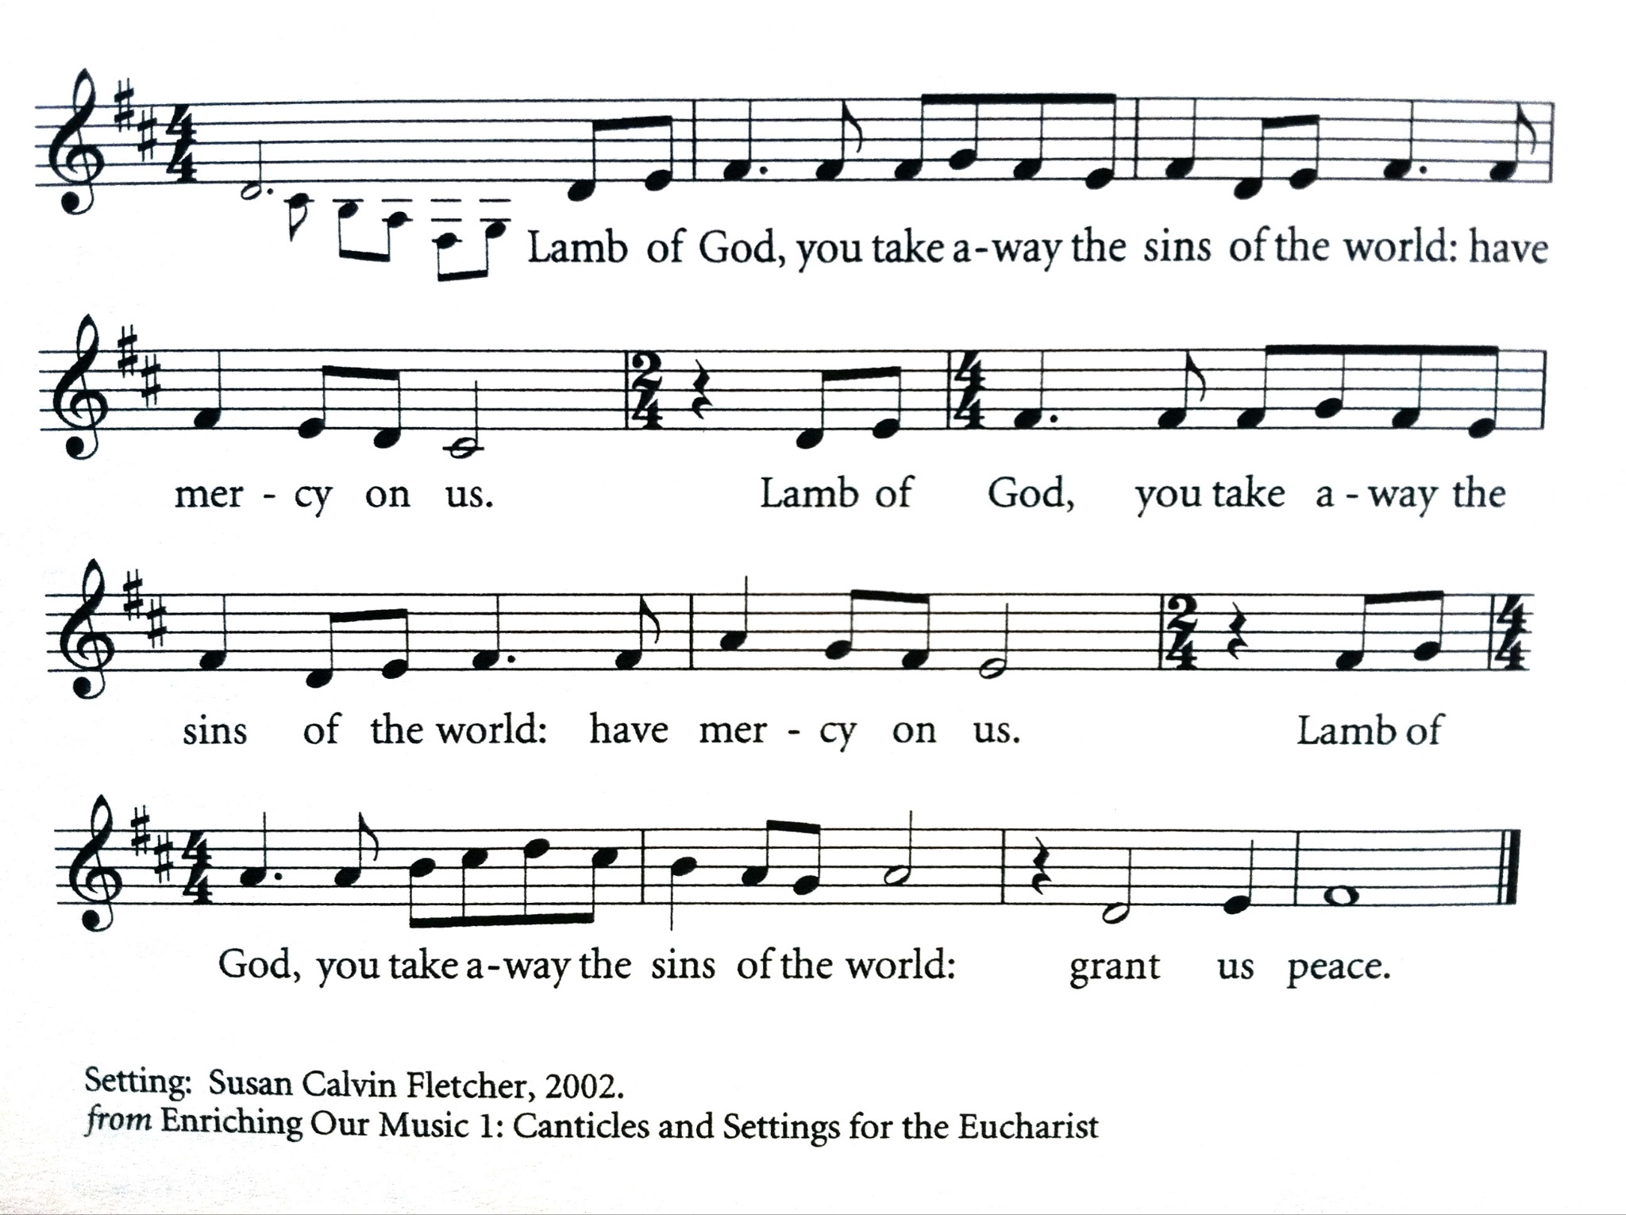
Setting: Susan Calvin Fletcher, © 2002 Susan Calvin Fletcher. Used by permission. All rights reserved. Reprinted under OneLicense.net A700244.

Invitation to Communion

The gifts of God for the people of God. Take them in remembrance that Christ died for you, and feed on him in your hearts by faith, with thanksgiving.

Instructions Concerning Communion and Healing

You are invited to receive Holy Communion. Following the usher’s instructions, we begin with those seated in the side sections, starting with the front pews. Please go to the back of the church and proceed down the center aisle to the communion rail. Return to your seat using the outside aisles of those sections. Those seated in the center sections, please come forward beginning with the back pews using the center aisle and return using the diagonal aisles.

Communion may be received kneeling or standing at the altar rails.. The bread is received in the open palm. (Gluten-free wafers are available). You may drink from the cup, or place your hand on the base as a sign of devotion. Intinction (dipping the bread/wafer) is not permitted at this time.

Those who do not wish to receive Communion are invited to come forward for a blessing, indicated by crossing your arms over your chest.

Communion can also be brought to you in the pews. Please communicate this request to an usher or the clergy.

The Healing team is available to offer healing prayers at the side of the church. Please tell your healing minister if you have a specific prayer need and if you would like a laying on of hands, just prayers or both.
[10:00 service]
Communion Hymn 699 Jesus, Lover of my soul Aberystwyth
328 Draw nigh and take the Body of the Lord Song 46

✠ The people kneel or stand as they are able.

Post Communion Prayer

Let us pray.
All God of abundance,
you have fed us
with the bread of life and cup of salvation;
you have united us
with Christ and one another;
and you have made us one
with all your people in heaven and on earth.
Now send us forth
in the power of your Spirit,
that we may proclaim your redeeming love to the world
and continue for ever
in the risen life of Christ our Savior. Amen.

Prayer Over the People

Look mercifully on this your family, Almighty God, that by
your great goodness they may be governed and preserved
evermore; through Christ our Lord. Amen.

[10:00 service] Recessional Hymn 690 Guide me, O thou great Jehovah Cwm Rhondda

✠ The people stand for the hymn as they are able.

The Dismissal

Priest Go in peace to love and serve the Lord.
People Thanks be to God.

[10:00 service] Postlude Symphony #6 (Intermezzo) Charles-Marie Widor

The worship is over ✠ The service begins

Participating in Today’s Liturgy:
Lector at 8:00 a.m.: Becky Moore
Lector at 10:00 a.m.: Danielle Larson-Clark
Intercessor at 10:00 a.m.: Danielle Larson-Clark
Eucharistic Minister at 8:00 a.m.
Eucharistic Minister at 10:00 a.m.: Judy Blaisdell
Welcome Team/Usher: Patricia Gianotti
Live Streaming Tech: Leslie Pendleton
Altar Guild: Carla Ranks, Priscilla Santiago
Hospitality: Kim Billings, Suzanne Fong, Mary Webber
This week at Christ Church
March 5-11
Sunday | Lenten Program 11:15 a.m. in Parish Hall  PSP Rehearsal 1:00 p.m.
Tuesday | Bible Study 11:00 a.m.  PSP Rehearsal 6:00 p.m  Scouts 6:00 p.m.
Wednesday | Oasis Sisters ZOOM Meeting 10:30 a.m.  PSP Rehearsal 4:00 p.m.  Choir Rehearsal 7:00 p.m.
Thursday | Gentle Yoga 9:30 a.m.
Saturday | Judy Hinds Funeral 11:00 a.m.

Our Rector Mark will be traveling to Cuba this week with four others from Christ Church. For pastoral emergencies, please contact the Rev. Melissa Remington at (304) 951-0845. Mark will be back in the office on Tuesday, March 21.

Encountering Jesus Today: A Lenten Series Using Video Excerpts from “The Chosen.”
"The Chosen" is a compelling video series that has captured the hearts and minds of people across the globe, people from all faiths, young and old. Written with a contemporary flair, “The Chosen” brings the Gospel Stories to life. Applying artistic interpretation to historical facts, the series is being credited for setting a new standard in depicting Christ. It allows its viewers to reimagine what it might have been like to encounter Jesus, the man and the Messiah.

During this five-week Lenten series, we will apply the week’s Lectionary readings to vignettes from The Chosen, using them as a springboard to engage in discussions around universal questions and challenges about faith, purpose, and belief – questions that are as relevant today as they were over 2000 years ago. Like Paul on the road to Damascus or the disciples following his call, how can we look more personally at the life of Jesus, and how might we apply his teachings in our world today?

Come join us for a time of sharing and rich dialogue. Please feel free to invite your friends.
· March 19
· March 26

“The Chosen” has completed three seasons. If you would like to watch, here’s how:
· Seasons 1-2 are available on Amazon Prime and many clips can be found on YouTube.
· Seasons 1-3 are available for free using “The Angel Studios” app or “The Chosen” app, which you can download from Google Play and the App Store (can be watched on an iPad, iPhone, Android phone, Apple TV, Roku, etc.)

Inquirers’ Class: The Rector is offering Zoom sessions for those who want to learn more about the Episcopal Church and for those who might be interested in being confirmed or received by the bishop on May 7, 2023.

Next class: March 21. Tuesday at 7 p.m. Episcopal Liturgy and the Sacraments. Zoom link on the homepage.
CHRIST CHURCH
43 Pine St., Exeter, NH 03833
Phone: (603) 772-3332 E-mail: office@christchurchexeter.org

Office Hours: Mon, Tue, Thur 9 a.m. - 12 Noon, Weds 9 a.m. - 4 p.m. OFFICE CLOSED FRIDAYS

Rector Ext. 12 [cell phone 860 490-8544]
The Rev. Mark Pendleton mpendleton@christchurchexeter.org

Priest Assoc. for Pastoral care
The Rev. David Holroyd dholroyd@christchurchexeter.org

Priest Associate Ext. 13
The Rev. Melissa Remington mremington@christchurchexeter.org

Interim Director of Music
Suzanne Jalbert Jones musicdirector@christchurchexeter.org

Organist
Bruce Adami bruce@christchurchexeter.org

Administrative Assistant Ext. 11
Darla Watt office@christchurchexeter.org

Bookkeeper
Jeannie Madley bookkeeper@christchurchexeter.org

Senior Sexton
George Malgeri ssexton@christchurchexeter.org

Artistic Director of Pine Street Players
Lexi Meunier thepinestreetplayers@gmail.com

Events Coordinator
Christina DeMaio events@christchurchexeter.org

Vestry
Senior Warden Patricia Gianotti
Junior Warden Judy Blaisdell Treasurer Richard Ingram
Clerk John Cofer

Lauri Ayers John Hodsdon Susan Dixon
Christopher Sera Jennifer Murray John Woodard
Morgan McCay Alice Bentley

